Vásconez Müller, A., Bernard, B. and Vasconez, F. J. (2024) “Near-real-time ash cloud height estimation based on GOES-16 satellite imagery: A case study of the 2022–2023 eruption of Cotopaxi volcano, Ecuador”, Volcanica, 7(1), pp. 405–419. doi: 10.30909/vol.07.01.405419.

Supplementary Material 3: Scatter plots of ash cloud heights obtained via the six different methods plotted against each other, to complement the scatter plots shown in the manuscript in Figure 6.
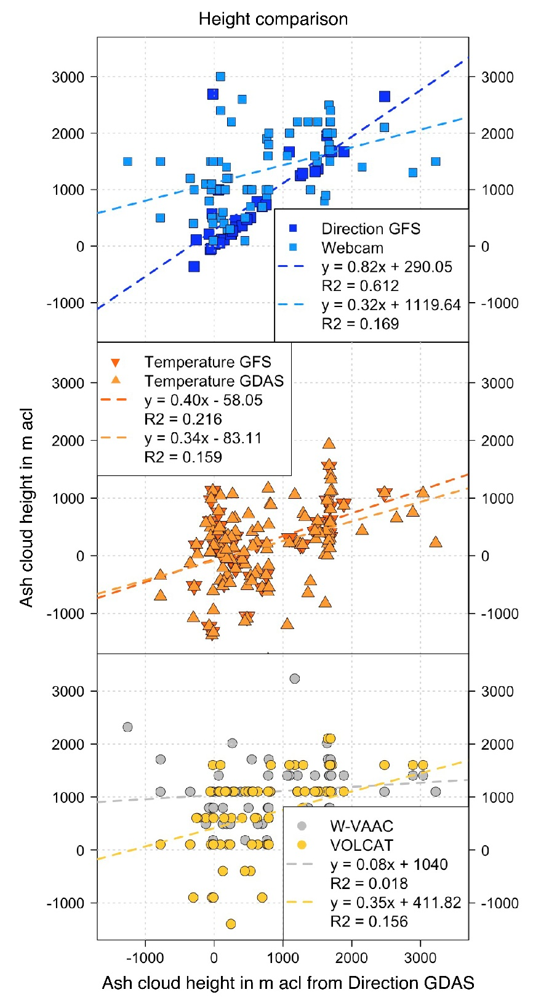
C
B
A
Figure S3-1. Comparison of ash column heights estimated from the observed ash cloud dispersal direction combined with GDAS atmospheric data and heights retrieved from: [A] direction GFS and webcam; [B] brightness temperature with GFS and GDAS atmospheric data; as well as [C] heights obtained from W-VAAC advisories and VOLCAT products.

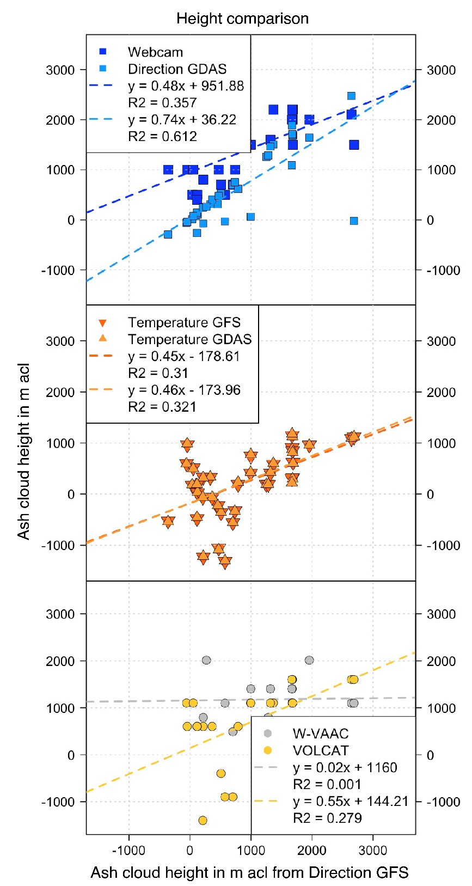
C
B
A
Figure S3-2. Comparison of ash column heights estimated from the observed ash cloud dispersal direction combined with GFS atmospheric data and heights retrieved from: [A] direction GDAS and webcam; [B] brightness temperature with GFS and GDAS atmospheric data; as well as [C] heights obtained from W-VAAC advisories and VOLCAT products.

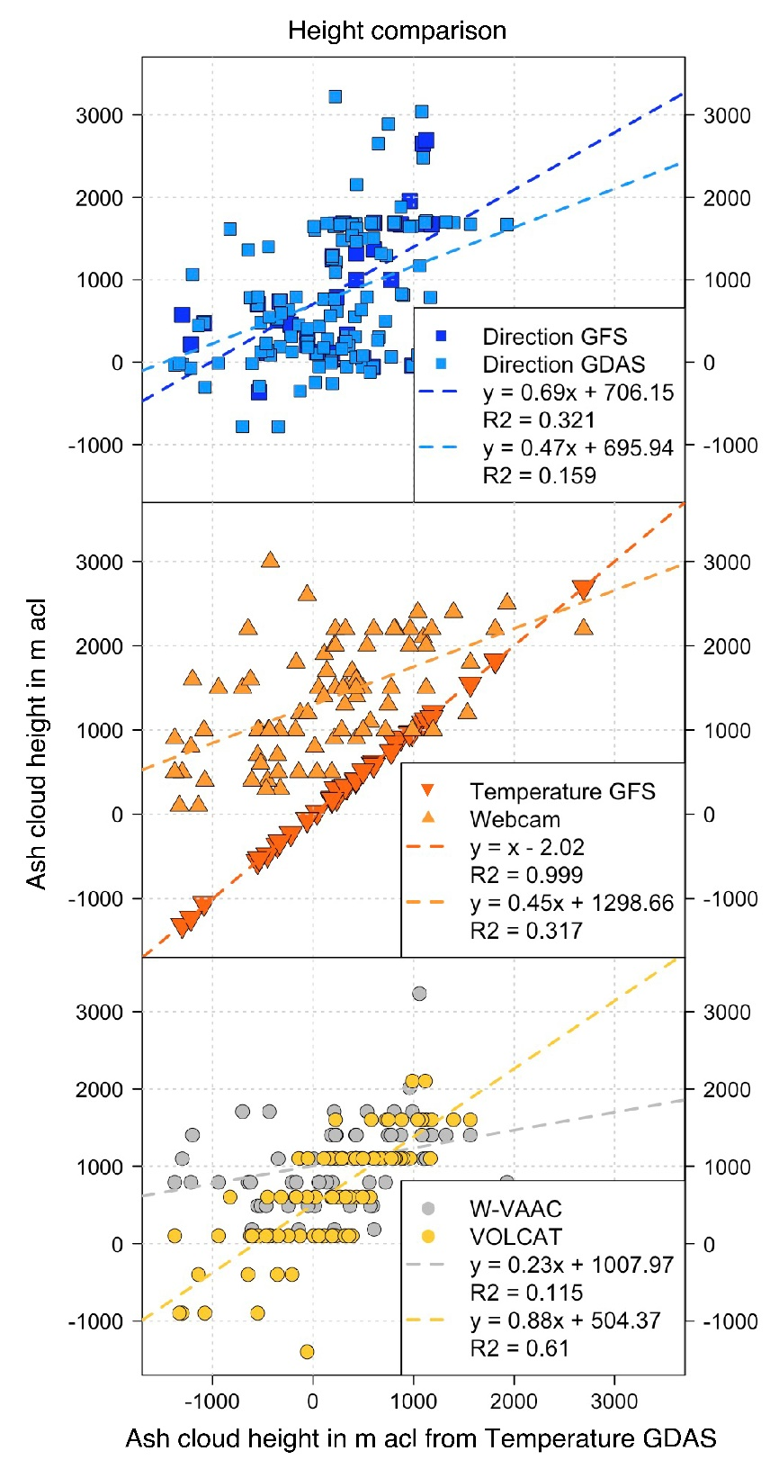
C
B
A
Figure S3-3. Comparison of ash column heights estimated from the ash cloud brightness temperature combined with GDAS atmospheric data and heights retrieved from: [A] direction with GFS and GDAS data; [B] brightness temperature GFS and webcam images; as well as [C] heights obtained from W-VAAC advisories and VOLCAT products.

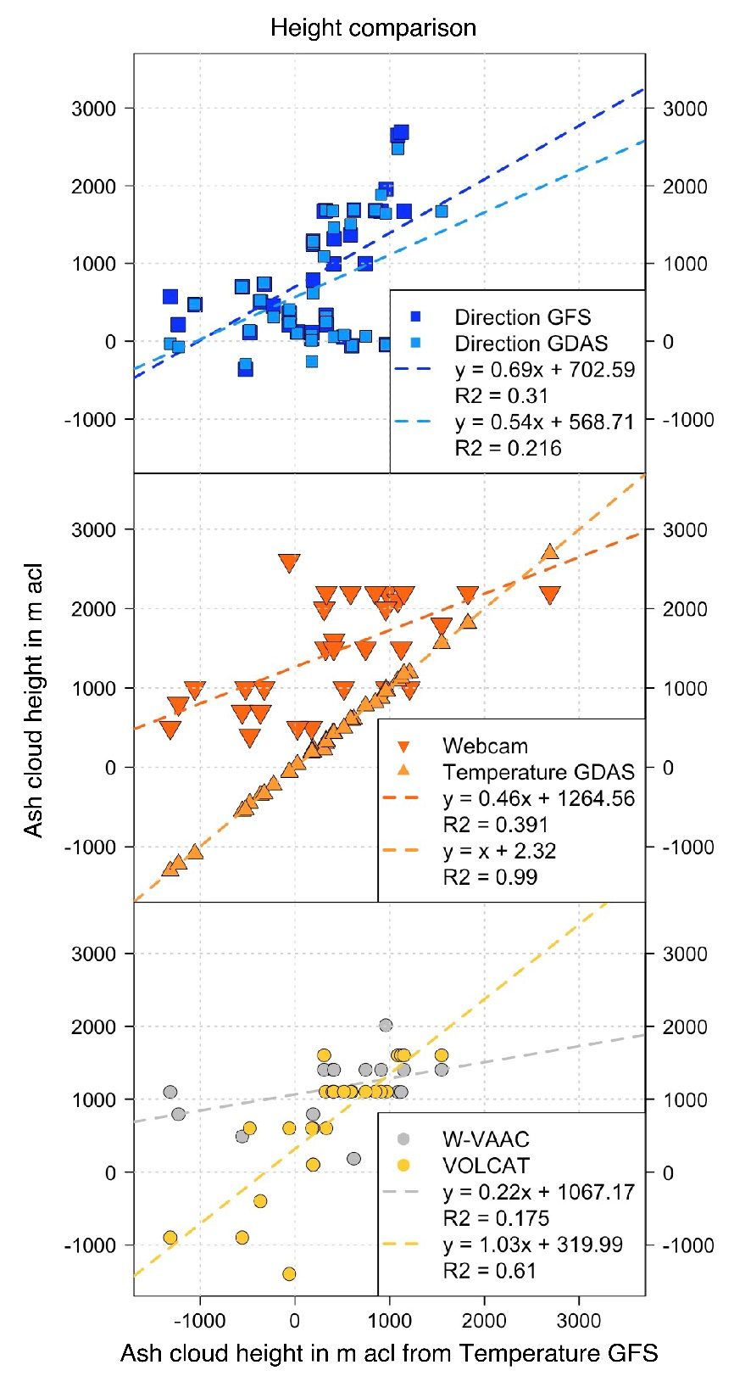
C
B
A
Figure S3-4. Comparison of ash column heights estimated from the ash cloud brightness temperature combined with GFS atmospheric data and heights retrieved from: [A] direction with GFS and GDAS data; [B] brightness temperature GDAS and webcam images; as well as [C] heights obtained from W-VAAC advisories and VOLCAT products.
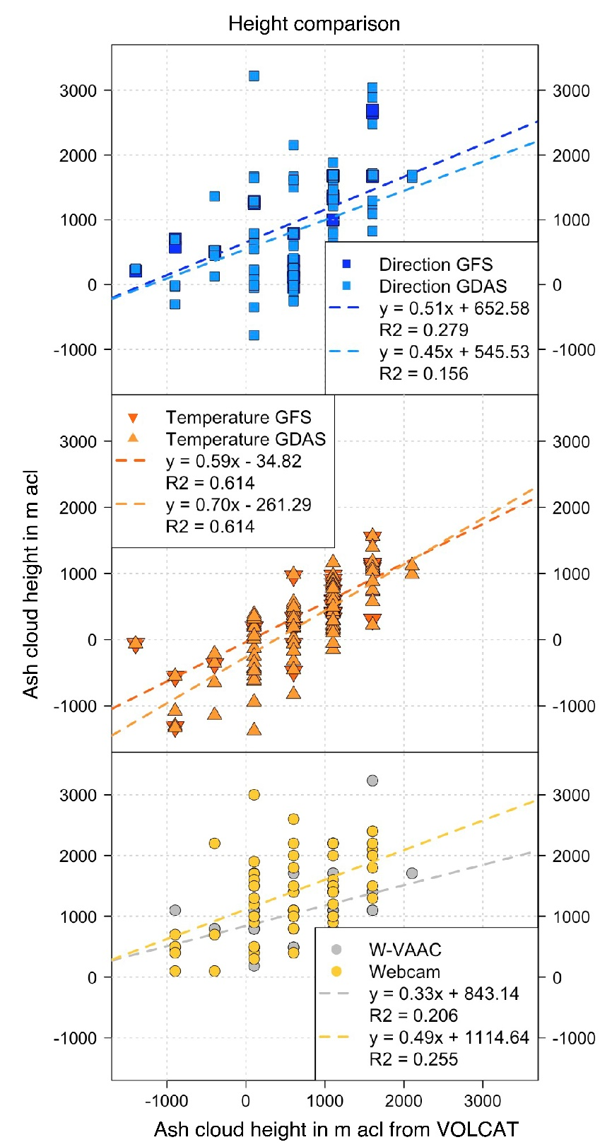
C
B
A
Figure S3-5. Comparison of ash column heights retrieved from VOLCAT products and heights estimated from: [A] direction with GFS and GDAS data; [B] brightness temperature with GFS and GDAS data; as well as [C] heights obtained from W-VAAC advisories and webcam images.
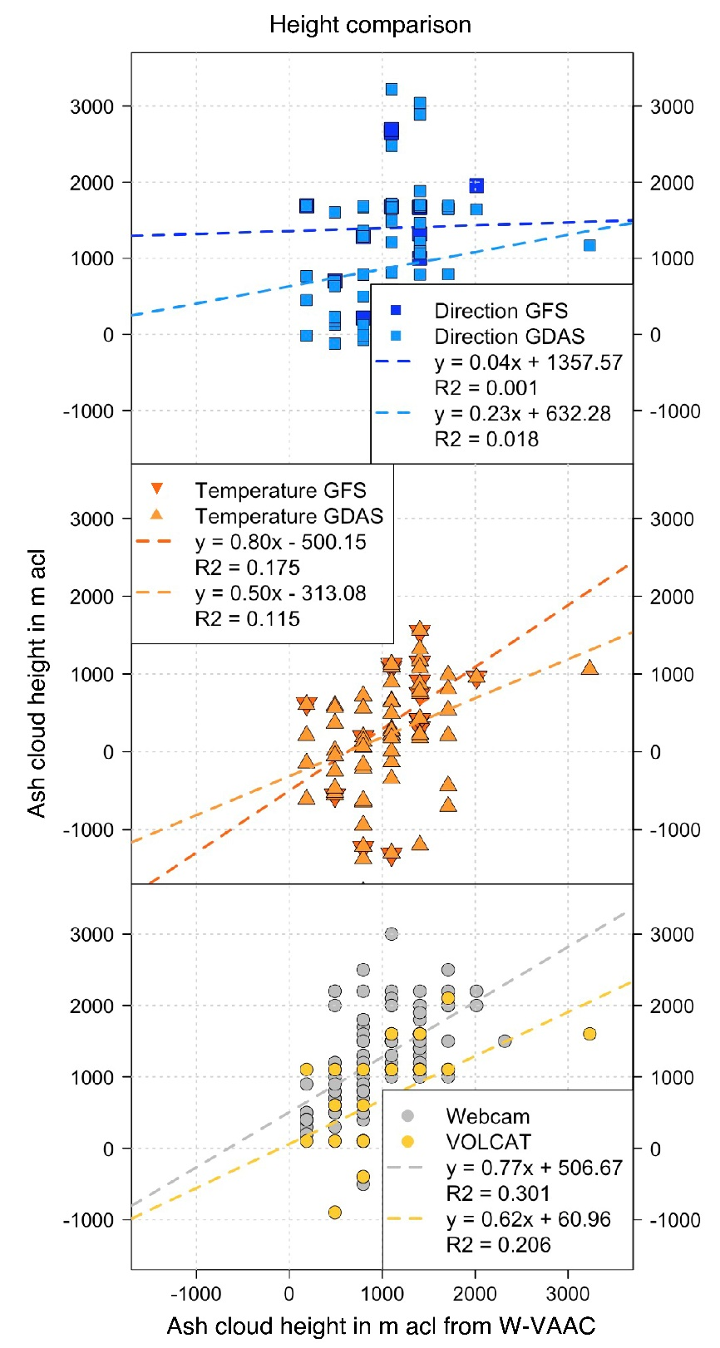
C
B
A
Figure S3-6. Comparison of ash column heights retrieved from W-VAAC advisories and heights estimated from: [A] direction with GFS and GDAS data; [B] brightness temperature with GFS and GDAS data; as well as [C] heights obtained from webcam images and VOLCAT products.

