This supplementary file appears alongside the article:
Stephens, T. L., Walker, R. J., Healy, D., and Bubeck, A. (2021) "Segment tip geometry of sheet intrusions, II: Field observations of tip geometries and a model for evolving emplacement mechanisms", Volcanica, 4(2), pp. 203-225. doi: https://doi.org/10.30909/vol.04.02.203225.
Stephens et al. [2021] should be cited if these data are used independently of the original article.

Contents
1 Geological Background for the Additional Study Sites 2
1.1 The Loch Scridain Sill Complex, Isle of Mull, UK 2
1.1.1 Field Observations 2
1.2 San Rafael Subvolcanic Field, Utah, USA 5
1.2.1 Field Observations 6
1.3 Birsay Dykes, Orkney, UK 9
1.3.1 Field Observations 9
2 Unannotated Photos 11

Geological Background for the Additional Study Sites

The Loch Scridain Sill Complex, Isle of Mull, UK
The Loch Scridain Sill Complex (LSSC) intrudes into subvertically bedded and foliated metasedimentary Moine basement and the overlying horizontally bedded cover sequences: Mesozoic sedimentary strata and Paleogene lava. Here we show examples of Paleogene sill segments hosted within the Moine basement and lava sequence in the southwest of the island (SF1-Fig. 1). A more detailed description of the setting for the sills, and sill geometry, is given by Stephens et al. [2017].

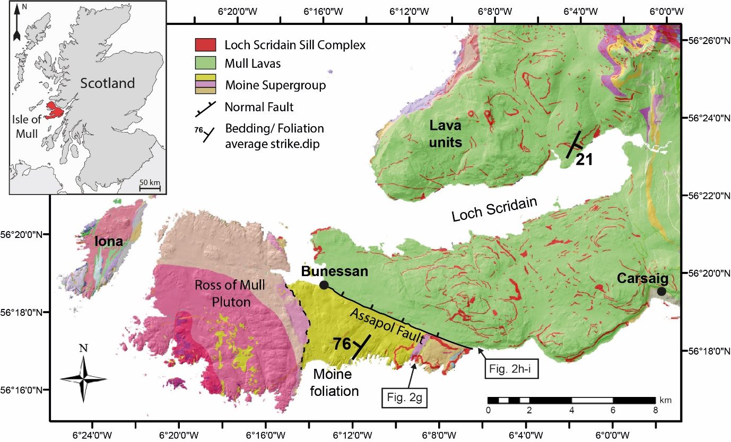
SF1-Figure 1. Location Map for Figure 2g: Loch Scridain Sill complex located on the Ross of Mull, Isle of Mull, UK.

Field Observations
Segments with tapered tips are common in the Moine basement, exploiting sub-horizontal fractures. Figure 2g (see also SF1-Fig. 2a-b) shows two sill segments hosted within the metasedimentary Moine basement. The upper sill displays tapered abandoned tips along its margin, the lower sill segment has a circular tip geometry. Subvertical bedding is locally deflected about the circular tip, suggesting propagation via viscous indentation (or ‘bulldozing’), but bedding appears uniform along the rest of the segment (Fig. 2g; also SF1-Fig. 2a). Notably bedding is sub-vertical, therefore the upper and lower sill segments were emplaced across the same host rock units. Little lateral variation is observed within the beds at the outcrop, indicating that the observed differences in tip geometry here cannot be the result of mechanical stratigraphy or lithological variations. Lenses of melted host rock occur along the margin of the lower segment, which Kille et al. [1986] inferred resulted from prolonged turbulent magma flow that prevented chilling and enabled a continuous heat flux into the wall rock, causing melting. Differing tip geometries in the metasedimentary Moine basement example may, therefore, be the result of differing flow regimes in the upper and lower segments, where prolonged turbulent flow in the lower segment enabled inflation and rounding.
Tapered and rounded sill segment geometries also occur in the lava cover sequence (Fig. 2h-i). Sill segments cut across, and step against, subvertical cooling joints and display sharp, planar, and glassy margins. Figure 2h (see also SF1-Fig. 2c-d) highlights a breached relay with an abandoned tip. The tapered tip displays colour and textural variation: a red finely crystalline interior and a grey glassy margin. The contact between the red finely crystalline interior and grey glassy margin is rounded. We interpret this to represent two stages of growth: chilling of the tip and margin, followed by inflation of the molten segment interior and rounding of the internal contact.
Relay zones between adjacent offset segments in the lava host are fractured; most of the underlapping and approximately collinear segments were linked, noted by steps in the contact geometry. Figure 2i (see also SF1-Fig. 2e-f) shows a close-spaced fracture network within a relay zone between offset underlapping segments. At the contact between the relatively massive lava and the densely fractured relay zone, the lower sill segment changes from a planar sheet-like geometry, to an irregular lobate geometry with multiple bulbous terminations. Similar geometries have been observed in brecciated dyke relay zones [Kavanagh and Sparks, 2011], and where magma is emplaced into fluidized host rock [see, e.g., Schofield et al 2014; Fig. 2-3]. Fluidization occurs in poorly consolidated sedimentary units and is therefore unlikely the cause of the irregular geometry noted here. Saffman-Taylor instabilities, however, do not require the host material to be fluidized, only that it acts as a viscous medium. A high fracture-density can change the rheology and mechanical properties of a material by lowering Young’s Modulus, E, and increasing Poisson’s Ratio, ν [e.g. Heap and Faulkner, 2008; Heap et al., 2010]. Here, we infer that the locally irregular sill tip geometry was controlled by changes to the mechanical properties of the lava in the densely fractured relay zone.

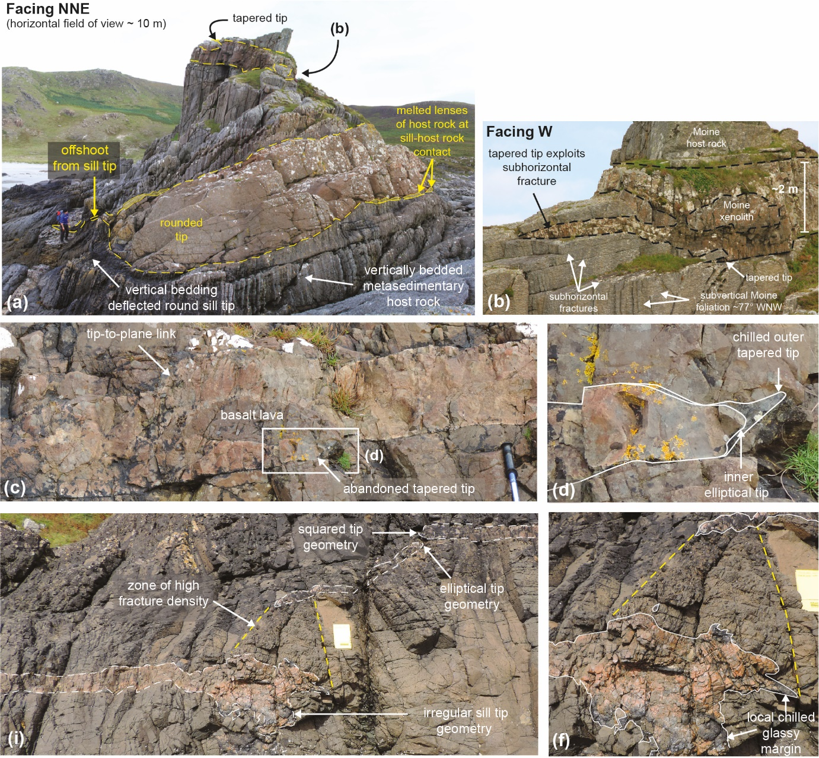
SF1-Figure 2. Additional field examples from the Loch Scridain Sill Complex, Isle of Mull, UK.

San Rafael Subvolcanic Field, Utah, USA
The Pliocene San Rafael Subvolcanic Field (SRSVF) is located in the north-western Colorado Plateau, central Utah, and comprises numerous, sills, dykes, and volcanic breccia bodies that were emplaced at ~1 km depth between 4.6 and 3.7 Ma [Delaney and Gartner, 1997; SF1-Fig. 3]. The outcropping sills and dykes are predominantly hosted within the Middle Jurassic Entrada Sandstone Formation [Gartner, 1986; Delaney and Gartner, 1997; Richardson et al., 2015], which comprises interbedded sandstone, siltstone, and claystone units, and represents part of a paralic environment [Gartner, 1986; Peterson, 1988]. Continuous thick sills cut across formation boundaries and abandoned tips along their contacts indicate that they comprise multiple linked offset segments [Walker et al., 2017]. Segmented thin sill networks are also locally associated with the thick continuous sills [Walker et al., 2017; Stephens et al., 2018]. Further detailed descriptions of the overall sill geometries are provided by Walker et al. [2017] and Stephens et al. [2018]. Here, we show examples of the various sill and dyke segment geometries and spatial relationships.

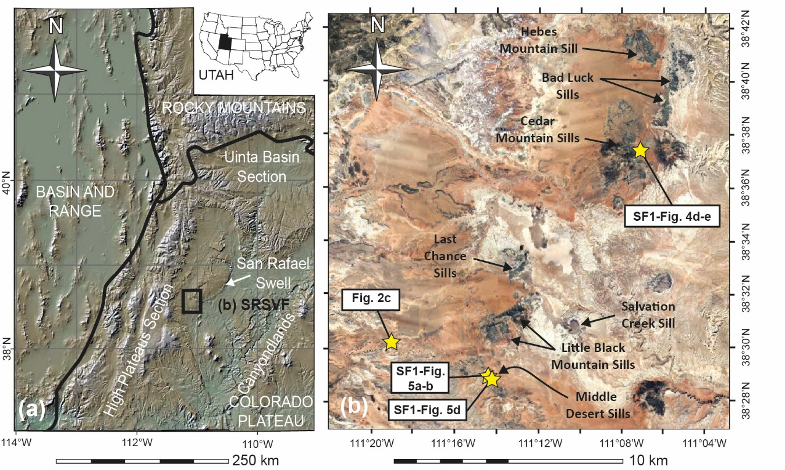
SF1-Figure 3. Location Map for Figure 2a-c: San Rafael Sub Volcanic Field, Utah, USA. (b: Satellite Image from Google Earth: Accessed 09/08/2020)

Field Observations
Sill segments in the Utah study area display collinear and offset (overlapping and underlapping) segment arrangements (SF1-Figs 4 and 5). Overlapping segments have tapered tips, and overlap zones typically display rotated host rock units and secondary fractures that are oriented oblique to the main segments; in some cases, these fractures have been dilated and intruded (SF1-Fig. 4). In all cases, overlap zones are bleached and some are brecciated, suggesting localised pore fluid overpressure associated with sill emplacement.
Underlapping segments display offset (Fig. 2a-b and SF1-Fig. 4d-e) and approximately collinear (SF1-Fig. 5) arrangements and have rounded to blunt tip geometries. Most underlapping segments are associated with a localized zone of bleached and brecciated host rock immediately ahead of the tip. Brecciation is continuous between underlapping segments with relatively small offset, and in some cases thin sheets with tapered tips cut obliquely across the brecciated relay (SF1-Fig. 4d-e), in some cases creating a breached relay and a continuous sheet (SF1-Fig. 4d). Some offset underlapping segments also display abandoned tapered tips. Similar geometries were also noted for dyke segments in the area (Fig. 2c).
SF1-Figure 5a-b shows an example of thick sill segments hosted within stacks of thin sills. The thin sills have sheet-like geometries with tapered tips, indicative of elastic-brittle emplacement. The thick sill has a rounded tip. Immediately ahead of the rounded tip the thin sills and host rock are locally brecciated, suggesting lateral propagation via bulldozing (viscous indentation). Notably, brecciation suggests that the host rock behaved initially in a brittle manner indicating that the thin sills were chilled prior to inflation and lateral propagation of the thick sill segment. We interpret the outcrop shown in SF1-Figure 5a-b to represent three stages of emplacement; (1) thin sills emplaced via elastic-brittle fracture propagation; (2) chilling and flow localisation within the thin sill network to form a single through-going sheet; (3) brecciation of the thin sills and host rock likely as a result of pore fluid boiling, which caused the host rock to behave as a disaggregated medium and promoted inflation and rounding of the thick sill segment. The differences in host rock deformation (i.e., fluidization or brecciation), are likely controlled by the host rock mechanical properties [e.g., Baer, 1991], and rate of magma emplacement (driving pressure) versus cooling and crystallisation.

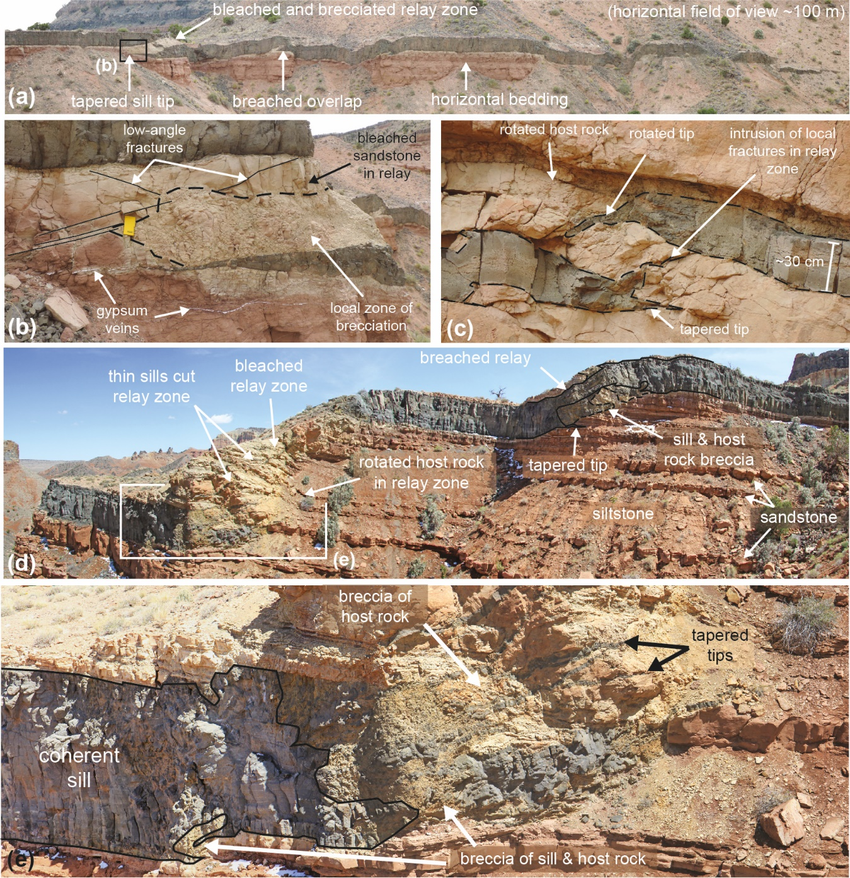
SF1-Figure 4. Additional field examples of offset segments from the San Rafael Sub Volcanic Field, Utah, USA. (a) Overview photograph showing multiple linked segments and different styles of relay deformation: (b) bleached and highly fractured/brecciated relay zone, yellow notebook for scale; (c) rotated relay zone with oblique fractures, some have been intruded. (d) Un-breached and breached underlap zones between offset segments. (e) Thin sheets cut through bleached and brecciated underlap zone ahead of blunt sill tip. (Unannotated photos available in Section 2).

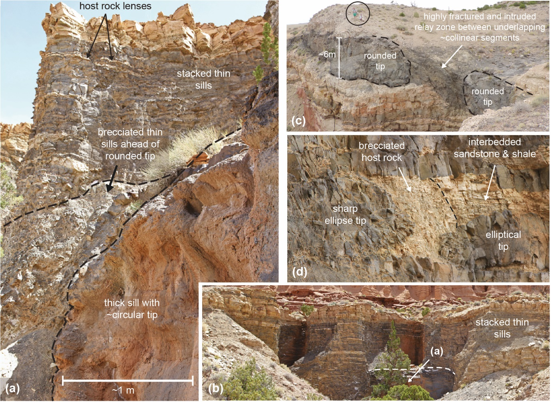
SF1-Figure 5. Additional field examples of approximately collinear underlapping segments from the San Rafael Sub Volcanic Field, Utah, USA. (a) Thick sill segment hosted in a stack of thin sills; thin sills ahead of rounded tip are brecciated. Location shown in (b). (c) Collinear underlapping segments with blunt tips and a heavily intruded underlap zone. (d) Collinear underlapping segments with rounded segment tips associated with a bleached and brecciated relay zone. (Unannotated photos available in Section 2).

Birsay Dykes, Orkney, UK
The late Permian Birsay dykes are exposed on the North West coastline of Orkney (SF1-Fig. 6). The dykes intrude the Middle Devonian lacustrine sedimentary sequence, which comprises thinly bedded sandstones, siltstones, and mudstones [Andrews and Hartley, 2015]. A more detailed description of the setting for these dykes, and overall dyke geometry, is given by Healy et al. [2018]. The studied dykes are exposed along a wave-cut platform, which provides and extensive horizontal cross-section of the dyke segments at Birsay. Here we show examples of dyke tip geometry and host rock deformation between the laterally adjacent dyke segments.
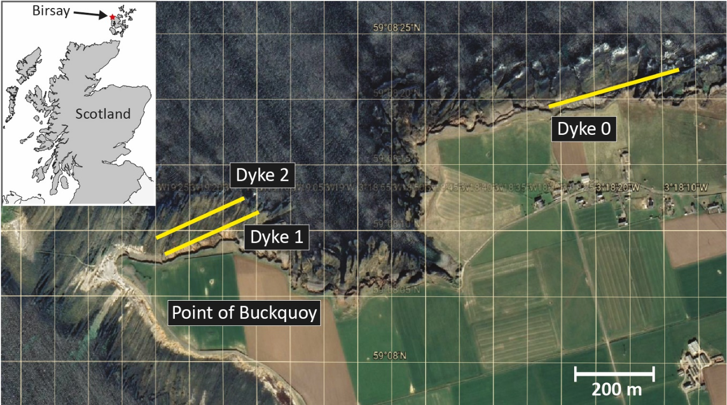
SF1-Figure 6. Location Map for Figure 14: Birsay Dykes, Orkney, UK. (Satellite Image from Google Earth: Accessed 07/08/2020, Imagery & Data attribution: CNES / Airbus).

Field Observations
Most dyke segments at Birsay comprise en-echelon arrays, generally no overlap or underlap occurs at the relay zone but the offset between segments varies; a detailed description of the segment relationships is provided by Healy et al. [2018]. Dykes display tapered and blunt segment tip geometries in both mudstone (Fig. 2e-f; see also SF1-Fig. 7a-c) and siltstone (Fig. 2d; see also SF1-Fig. 7d-e) host rock. Segments with tapered tips cause bending of pre-existing host rock fractures (Fig. 2e; see also SF1-Fig. 7a, d); while segments with blunt tips are associated with local fracturing ahead of the tip (Fig. 2f; see also SF1-Fig. 7b, e), baked relay zones (noted by local darkening of colour in the relay zone: SF1-Fig. 7c), and densely fractured relay zones (SF1-Fig. 7e). Where the host rock ahead of the dyke tip is densely fractured, the blunt tips have local irregularities and magma fingers extend into the fractured zone.

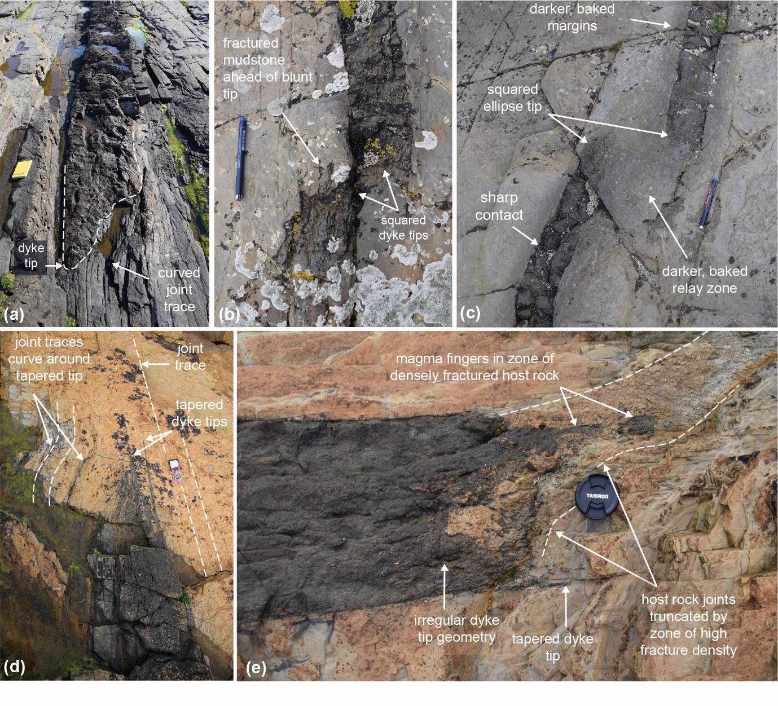
SF1-Figure 7. Additional field examples of dyke tip geometries at Birsay, Orkney, UK. (a) Joint traces curve around, and are truncated by, an asymmetrical tapered tip, notebook for scale. (b) Locally fractured host rock ahead of blunt (superellipse) underlapping dyke segments, pen for scale. (c) Baked host rock in relay zone between underlapping dyke segments with rounded tips; pen for scale. (d) Joint traces curve around asymmetrical tapered tip; compass for scale. (e) Joint traces truncated by highly fractured host rock ahead of blunt dyke tip. Magma fingers intrude the highly fractured zone, lens cap for scale. (Unannotated photos available in Section 2).

Unannotated Photos
Figure 2
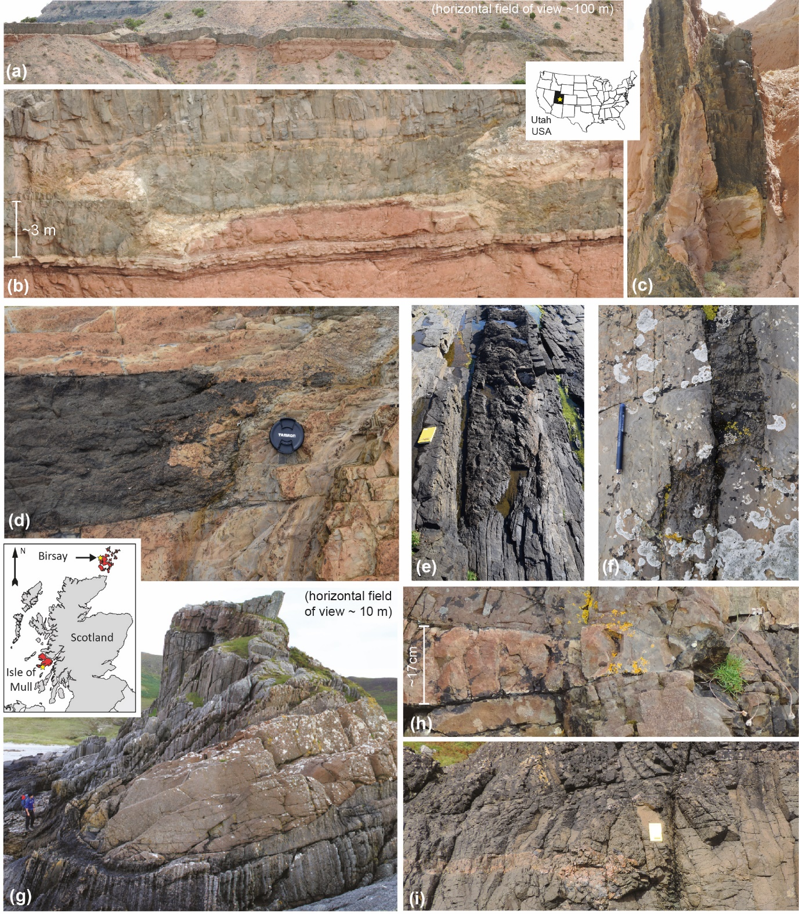
(a-c) San Rafael Sub Volcanic Field: Location (a-b): Little Black Mountain; Location (c): Cathedral Valley Dykes: 38°30’15”N, 111°18’53”W.
(d-f) Birsay, Orkney, UK: Location (d): Dyke 1; ~HY 244 285; Location (e): Dyke 0 East; ~HY 255 288; Location (f): west of Dyke 1; ~HY 243 285
(g-i) Loch Scridain Sill Complex, Isle of Mull, UK: (Locations also shown on SF1-Fig1), Location (g): ~580 m SW of Scoor House: 56°17’20”N, 6°09’58”W; Location (h-i): ~56°17’48”N, 6°07’26”W.
Figure 5
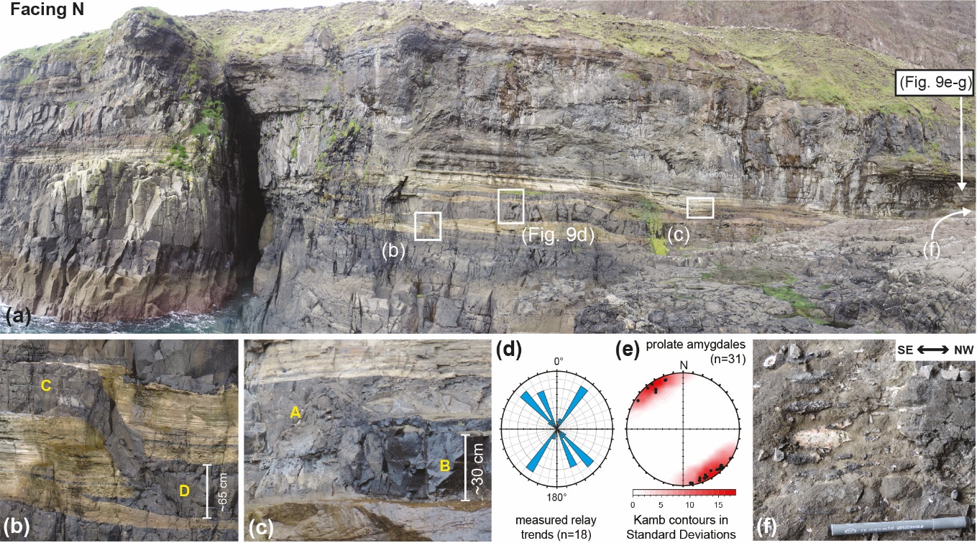
Little Minch Sill Complex, Isle of Skye, UK
Location: SK-1: Cliff Face: ~ 57°25’21”N, 6°45’25”W

Figure 7
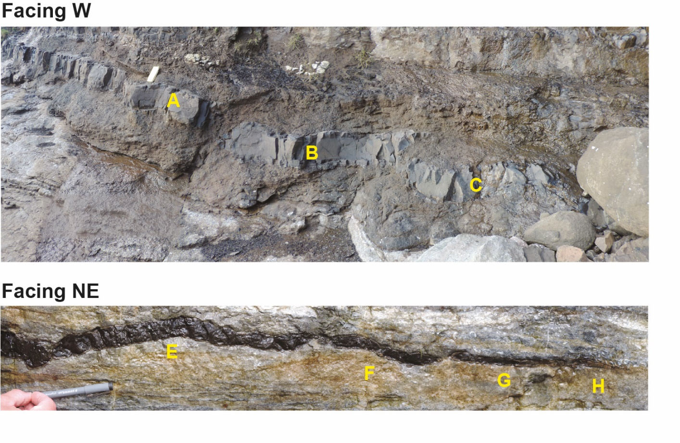
Little Minch Sill Complex, Isle of Skye, UK
Lower Photo Location: Waterfall: ~ 57°25’39”N, 6°46’36”W

Figure 8
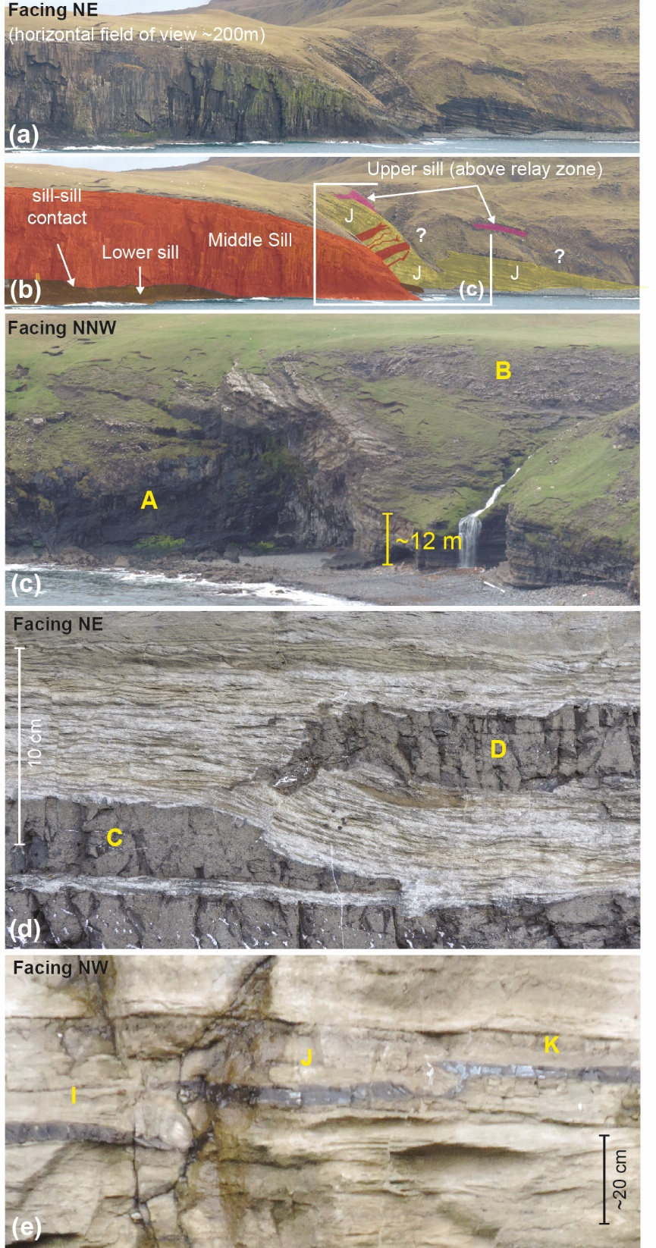
Little Minch Sill Complex, Isle of Skye, UK
Location (a-d): Waterfall: ~ 57°25’43”N, 6°45’57”W
Location (e): SK-1 Cliff Face: ~ 57°25’21”N, 6°45’25”W

Figure 9
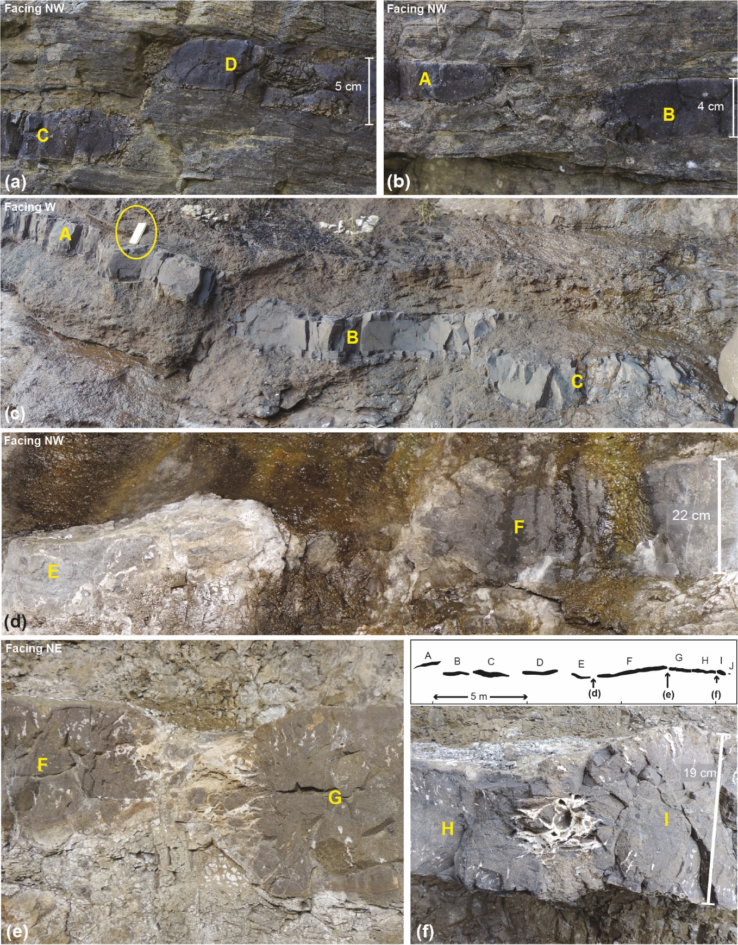
Little Minch Sill Complex, Isle of Skye, UK
Location (a-b): East Coast: ~ 57°35’02”N, 6°08’27”W
Location (c): SK-70: ~ 57°25’21”N, 6°45’12”W
Location (d): SK-1: Cliff Face: ~ 57°25’21”N, 6°45’25”W
Location (e-g): SK-1 Under Overhang: ~ 57°25’21”N, 6°45’25”W

Figure 10
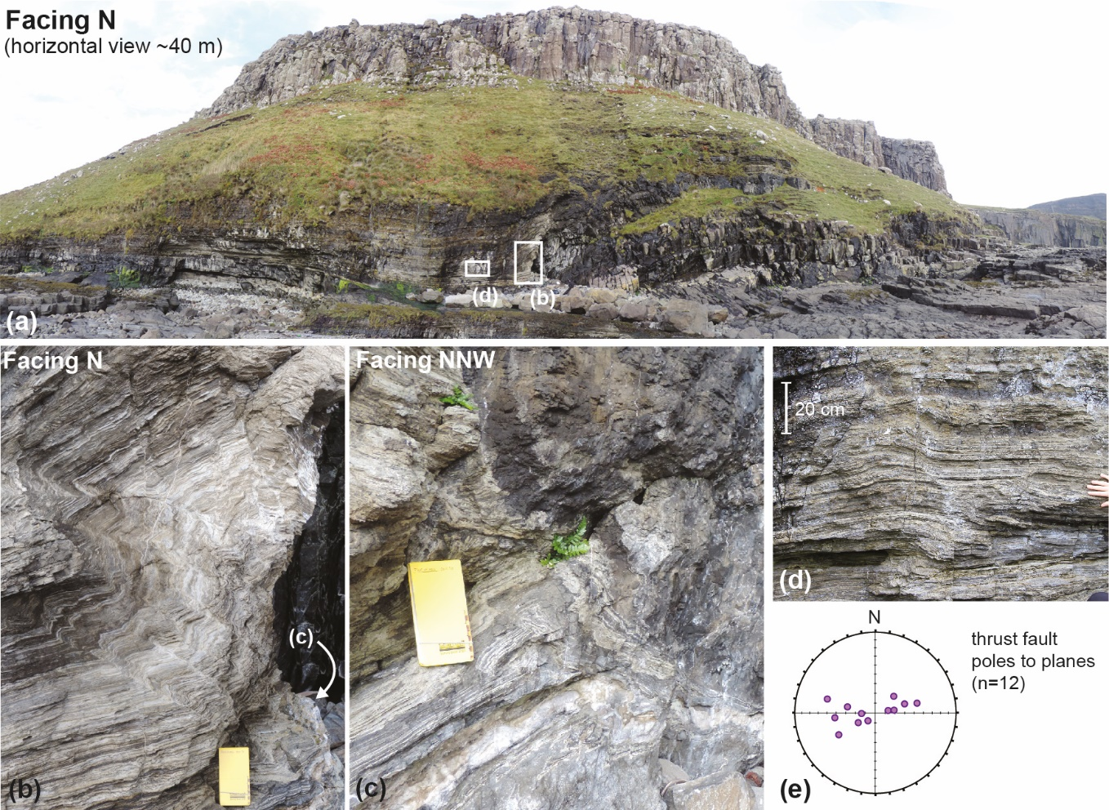
Little Minch Sill Complex, Isle of Skye, UK
Location: Bulldozing Sills: ~ 57°25’39”N, 6°46’36”W

Additional Examples
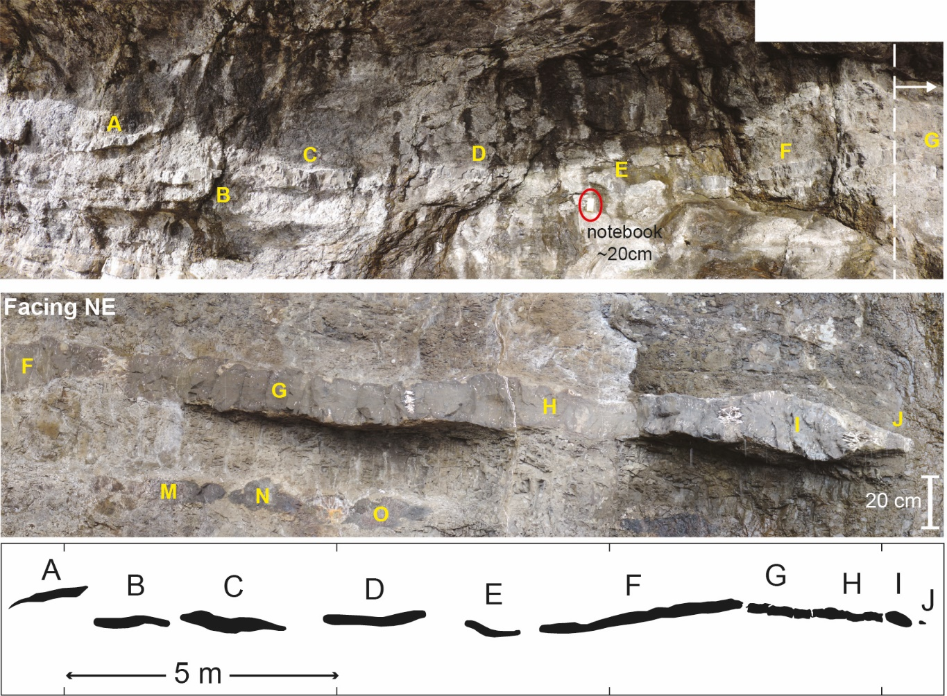
Little Minch Sill Complex, Isle of Skye, UK
Location: SK-1 Under Overhang: ~ 57°25’21”N, 6°45’25”W

Additional Examples
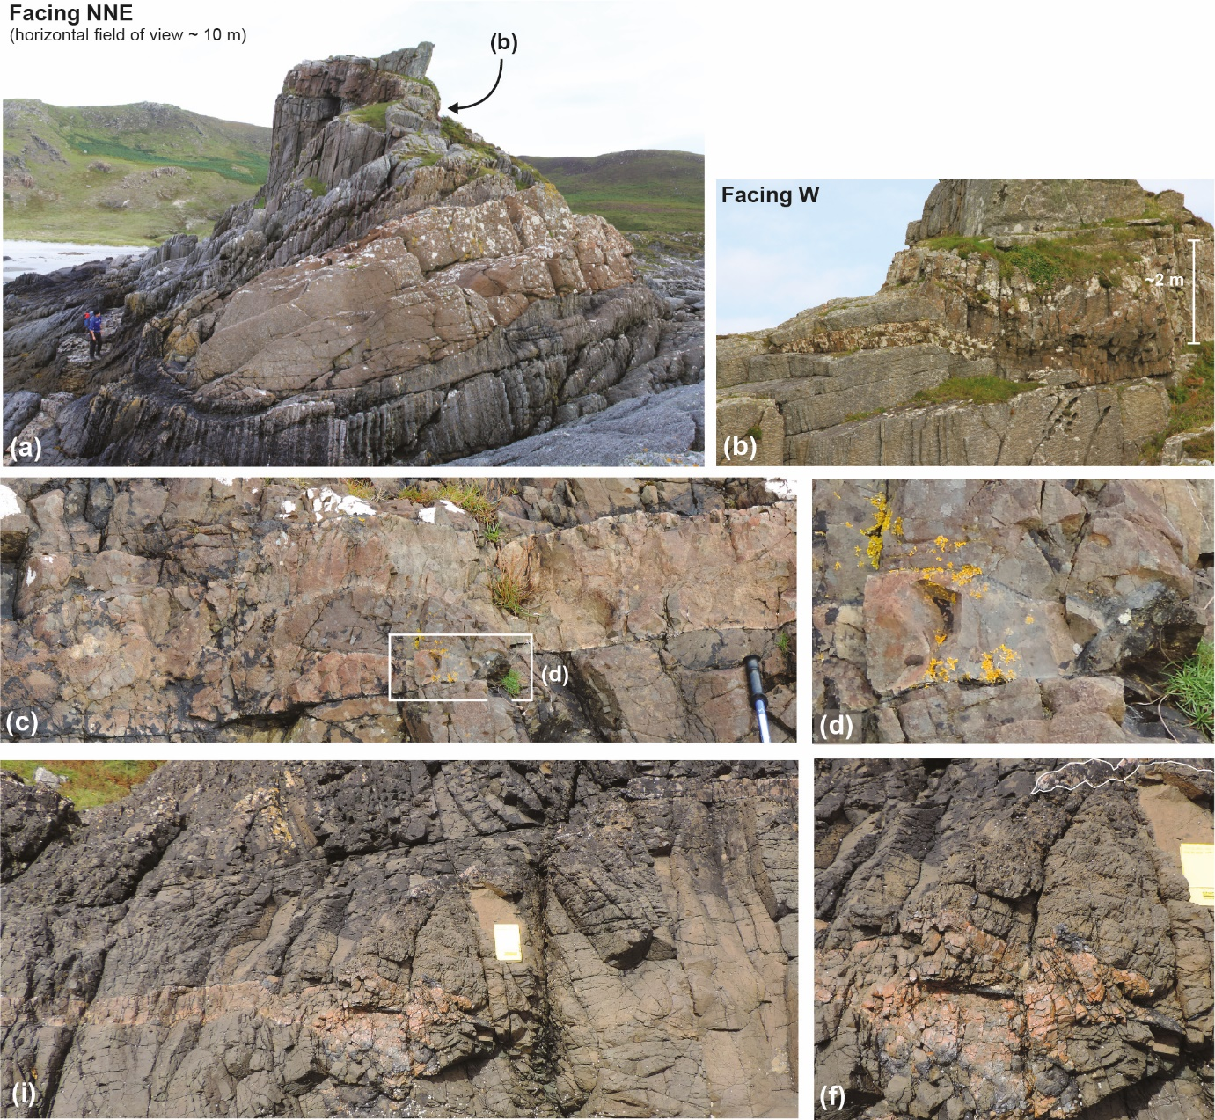
Loch Scridain Sill Complex, Isle of Mull, UK: (Unannotated SF1-Figure 2)
Location (a-b): ~580 m SW of Scoor House: 56°17’20”N, 6°09’58”W
Location (c-f): ~56°17’48”N, 6°07’26”W.

Additional Examples
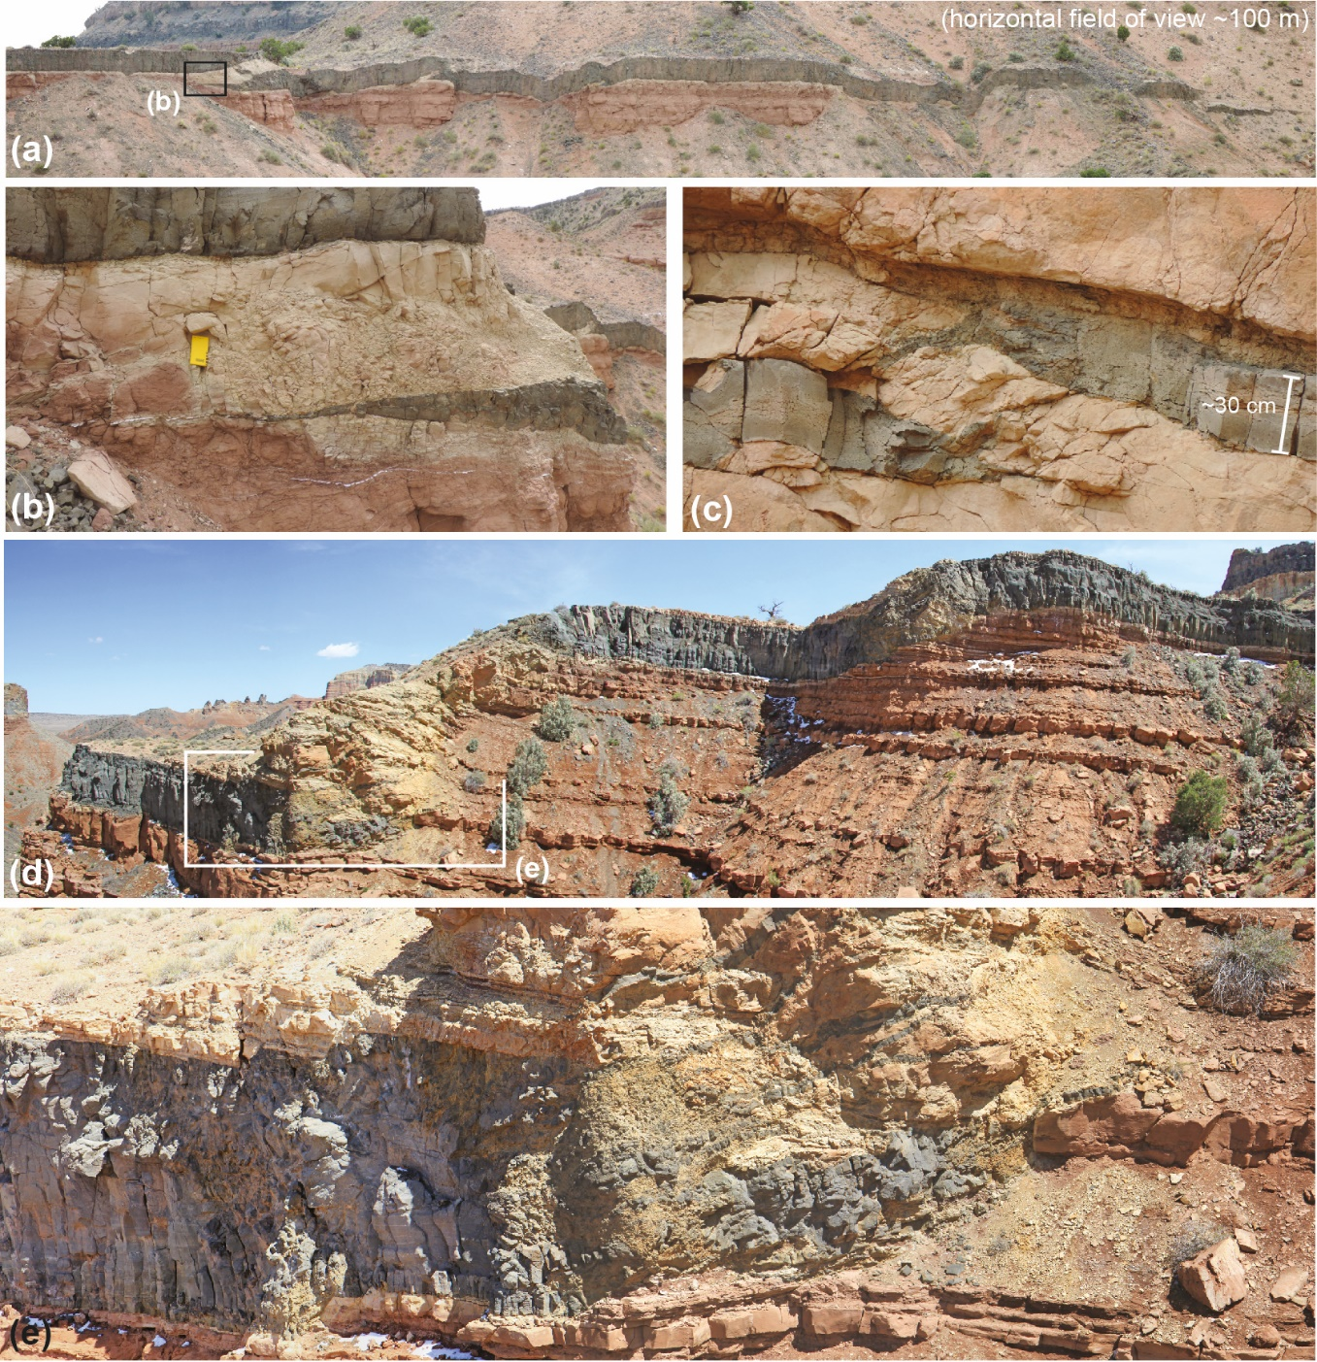
San Rafael Sub Volcanic Field: Offset segments (Unannotated SF1-Figure 4)
Location (a-b): Little Black Mountain
Location (c): Outcrop by road between Middle Desert Sill & Little Black Mountain: ~38 29’48”N, 111 14’46”W
Location (d-e): Central Cedar Mountain Sill

Additional Examples
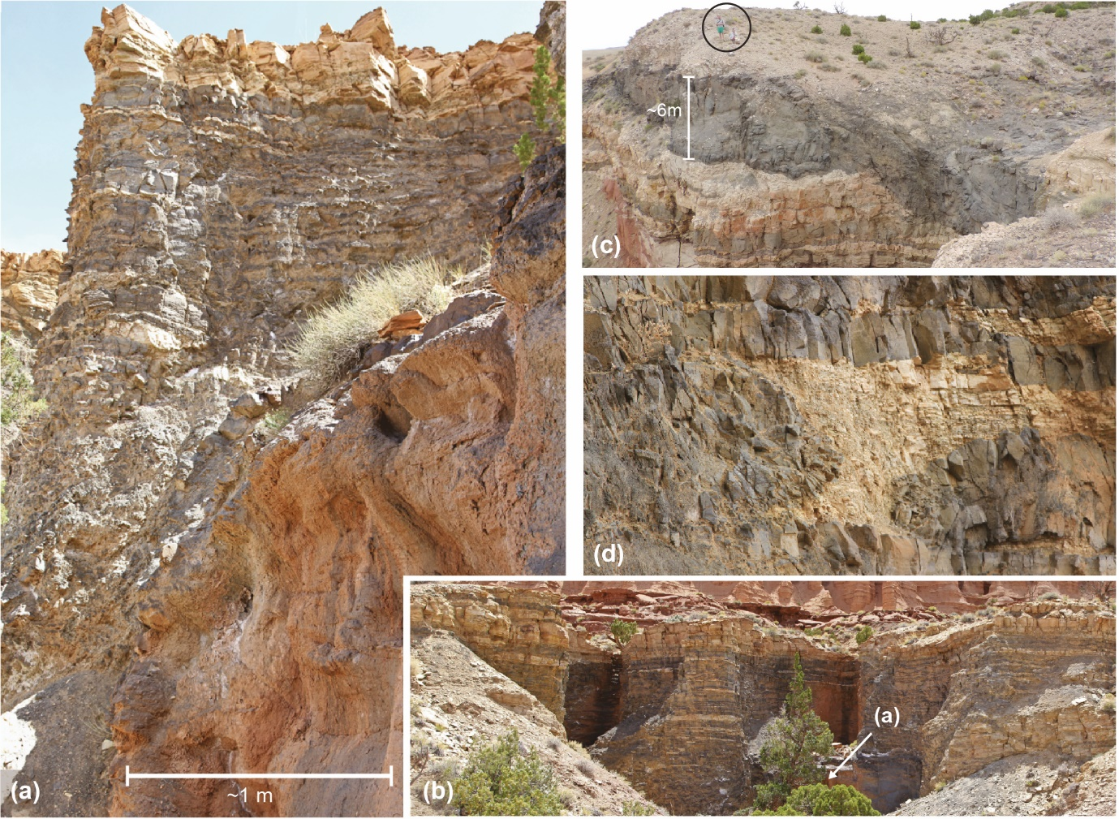
San Rafael Sub Volcanic Field: Collinear Segments (Unannotated SF1-Figure 5)
Location (a-b): Middle Desert Sill: 38°29’05”N, 111°14’32”W
Location (c): Little Black Mountain
Location (d): Middle Desert Sill: 38°28’57”N, 111°14’19”W

Additional Examples
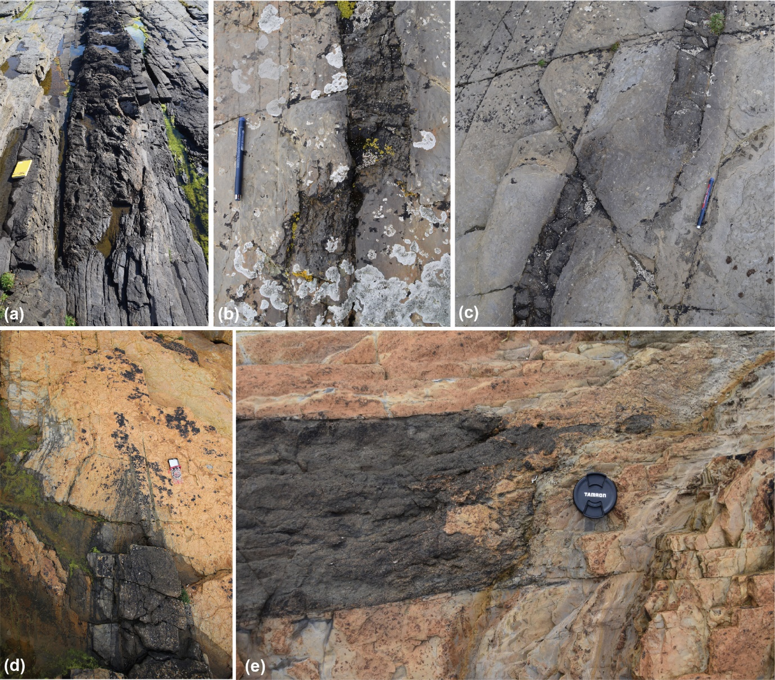
Birsay, Orkney, UK: (Unannotated SF1-Figure 7)
Location (a): Dyke 0 East; ~HY 255 288
Location (b-c): west of Dyke 1; ~HY 243 285
Location (d): Dyke 1; ~HY 244 285
Location (e): Dyke 1; ~HY 244 285

