This Supplementary Material accompanies the article
“Laser heating effect on Raman analysis of CO2 co-existing as liquid and vapor in olivine-hosted melt inclusion bubbles” by Charlotte L. DeVitre et al. The original article should be cited if this material is used:
DeVitre, C. L., Dayton, K., Gazel, E., Pamukçu, A. ., Gaetani, G. and Wieser, P. E. (2023) “Laser heating effect on Raman analysis of CO2 co-existing as liquid and vapor in olivine-hosted melt inclusion bubbles”, Volcanica, 6(2), pp. 201–219. doi: 10.30909/vol.06.02.201219.
Supplementary materials

UNCERTAINTY
We collected additional Raman spectra using a WiTec Alpha 300R Raman spectrometer at the Department of Earth and Planetary Sciences at the University of California – Berkeley (UCB) to assess the precision of measurements in three power cycles (i.e., ascending, descending and ascending laser power from 0.5 to 20 mW). While this instrument has yet to be fully calibrated using an FDCA (DeVitre et al., 2021), the system is overall identical to the Raman instrument at Cornell, equipped with a green solid state 532.047 nm laser focused as an excitation source with a 50x objective (x0.55NA, 9.1 mm focal distance). Repeated measurements on a 0.62 g/mL CO₂ fluid inclusion from Fogo volcano in Cabo Verde that was measured during calibration at Cornell University indicate an offset between the instruments of only about ±0.01 g/mL which can be seen on Fig. S1. We collected spectra at both 24°C and 37 °C for VB0.63 and VB0.28 over three alternating direction power cycles from 0.5 to 20 mW. All spectra were acquired with five accumulations of 45 s of integration time (total analytical time = 225 s) in a single window using 1800 grooves/mm (~0.54 cm⁻¹ spectral resolution). As with the Cornell data, the UCB data was corrected for non-linearity of the Raman shift axis using Neon (see main text methods for details).
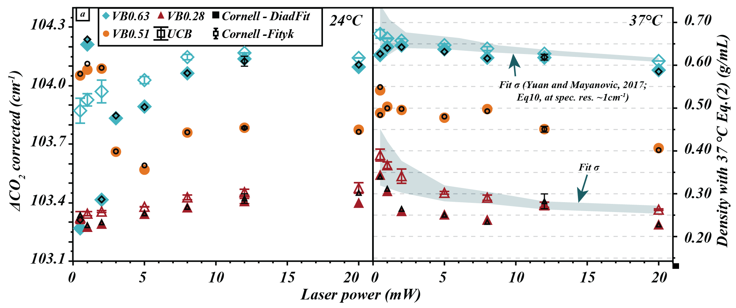
Figure S1. Fermi diad separation at 37˚C and 24˚C as a function of laser power for spectra acquired with two Alpha300R WiTec Raman instruments (UCB: empty symbols; Cornell: filled symbols) and fit with different open-source fitting software (DiadFit: large symbols; Fityk: small symbols with black outline). Error bars are shown on data acquired at the University of California – Berkeley based on three cycles of increasing and decreasing laser power. Shaded areas in panel b) represent calculated fitting error (Yuan and Mayanovic, 2017 equation (10)) based on the Intensity/FWHM of single peak-fits for 37 ˚C spectra collected at UCB. At low laser power, larger error is expected due to increased noisiness of spectra. Note however that this fitting error was estimated by Yuan and Mayanovic (2017) for a spectral resolution of 0.8-1 cm⁻¹ while the resolution of our instruments is ~0.54 cm⁻¹, so it is likely the fitting error is lower for our data. At 24 ˚C and low laser power, error is considerably larger due to the presence of two phases of CO₂ which may variably skew the fit to higher or lower Fermi diad separation. Error bars on Cornell’s 12 mW data are shown based on two repeated measurements of the same bubble made by different operators over one month.
Spectra were fit using Python tool DiadFit 0.0.50 (https://github.com/PennyWieser/DiadFit) following the same method as described in the main text. We also re-fit the Cornell data using the same tool for comparison purposes. In DiadFit, we used linear background subtraction (as described in the main text methods). We fit hot bands and C13 when visible and an additional gaussian under each CO₂ band when the overall intensity of the spectrum was large, in the same way as was done with Fityk. There is a small systematic offset between the Cornell and UCB data, which could be due to slight hardware or spectral calibration differences despite the instruments being nearly identical in construction (Fig. S1). The results for Fityk and DiadFit for spectra from a given instrument are indistinguishable within the error of the measurements. Trends observed in the Cornell data are reproduced in the UCB data at both temperatures. The UCB data also confirms the trends in VB0.28, which were difficult to observe in the Cornell data (likely because of increased stage stability at UCB). For VB0.28 in the UCB data, there is an offset between the 37 °C low power (<5 mW) data and the high power (>8 mW) data at 24 °C akin to what was found for the other two VBs at Cornell.
We show on Fig. S1b shaded areas corresponding to calculated fitting error via equation (10) in Yuan and Mayanovic (2017) based on the ratio of Intensity (CCD counts) and Full Width Half Maximum (FWHM) of the fitted peak for spectra acquired at UCB and 37 °C. Note that the fitting error equation from Yuan and Mayanovic (2017) was estimated for a spectral resolution of 0.8-1 cm⁻¹ while the resolution of our instruments is ~0.54 cm⁻¹, so it is likely the fitting error is in fact lower for our data given that spectral resolution can have a significant impact on the uncertainty in the fit, though it is difficult to quantify at this time. Even if we consider this a “maximum error”, the trends in the data can still be observed.
We also evaluated the asymmetry factor (A_{s-norm}) of the two Fermi diad bands in the UCB spectra as a comparison (Fig. S2). As laser power increases, the symmetry for the two Raman bands also increases and converges towards the mean A_{s-norm} at 37 °C for all three bubbles. These trends match well those found in the data collected at Cornell and are significant within the error of the measurements.
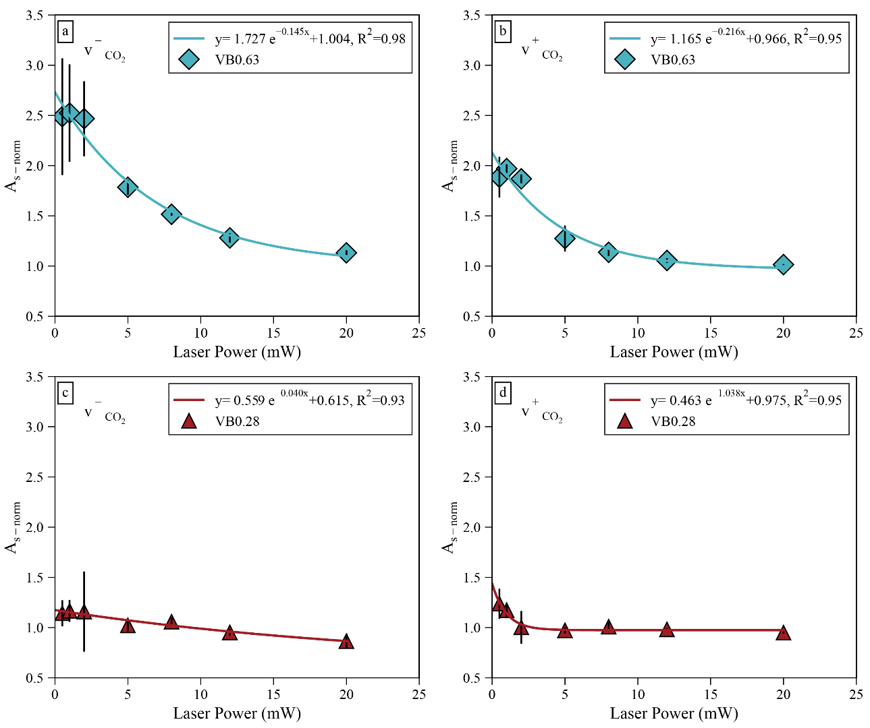
Figure S2. Laser power versus maximum band asymmetry factor A_{s-norm} for each vapor bubble for the 24 °C data (A_{s-24°C}) acquired at UCB normalized to the 37 °C data (A_{s-37°C}) using Eq. (5) in the main text. An exponential function is fit through the data. a-b) A_{s-norm} as a function of laser power for v⁻ and v⁺ bands of VB0.63. c-d) A_{s-norm} as a function of laser power for v⁻ and v⁺ bands of VB0.28. Error bars shown are calculated based on three cycles of changing laser power.

EFFECT OF THE DIFFRACTION GRATING AND SPECTRAL RESOLUTION
We collected spectra in the same vapor bubble (VB0.63) at two different diffraction gratings (1800 grooves/mm and 2400 grooves/mm to determine whether the contributions of L and V phases to the Raman spectrum could be visible at higher spectral resolution (~0.31 cm⁻¹) even when they are not visible at a lower spectral resolution (0.54 cm⁻¹). At 1800 grooves/mm and 8 to 12 mW laser power the contribution of the two phases are visually indiscernible even though there is a broadness and asymmetry to the peaks. In contrast, in spectra collected with the 2400 grooves/mm diffraction grating (Fig. S3), the liquid and vapor peaks in the spectrum are visually evident at 8 mW, present at 10 mW and nearly indiscernible at 12 mW, though all three are noticeably asymmetric. The 8 mW peak at the bottom of Fig. S3 was acquired after slight refocusing, so it is possible that at 12 mW they could still be present, only difficult to resolve given the exact position of the laser within the bubble. It is worthwhile to note that slight differences in focus can affect the analysis enough that one could easily miss the presence of two phases even in spectra with a very high spectral resolution (0.31 cm⁻¹). Additionally, it is very difficult to visually discern the contribution of the two peaks in spectra acquired with the lower spectral resolution (~0.5-1 cm⁻¹) and higher laser powers (>5 mW) that are commonly used for melt inclusion vapor bubble measurements.
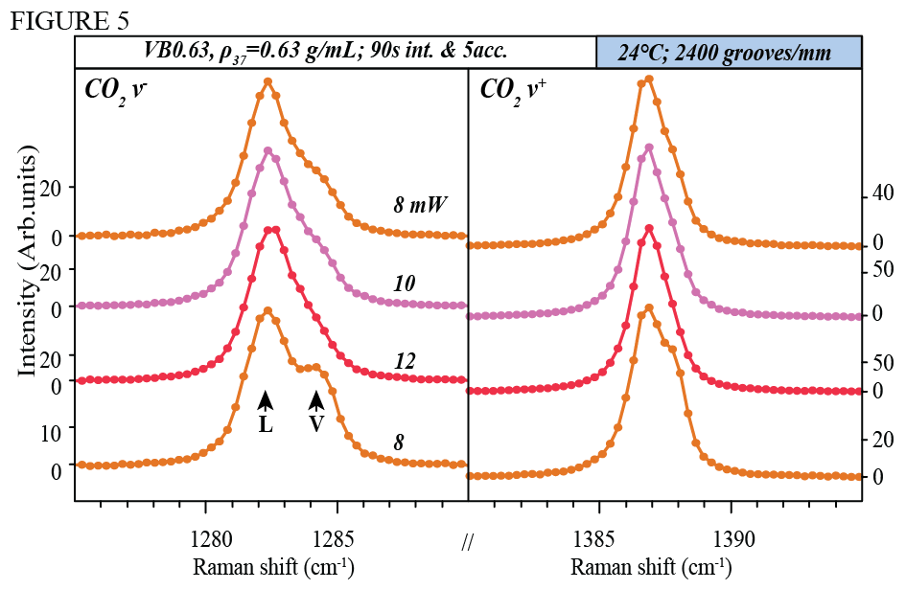
Figure S3. Closeup spectra of the lower (v⁻) and upper (v⁺) bands of CO₂ for bubble VB0.63 measured with the 2400 grooves/mm grating at T_{amb} and using 8, 10 and 12 mW. 8 mW was measured twice (refocused at the end of the session). All four spectra were acquired at 90s and 5 accumulations. Note that the vibrations corresponding to L and V are clearly resolvable at 8 mW. The vapor contribution decreases at 10 mW and further at 12 mW to the point that it is difficult to discern except by the asymmetry of the peak.

AN EFFECT OF VAPOR BUBBLE VOLUME AND DENSITY?
In section 3.4.5 in the main text, we discuss the relationship between peak asymmetry and laser power. We found that as laser power increases, the asymmetry factor (A_{s-norm}) of both bands of CO₂ decreases exponentially (Fig. 8 in main text) for each vapor bubble. A comparison of the decay constant λ_{As-norm} of each exponential fit to the bubble densities and bubble radii (Fig. S4) shows that larger bubbles may have larger λ_{As-norm} and low-density bubbles may also have larger λ_{As-norm}. We recognize that the sample set is very small (n=3) and that the error on λ_{As-norm} particularly for the v⁻ band of VB0.28 is very large. However, if this our findings are correct, it would mean that bubbles with higher CO₂ bulk densities require higher laser powers to exceed T_{crit} or the homogenization temperature. Though our dataset is too small to provide conclusive evidence on either of these relationships, it would be interesting to explore in future experiments.
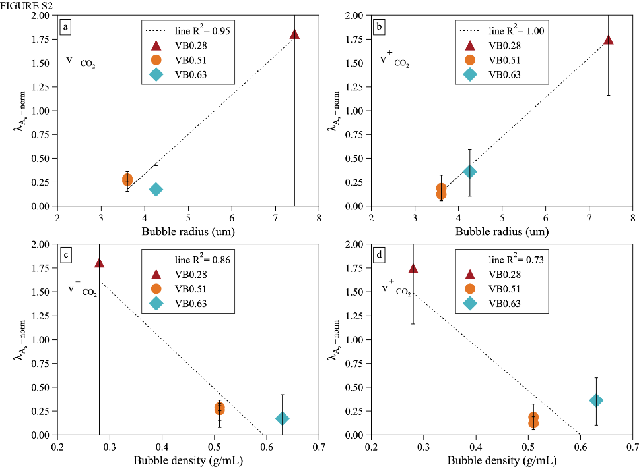
Figure S4. Exponential decay constant of A_{s-norm} (λ_{As-norm}) from Fig. 6 in the main text as a function of bubble radius and density. a-b) λ_{As-norm} as a function of Bubble radius for v⁻ and v⁺ bands respectively. c-d) λ_{As-norm} as a function of Bubble density for v⁻ and v⁺ bands respectively.

EFFECT OF INTEGRATION TIME AND ACCUMULATIONS
It could be hypothesized that at a given laser power, longer analysis times (longer exposure to the laser) could result in increased heating. For example, the heating model from Hagiwara et al., 2021 shows that, for fluid inclusions, ~90% of the heating induced by laser is achieved in the first 18s of exposure. This means that in theory, liquid and vapor phases should still be observable and/or measurable in an inclusion analyzed at laser powers suspected to heat above T_{crit} when analyzing for very short amounts of time. To test the effects of integration time and accumulations on our melt inclusion vapor bubble results, VB0.51 was analyzed at different integration times and accumulations at 0.5 mW (45s x 5 accumulations, 90s x 5 and 200s x 3), 5 mW (5s x 1, 5s x5, 10s x1, 10s x3, 20s x1, 45s x1, 10s x5, 30s x3, 90s x1, 45s x5) and 10 mW (5s x1, 10s x1, 5s x5, 20s x1, 10s x3 and 10s x5). We plot and report the data in Fig. S5 in order of exposure time to the laser (e.g., 10 s integration time and 5 accumulations would amount to 50 s total exposure time).
There are no discernable differences in our results after a given amount of time, other than the overall noisiness of the spectra. For example, the 0.5mW spectra collected with the 2400 grooves/mm grating over 225 s and 600 s analyses are nearly identical, with the former being only noisier and 4x weaker in overall intensity (main text Fig. 3l). Both the liquid and vapor phase contribution to the spectrum are resolvable regardless of the total exposure time. This suggests that no additional significant effect occurs after a certain amount of time and is consistent with predictions of the models from Hagiwara et al. (2021).
Our experiments at 5 and 10 mW and 1800 grating (Fig. S5a and b) in VB0.51 did not detect a clear contribution of L and V peaks to the spectra, although they appeared slightly broader at lower exposure times. For the experiments at 5 mW, the peaks were found to be lightly asymmetric compared to the mean asymmetry at 37 °C (Fig. S5c) but there was no change with exposure time. At 10 mW, there was only a very weak effect of exposure time to the laser on asymmetry (see Fig. S5d). However, neither trend was found to be statistically significant, the spectra are overall very noisy, and it is probable that VB0.51 is never fully a single-phase when exposed at 5 and likely even 10 mW laser powers. As such, added integration time would result in no further change in the spectrum like the experiments at 0.5 mW. While it is possible that experiments at 20 mW or above could show different results, we did not pursue these given that it is unlikely that analyzing vapor bubbles at low integration or accumulation times would be useful. This is because such measurements would be very noisy, which harms the precision of measurements due to increased difficulty in peak-fitting. As such, we do not recommend analyzing vapor bubbles with very low integration times or accumulation numbers.

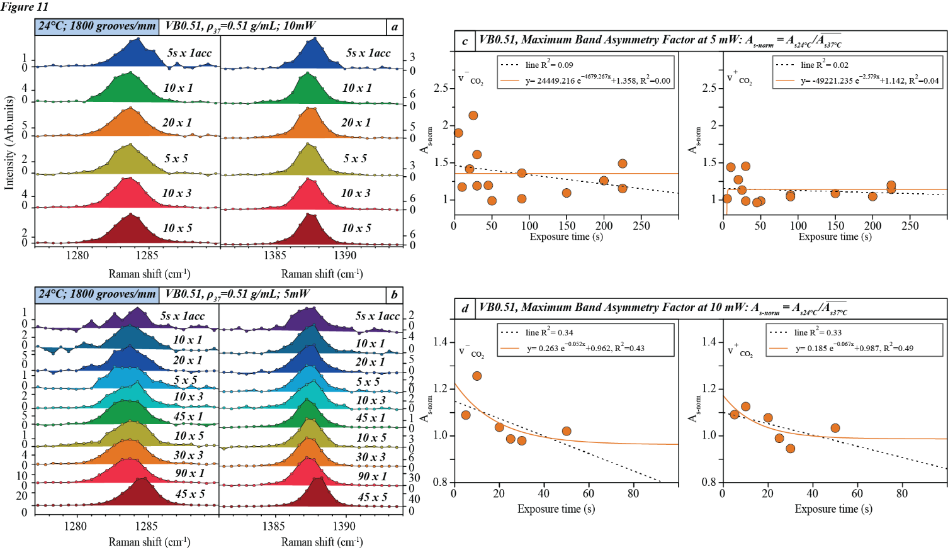
Figure S5. Effect of integration time and number of accumulations on the spectra of VB0.51 acquired at 24 °C at two different laser powers. a) Spectra measured at 5 mW laser power on sample using different integration times and number of accumulations. Spectra are plotted from the top down in order of increasing total exposure time to the laser. b) Exposure time to the laser versus maximum band asymmetry factor A_{s-norm} at 5mW for the 24 °C data (A_{s-24°C}) normalized to the 37 °C data (A_{s-37°C}) using Eq. (5) in section 4.5. No trend was found. c) Spectra measured at 10 mW laser power on sample using different integration times and number of accumulations. Spectra are plotted from the top down in order of increasing total exposure time to the laser. d) Exposure time to the laser versus maximum band asymmetry factor A_{s-norm} at 10mW. An exponential function is fit through the data. Neither of the trends are statistically significant, but there seems to be a slight increase in symmetry towards 20s exposure time to the laser at 10 mW.

