*This Supplementary Material accompanies the article*

“*Carbon release from Large Igneous Province magmas estimated from trace element-gas correlations*” by B. A. Black and A. Aiuppa. The original article should be cited if this material is used:

Black, B. A. and Aiuppa, A. (2023) “Carbon release from Large Igneous Province magmas estimated from trace element-gas correlations”, *Volcanica*, 6(1), pp. 129–145. doi: 10.30909/vol.06.01.129145.

**S1. Model uncertainties**

Our estimated parental CO2 contents stand on the assumption that (i) the gas (CO2/ST ratio) and trace element signature of modern OI and CR volcanism are suitable compositional analogues of Phanerozoic LIPs (Ernst, 2014), and (ii) that modern OI and CR volcanism exhibits globally correlated gas (CO2/ST ratio) and trace element (Sr/X) compositions. This latter point has found experimental validation in recent work (Aiuppa *et al.*, 2021). Our estimated parental CO2 contents (Tab. 1) further depend on uncertainties in parental S contents, as discussed below.

**S1.1 Uncertainties on parental melt S and CO2 contents**

Because we estimate CO2 concentrations from CO2/S ratios, uncertainties in melt sulphur concentrations yield corresponding uncertainties in estimated CO2. For the calculations shown in Table 1, we use maximum melt inclusion sulphur. For comparison we also show sulfur content and sulfide saturation (SCSS) as estimated from total ferrous iron (FeOt) using the empirical relationship of Blake et al. (2010), which represents a maximum sulfur concentration because magmas may be sulfide undersaturated. With the exception of CAMP, tholeiitic melt inclusion sulfur data plot on or below the 1:1 line with the upper limit from SCSS. Melt inclusion sulfur lower than SCSS could be explained by either sulfide undersaturated magmas (Reekie *et al.*, 2019) or partial degassing of S prior to melt inclusion entrapment, though sulfide saturation may be ubiquitous in tholeiitic basalts (O'Neill, 2021). Melt inclusion data in excess of SCSS may reflect supersaturation of sulfide or more oxidized magmas that contain some sulfur as sulfate (Jugo, 2009). The Siberian Traps melt inclusion suite includes melt inclusions from meimechites, an unusual group of very high (>18 wt%) MgO lavas that bear an uncertain relationship with other Siberian Traps lavas (Sobolev *et al.*, 2009; Elkins-Tanton *et al.*, 2007). Because some meimechite melt inclusions also have very high sulfur (up to ~0.5 wt%, perhaps due to more oxidizing conditions though the causes are not clear), we exclude these unusual rocks from our main calculation of CO2 from inferred CO2/S, instead assuming parental sulfur of 1966 ppm from the range of most S-rich melt inclusions other Siberian Traps lavas (Black *et al.*, 2014; Ivanov *et al.*, 2018).

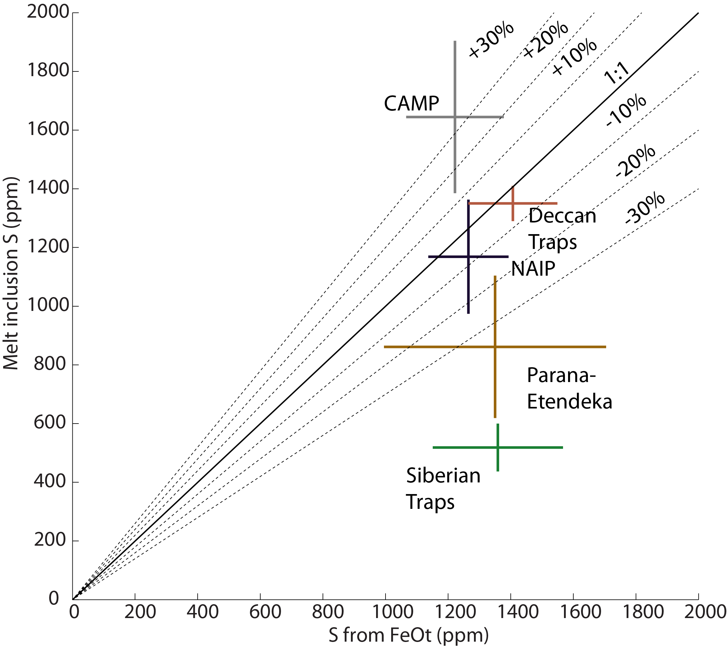

**Figure S1** – Sulfur from melt inclusions (length of bars shows range of three highest measurements) versus the FeOt proxy (Blake et al., 2010; length of bars shows ±1-sigma) for tholeiitic LIP magmas. Diagonal lines show percentage deviation from 1:1 correlation. Data plotting below the 1:1 line may reflect sulfide undersaturation. CAMP sulfur was estimated from cpx-melt sulfur partitioning (Callegaro *et al.*, 2014).

**S2 Estimation of parental melt Ba content**

The reliability of our predicted LIP CO2/S ratios and parental melt CO2 contents (Table 1) is tested by using the latter in combination with estimates of parental melt Ba contents for each LIP (Fig. 4b). Ba is similarly incompatible to CO2 during mantle melting (Rosenthal *et al.*, 2015), and mantle CO2/Ba ratios have been found (based on scrutiny of melt inclusions and undegassed MOR glass compositions) to cover a relatively narrow range, from ~48 (Hauri *et al.*, 2018) to ~396 (Miller *et al.*, 2019), with a possible average at ~97 to ~130 (Hauri *et al.*, 2018; Le Voyer *et al.*, 2019; Hirschmann, 2018). Degassed melt inclusions recurrently exhibit CO2/Ba ratios below the mantle range, owing to CO2 loss by degassing (Ba is a non-volatile element instead; (Le Voyer *et al.*, 2017)). Thus, for our estimated parental melt CO2 contents to be reliable, they need to convert into mantle-like CO2/Ba ratios if scaled to parental melt Ba.

One complication arises from the fact that Ba concentrations span widely (by > 1 order of magnitude) for each LIP (Table S1), implying that it is not straightforward to assign a representative Ba value for mantle-derived parental melts (those unfractionated by crystal fractionation and/or assimilation processes in the crust). As illustrated by the Siberian Traps example (Figure S2), data for each LIP (both whole-rocks and Melt Inclusions) exhibit negative correlations between Ba concentrations and MgO contents. We therefore take the most magnesian bulk rocks (or melt inclusions) as proxy for estimating the parental melt Ba contents. The procedure involves (i) fitting the MgO vs. Ba populations for each LIP (independent fits are performed for alkaline and tholeiitic LIPs) with power-law regression function, and (ii) using equation of the best-fit regression function to estimate Ba content at MgO = 25 wt. % (Figure S2). We use this 25 wt% MgO level as a compromise between using the most-magnesian (most primitive) compositions and data availability (more magnesian bulk rocks are unavailable for many LIPs).

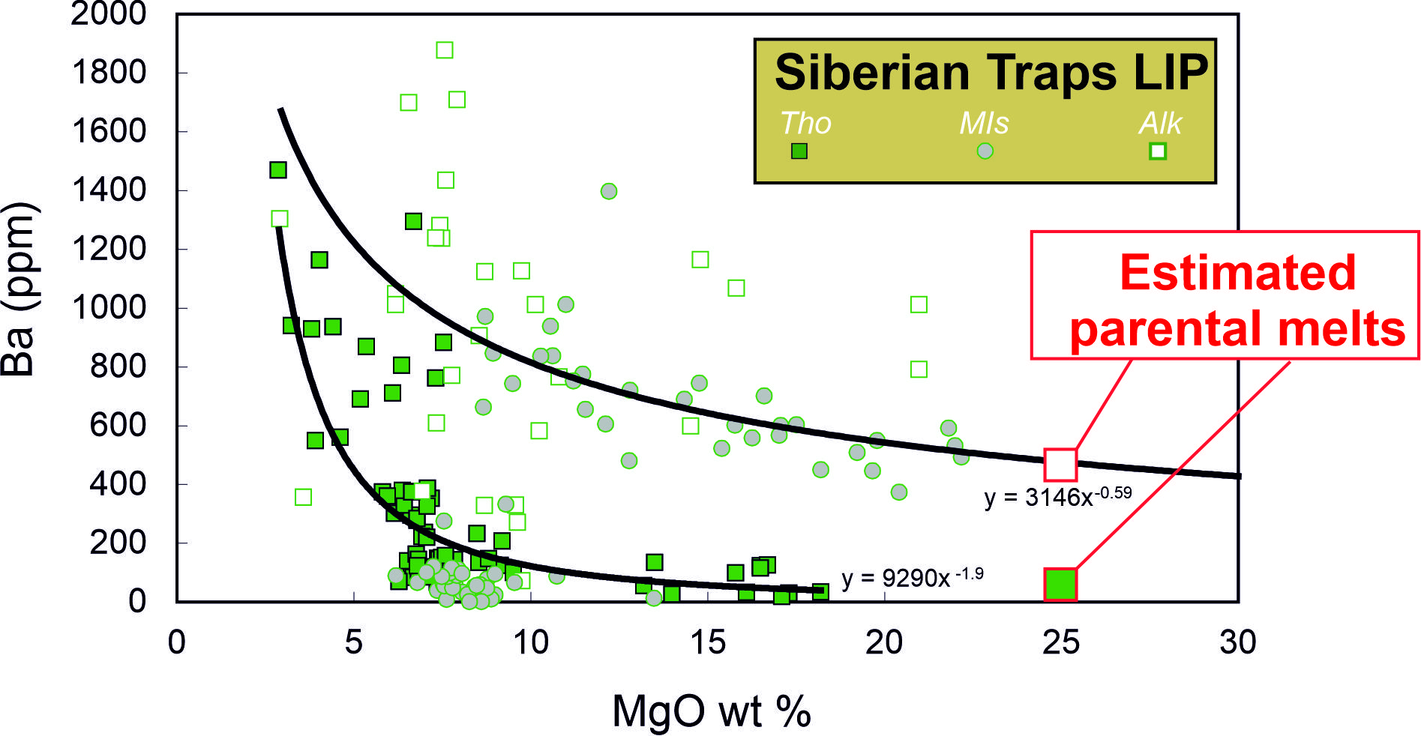 **Figure S2** – MgO vs Ba scatter diagram for Siberian Traps whole-rocks and melt inclusions (data from Supplementary Table S1). The best-fit regression lines for both alkaline and tholeiitic compositions are shown with the respective equations. The parental melt Ba contents (used in Fig. 4b) are obtained from solving the best-fit equations for MgO = 25 wt. %.

**References**

Aiuppa, A., Casetta, F., Coltorti, M., Stagno, V., Tamburello, G., 2021. Carbon concentration increases with depth of melting in Earth’s upper mantle. Nature Geoscience. 1-7.

Black, B. A., Hauri, E. H., Elkins-Tanton, L. T., Brown, S. M., 2014. Sulfur isotopic evidence for sources of volatiles in Siberian Traps magmas. Earth and Planetary Science Letters. 394, 58-69.

Blake, S., Self, S., Sharma, K., Sephton, S., 2010. Sulfur release from the Columbia River Basalts and other flood lava eruptions constrained by a model of sulfide saturation. Earth and Planetary Science Letters. 299, 328-338.

Callegaro, S., Baker, D. R., De Min, A., Marzoli, A., Geraki, K., Bertrand, H., Viti, C., Nestola, F., 2014. Microanalyses link sulfur from large igneous provinces and Mesozoic mass extinctions. Geology. 42, 895-898.

Elkins-Tanton, L. T., Draper, D. S., Agee, C. B., Jewell, J., Thorpe, A., Hess, P. C., 2007. The last lavas erupted during the main phase of the Siberian flood volcanic province: results from experimental petrology. Contributions to Mineralogy and Petrology. 153, 191-209.

Hauri, E. H., Maclennan, J., McKenzie, D., Gronvold, K., Oskarsson, N., Shimizu, N., 2018. CO2 content beneath northern Iceland and the variability of mantle carbon. Geology. 46, 55-58.

Hirschmann, M. M., 2018. Comparative deep Earth volatile cycles: The case for C recycling from exosphere/mantle fractionation of major (H2O, C, N) volatiles and from H2O/Ce, CO2/Ba, and CO2/Nb exosphere ratios. Earth and Planetary Science Letters. 502, 262-273.

Ivanov, A. V., Mukasa, S. B., Kamenetsky, V. S., Ackerson, M., Demonterova, E. I., Pokrovsky, B. G., Vladykin, N. V., Kolesnichenko, M. V., Litasov, K. D., Zedgenizov, D. A., 2018. Volatile concentrations in olivine-hosted melt inclusions from meimechite and melanephelinite lavas of the Siberian Traps Large Igneous Province: Evidence for flux-related high-Ti, high-Mg magmatism. Chemical Geology. 483, 442-462.

Jugo, P. J., 2009. Sulfur content at sulfide saturation in oxidized magmas. Geology. 37, 415-418.

Le Voyer, M., Kelley, K. A., Cottrell, E., Hauri, E. H., 2017. Heterogeneity in mantle carbon content from CO 2-undersaturated basalts. Nature Communications. 8, 14062.

Le Voyer, M., Hauri, E. H., Cottrell, E., Kelley, K. A., Salters, V. J., Langmuir, C. H., Hilton, D. R., Barry, P. H., Füri, E., 2019. Carbon Fluxes and Primary Magma CO2 Contents Along the Global Mid‐Ocean Ridge System. Geochemistry, Geophysics, Geosystems. 20, 1387-1424.

Miller, W. G., Maclennan, J., Shorttle, O., Gaetani, G. A., Le Roux, V., Klein, F., 2019. Estimating the carbon content of the deep mantle with Icelandic melt inclusions. Earth and Planetary Science Letters. 523, 115699.

O'Neill, H. S. C., 2021. The thermodynamic controls on sulfide saturation in silicate melts with application to ocean floor basalts. Magma Redox Geochemistry. 177-213.

Reekie, C., Jenner, F. E., Smythe, D. J., Hauri, E. H., Bullock, E. S., Williams, H. M., 2019. Sulfide resorption during crustal ascent and degassing of oceanic plateau basalts. Nature Communications. 10, 82.

Rosenthal, A., Hauri, E. H., Hirschmann, M. M., 2015. Experimental determination of C, F, and H partitioning between mantle minerals and carbonated basalt, CO 2/Ba and CO 2/Nb systematics of partial melting, and the CO 2 contents of basaltic source regions. Earth and Planetary Science Letters. 412, 77-87.

Sobolev, A. V., Sobolev, S. V., Kuzmin, D. V., Malitch, K. N., Petrunin, A. G., 2009. Siberian meimechites: origin and relation to flood basalts and kimberlites. Russian Geology and Geophysics. 50, 999-1033.

stylefix