This Supplementary Material accompanies the article
“Impacts on water transport networks after three widespread volcanic ashfalls in Andean Patagonian lakes” by Pablo Agustín Salgado et al. The original article should be cited if this material is used:
Salgado, P. A., Villarosa, G., Beight, D., Outes, V., Stewart, C., and Baranzini, F. (2023) “Impacts on water transport networks after three widespread volcanic ashfalls in Andean Patagonian lakes”, Volcanica, 6(2), pp. 173–200. doi: 10.30909/vol.06.02.173200

Supplementary Material: Overview of case studies
This document compiles detailed narratives on all the observed consequences of recent explosive volcanic eruptions on Patagonian inland shipping. These reconstructions deal with the immediate to long-term effects of volcanic ash on water transport at different sites impacted by both primary ash fallouts and/or secondary phenomena, such as pumice rafts, sedimentation issues, mass-wasting processes, fluvial and aeolian remobilization of tephra deposits, etc., while also summarizing the most relevant mitigation and remediation actions observed. All the consequential water-based emergency response actions and recovery efforts undertaken have been separately summarized and evaluated by Salgado et al. (2022). The impact data on which this narrative document is based served as the basis for systematizing volcanic ash impacts on water transport networks (described in Section 4 and tabulated in Table 3), and for assessing the effectiveness of different mitigation and recovery strategies (described in Section 5). Importantly, this comprehensive overview is the first written empirical record of past experiences on the subject, contributing to a better understanding of how different courses of events may unfold following explosive volcanic eruptions.

S.1 The 2008 Chaitén eruption

S.1.1Los Alerces National Park lakes
Los Alerces National Park and Reserve is a famous tourist destination in Patagonia, located in the Andean region of the Chubut province, with the Chilean border by the west side. The Los Alerces fluvio-lacustrine basin comprises a chain of glacial lakes connected by short river courses, and the largest ports (Table 1), lodgings, and campsites in the area sit on the eastern shores of Lago Rivadavia, Lago Verde, Lago Menéndez, and Lago Futalaufquen, from where various tourist ships sail daily during the summer season. The ports in this region, located up to 85 km away from the volcano, were affected by up to 15 mm of fine-grained rhyolitic ash (Figure 1), and all tourists and tourism workers evacuated the Park almost entirely throughout the first day (Salgado et al. 2022). However, various ships sailing in the early hours of the day sustained loss of functionality associated with waterborne tephra. For example, two smaller ships fishing in Lago Menéndez, regardless of the ongoing ashfall lost their functionality near Isla Grande (Figure 1) when forcing their way through a thin coating of fine floating pumice. Improvised clearances of the motors’ clogged inner filters were sufficient to restart the engines and attain a safe return to Puerto Chucao (Table 1; Figure 1), which was later severely affected by the eastward drift of floating pumice rafts. Shipping remained completely disrupted for almost six months, until the following summer season. Larger primary passenger ships (Table 2) remained moored in ports while the smaller ships were rapidly pulled out of the water and safeguarded, or covered with sailcloth covers, and their engines with plastic bags. Once the most energetic eruptive phase subsided a week later, the uncovered moored ships were cleared of ash without reports of significant damage beyond accelerated corrosion of metallic surfaces and engine air filters requiring replacement. In particular, the few ships that remained berthed at Puerto Bustillo (Table 1; Figure 1), the only gable-roofed mooring base in the area, experienced almost no damage from primary ash fallouts (and pumice rafts), although they were not exempt from ash accumulating on exposed deck surfaces and the need for deep cleaning. During the volcanic crisis, many rural homesteads in the area were assisted by means of coastguard ships through occasional sailings, handled by the few authorities remaining on-site (Salgado et al. 2022). For these purposes, the use of waterjets in southern Los Alerces was almost immediately interrupted, after verifying the effect of waterborne tephra on inlet pipes, channels, and pumping systems. In northern Los Alerces, winter rains were regarded as sufficient for removing the bulk of ash deposited on port sites. Conversely, managers in southern ports, affected by thicker deposits of ash, reported requiring more arduous clean-up efforts, without reporting significant damage to port infrastructure, beyond slight deterioration of exposed surfaces.

S.1.2 Futaleufú dam & storage lake
Southwards Los Alerces, far over 30 mm of fine-grained ash fell around the Amutui Quimei storage lake, upstream of the 448 MW Futaleufú power dam, located 90 km away from the volcano (Figure 1). Pumice fragments remained suspended in the lake for over eight weeks (Wilson et al. 2012),making the operability of supporting ships more difficult, since waterborne tephra rapidly clogged the seawater inlets from the outboard engine’s cooling system. Minor effects were reported for primary ashfalls over supporting ships.

S.2The 2011-2012 Cordón Caulle eruption

S.2.1 Villa La Angostura & northwestern Lago Nahuel Huapi
The northwestern region of the Lago Nahuel Huapi fluvio-lacustrine basin was affected by the most sizeable accumulation of tephra (Villarosa and Outes 2013; Alloway et al. 2015), including the heavily navigated areas around Villa La Angostura, a tourist village located 50 km away from the eruptive center (Figure 2) and impacted by between 150 mm and 170 mm of lapilli to very fine-grained rhyolitic ash. The two catamarans that sail daily from the city center managed to return with a full load of tourist passengers from Puerto Quetrihué (Table 1; Figure 2) amidst almost zero visibility that same afternoon, with no impacts reported on the navigation, communication, or engine’s cooling systems. From there, shipping was suspended for 45 consecutive days due to reduced airborne visibility and the persistence of waterborne tephra over the lakes.
Immediately after, lake authorities initiated a spontaneous and unsuccessful attempt to evacuate various communities living closest to the volcano in the Perilago, a rural area on the western shores of Lago Nahuel Huapi particularly inaccessible by ground transport (Figure 2; PNNH 2019),during which two official high-speed ships lost functionality amid the procedure (Salgado et al. 2022). The first RIB (Table 2), being the most advanced ship available at the time, was specifically addressed for this task. However, the fully computerized communication and navigation systems failed almost immediately when exposed to airborne ash, rendering the ship completely inoperable. The crew onboard, composed of two officers, had to row the inoperative ship to the shore of the Perilago amid the heavy ashfall, almost zero visibility, and extremely loud electrical discharges over the lake surface. The ship then had to be manually towed from the shore to the nearest pier, where the crew had to take refuge for the night, at the house of one of the families of the Perilago. A second official RIB immediately set sail from Villa La Angostura, heading to the rescue of the stranded crew, but also lost functionally due to engine failures since massive pumice rafts covering the lake surface clogged the seawater intakes very quickly, resulting in the engine’s overheating. This second crew had to spend the night sheltered in the already evacuated cottage of a housekeeper at the tourist Puerto Quetrihué. A third speedboat was unexpectedly resilient to the effects of airborne and waterborne tephra and was able to assist these stranded crews the following days (Figure S1). The officers interviewed recall that the lower and midsection units of the outboard engine of this third ship were particularly enlarged, plunging water inlets deeper below the pumice raft and avoiding clogging (at least in the short term).
All these spontaneous, sparse, and unplanned efforts to withdraw the rural population living closest to the volcano were progressively taken on by a Local Committee for the Rural Emergency (CLER; Anselmi et al. 2012),which ended up coordinating a better-organized procedure to assist these communities sheltered in-place. This strategy was modified mostly on account of the families’ reluctance to leave their farms and animals, and further difficulties arising from logistical constraints for mobilizing people and livestock (Salgado et al. 2022). The transportation of basic supplies (such as bottled drinking water for human and livestock consumption, bales of hay, masks, etc.), first responders, veterinary doctors, and evacuated people and livestock, was particularly managed by El Patagón, a large ferry barge usually berthed in Villa La Angostura, brought to the city for tourist purposes, plus various supporting smaller ships from Prefectura Naval Argentina (Figure S2). Once more, the use of waterjets for these purposes was rapidly discouraged, after verifying the effect of waterborne tephra on inlet pipes, channels, and pumping systems, rendering ships inoperable.
Since the 2011-2012 Cordón Caulle volcanic eruption took most ship owners by surprise, many boats abided the volcanic ashfall anchored, moored, or berthed uncovered at the many docks and wharves in the area. Immense volumes of wet tephra and snow were observed to accumulate on the decks, causing hazardous plunges of the ship’s waterlines and the breakage of moorings on berthed or moored ships. In the vicinity, there were numerous records of ships found heeled over, or even capsized. For example, an uncovered small cruise-ship anchored in Puerto Bahía Manzano (Table 1; Figure 2) was found capsized during the first days of the eruption. This was the preceding case that motivated many ship owners in Villa La Angostura to safeguard the vessels and to periodically clear the tephra that accumulated over the ships’ deck. A further example was a new and relatively large speedboat, found overturned and half-sunk about ten days later, still moored by bow and stern within Muelle Correntoso (Figure 2), despite a canvas cover fitted to protect the ship. In all of these and other cases, the specific reasons leading to ships sinking are still not fully determined. Unofficially, sailors in the area recall that the small cruise-ship capsized because of the uneven load of wet ash accumulating on a largely terraced stern, causing the pitch and downward heave of the ship to capsize. On the other hand, the speedboat’s owner related the incident to bilge pumps malfunctioning due to sustained periods of inoperability.
Conversely, there were no reports of structural damage to port infrastructure in the area, despite the immense volumes of wet tephra and snow accumulating over such flat structures, in contrast to the numerous records of roof collapses reported in the city (Wilson et al. 2013; Craig et al. 2016). Generally, impacts observed at ports’ land-side domains in this area included the deterioration of exposed surfaces (including corrosion of metallic frames or fittings and wood rot), damage to port equipment (if present), and disruption to electricity supplies.
Important volumes of floating pumice covering the surface of the lake were observed close to Villa La Angostura during several weeks. However, large rafts of pumice were then rapidly dragged away southeastwards by prevailing winds, causing little damage to ports’ sea-side domains. Thick deposits of lapilli and ash accumulated in open shores exposed to the wind, facing north-northwest (e.g., Figure S3), with no deleterious effects on port draft depths associated with tephra buildup. However, many sailors reported that the sinking of floating pumice was not forthright; some patches of pumice remained suspended at shallow depths below the water surface, reachable by the engine’s seawater inlets and hard to recognize and avoid. In April 2012, small pumice fragments clogged and blew a small ship’s outboard engine with eight tourists on board, despite the preventive usage of pre-filters at water intakes and visual monitoring of the motor’s telltale. Going off course battered by wind, and in danger of crashing against a rocky shore, an emergency para-anchor had to be deployed while waiting for official aid.
Although there are no large ports in the northwestern Lago Nahuel Huapi, numerous and extremely severe impacts on water transport have been reported in this region, most of them associated with tephra sedimentation processes and fluvial-remobilization issues. The Lago Nahuel Huapi fluvio-lacustrine basin in this proximal to medial environment was mantled with > 170 mm of tephra fall deposits, with maximum thicknesses of about 500 mm (Alloway et al. 2015). In the following years, successive winter rains caused seasonal rises and shifts of tributary streams in catchment areas closer to the volcano, remobilizing fresh and massive pyroclastic deposits that drain into the lake, developing new pumice rafts. In winter 2019 (during a geo-meteorological crisis that isolated Villa La Angostura from any ground access for a month; Salgado et al. 2022), another small ship with 10 passengers on board blew its engine due to blockages on seawater intakes when crossing a thread of floating pumice, close to a stream’s mouth in Brazo Rincón (Figure 2). Even nowadays, more than ten years after the eruption, thin strands of renewed pumice rafts are still reported after heavy rains, mostly close to the Pireco and Totoral rivers’ mouths in Brazo Rincón (Figure 2) and other branches and lakes in the region (such as Brazo Última Esperanza in the Nahuel Huapi Lake, Lago Espejo, Lago Correntoso, etc). In this area, the massive accumulation of shore deposits of lapilli and ash in open shores affected many beaches usually used for the embarkation and disembarkation of smaller ships.
The remobilization of massive volumes of tephra through rivers and streams in these near-vent watersheds, receiving ~72 x 106 m3 of tephra (Beigt et al. 2019), triggered substantial geomorphic changes (leading to flooding, channel aggradation, migration, or avulsion, and secondary lahars), causing severe damage to road networks, bridges, and residential buildings in the nearby (mostly during the rainy winter season), causing disruption to regular (and recreational, during the summer season) shipping activities in the area.
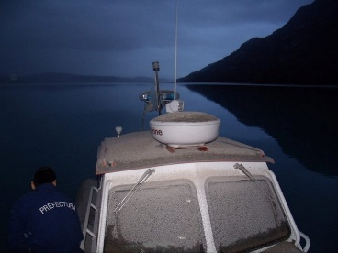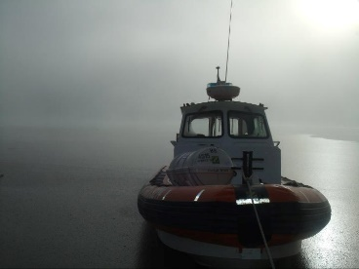
Figure S1: An inoperative coastguard after a failed attempt to evacuate threatened communities in the Perilago rural area (05/06/2019). Photos courtesy of Prefectura Naval Argentina.
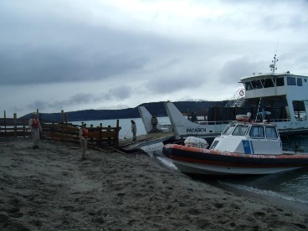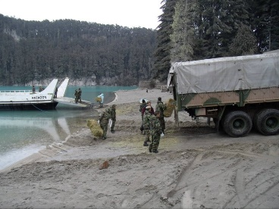
Figure S2:Rural and social assistance for stranded communities in the Perilago (19/06/2011). Photos courtesy of Prefectura Naval Argentina.
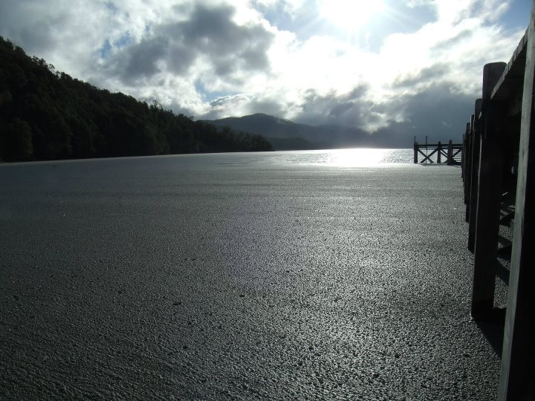
Figure S3:An example of massive pumice rafts generated during the 2011-2012 Cordón Caulle volcanic eruption, accumulating at a small wooden wharf in Lago Espejo, close to Villa La Angostura.

S.2.2 Lago Traful
The Lago Traful is a smaller lake in the northern region of the Nahuel Huapi National Park. The lake is located over 50 km away from Cordón Caulle, and it was reached by up to 85 mm of medium to fine-grained ash, measured at its western end (Villarosa and Outes 2013; Alloway et al. 2015). Like the Perilago (Section 3.2.1), there are various communities farming on the northern shores of the lake, in areas mostly inaccessible by ground. In the absence of communications, two emergency sailings were separately deployed for evacuating these communities, although farmers refused to leave the northern shores of the lake, coping with the volcanic ashfall sheltered on site (Salgado et al. 2022).Both RIBs sustained failures due to blockages of their engines’ water intakes, requiring manual clearances in the middle of the procedures, but no damage to the navigation and communication systems.
On the southern shore of the lake sits Villa Traful (Figure 2), a very small coastal hamlet heavily visited during the summer season. Massive rafts of floating pumice formed on the lake because of the heavy primary ash fallout that affected this area, accumulating ~50 mm of medium to fine-grained rhyolitic ash in the town nearby. Of these, only small amounts of floating pumice were observed to enter in the bay of Puerto Traful(Table 1; Figure 2), as pumice rafts were rapidly cleared away because of the strong eastward wind fetch that usually impairs the lake’s surface. Hence, important volumes of pumice, covering the surface of the lake for several weeks, formed thick deposits on the lake’s easternmost shores or in wind-protected bays. However, in Puerto Traful, preexisting water-depth issues were critically exacerbated after the 2011-2012 ashfall event due to tephra sedimentation and a sustained period of low lake levels, diminishing suitable drafts and compromising part of the harbor. Since water activities in the city are concentrated during the summer season, few ships remained on site during the volcanic ashfall. Still, moored, berthed, and pulled-out-of-water ships sustained serious damage, including the breakage of moorings; damage and deterioration to deck equipment and surfaces (rot, abrasion, corrosion, and scratching of windscreens); clogging of air-filtration systems; fuel and lubricating oil contamination; and volcanic ash ingress into ship interiors, requiring deep clean-up before resuming activities due to the contamination of housed electronic devices and computers with fine ash.
The port facilities needed to be cleared of ash, and while some damage and deterioration on various exposed surfaces was verified, no remediation work was required for (partially) resuming water activities the following summer. Clean-up in the hamlet’s urban environment took a few months to start, given sustained disruption to critical infrastructure services in the town and grave ground-accessibility issues. Once started, and during the first few days, some collected material from Villa Traful was dumped in the lake, close to the port. These actions were promptly modified once the managers acknowledged the potential impact of waterborne tephra on ships and ports. Nonetheless, it could not be verified that the pyroclastic material dumped in the lake worsened sedimentation issues and loss of draft in the harbor.
During the subsequent 2015 Calbuco volcanic eruption, slight dacitic-andesitic ashfalls reached Puerto Traful, causing negligible effects on ships and the port.

S.2.3 Bariloche & southern Lago Nahuel Huapi
The southern shore of the lake was affected by ashfall thicknesses increasing steeply towards its middle central part (Figure 2). In this area, Puerto Pañuelo, Club Náutico Bariloche, and Puerto San Carlos (Table 1; Figure 2) stand as three of the largest and most transited port sites, where various and severe volcanic ash impacts on ships and ports were surveyed. Lake authorities at this part of the lake prohibited shipping for eight consecutive days (although commercial shipping only restarted several months later), stranding eight workers in Puerto Blest (Table 1; Figure 2), a famous tourist destination only accessible via waterways (Salgado et al. 2022).
Puerto Pañuelo is the largest and most transited tourist port in this area. At the time, it handled four large primary passenger yachts and catamarans (seating between 260 and 300 passengers each) sailing daily year-round, plus other supporting and official ships. The port, located 75 km away from the volcano, was affected by up to 45 mm to 50 mm of medium to coarse-grained rhyolitic ash. During the first days, the direct fallout of fine ash created a very thin coating of floating pumice over Puerto Pañuelo. However, shipping conditions worsened dramatically throughout the following weeks, as the wind dragged immense volumes of thicker and coarser pumice rafts straight into the open natural harbor (Figure S4). Port authorities and managers on-site measured the pumice raft to be about 35 cm thick on average in the inner part of the bay by vertically introducing an iron bar through the sheet of floating pumice to the surface of the water (Figure S5).Successive accumulations of pumice on the inner part of the bay rapidly prograded and compromised the harbor basin almost entirely (Figure 10). In the subsequent days, wet pumice froze due to low temperatures and blocked a small service cargo-ship on the inner part of the harbor, which had to be liberated by breaking the surrounding sheet of frozen pumice with shovels. Port managers installed a line of floats in the harbor entrance to halt the input of pumice, but it was soon retired after proving unworkable (Figure 10).
Similarly, authorities in Club Náutico Bariloche also installed a boom of floaters at the harbor entrance, with better results. The Club Náutico Bariloche is a civil association with legal status for the practice of water sports and recreational shipping activities. This nautical club (3.5 km away from Bariloche city center) sits on a ship-base with multiple docks within a 200 m-long breakwater structure, serving hundreds of motorsails, speedboats, and secondary passenger cruises as large as 40 m-overall length. Most of the time, the pumice rafts dragged by the regular westerly wind were diverted away by the breakwater structure. In this case, the boom was periodically installed between the harbor’s breakwater and the shoreline’s revetment in a bid to prevent the ingress of pumice into the artificial harbor basin when the wind blew occasionally from the east (Figure S7). This line of floats and sailcloth-fabric-barrier fixed to the lake floor was first installed a month after the beginning of the eruption, and it was sporadically reinstalled throughout the entire following year, when east wind was forecasted. The club, located 95 km away from the volcano, was affected by up to 35 mm to 40 mm of medium to coarse-grained rhyolitic ash. In this case, primary ashfalls caused extensive damage to all the machinery necessary for the management of such a large number of ships. Volcanic ash caused increased wear on many moving parts and extensive corrosive damage to metallic equipment, rendering various cranes, two crawlers, and a ship elevator virtually inoperable, which required deep cleaning and the replacement of many components. Since the initiation of the volcanic ashfall in this area, the club remained completely inactive for approximately 20 consecutive days and, unexpectedly to the club authorities, many ship moorings were found damaged or broken because of ships tilting, pitching, and heaving downward by effect of wet volcanic ash and snow accumulations on many vessels.
Immediately afterwards, intensive dredging work began in the club’s bay to removed settled tephra and to avoid draft issues in the harbor. However, during the following months, large amounts of tephra were transported by a small stream flowing into the harbor’s basin, causing serious water-depth issues, and leading to enhanced and continuous dredging work. The stream had to be diverted away in the following years, due to the sustained input of tephra from uplands (Figure S7). In 2021, ten years after the Cordón Caulle volcanic eruption, regular maintenance dredging still removes great amounts of settled tephra from the semi-open basin of Club Náutico Bariloche.
Long-term sedimentation issues and draft losses were also reported in Puerto Pañuelo. Over time, the high delivery of sediment input in the open bay and the sinking of floating pumice silted up the harbor. These loose deposits of tephra were easily remobilized by passing ships, causing sustained problems with the engine’s cooling systems and other submerged parts of the ships (see below). The deterioration of suitable draughts due to tephra sedimentation persisted even years after the eruption, leading to unscheduled dredge works initiated in 2016 (Figure 10). Maneuverability conditions in the harbor were also hampered due to poor beaconing and sustained low lake levels, and within the 7 years after the eruption, two large ships crashed and bent their propeller blades against the bedrock, representing serious downtimes and economic losses to the company handling larger tourist vessels.
Throughout southern Lago Nahuel Huapi, all ships were similarly impacted by the effect of primary ashfalls, causing stability issues (roll, pitch, and heave) and damage or breakage of moorings; damage to deck surfaces and equipment; volcanic ash ingress to ship’s interiors and contamination of navigation and communication systems; contamination of fuel and lubricating oils; collapse of canvas cabins; etc. At Club Náutico Bariloche, some centralized computer-aided systems for navigation and communications could not be restored to functionality following the volcanic ashfall, despite arduous clean-up efforts and sustained periods of inoperability. On the other hand, impacts associated with the effect of waterborne tephra on ships were particularly enduring and more severe in Puerto Pañuelo, where the encounters of ships with pumice rafts were much more frequent than in other sites throughout this region. The abrasive action of high loads of floating ash caused the wearing of many ships’ underbodies, including a singular deep abrasion mark that appeared on many primary passenger ship hulls’ bows, forming above the waterline where the swell usually brakes. In 2011, during the volcanic eruption, an unscheduled underwater audit was carried out in Puerto Pañuelo with specialized divers to check the status of the submerged sections of the propulsion and transmission systems of various larger ships, given the persistence of massive pumice rafts and waterborne tephra in the area. By then, divers found no visible damage to the different submerged parts of the ships’ underbodies and the commercial shipping activity was slowly resumed, constantly avoiding further encounters with pumice rafts in open waters by dodging them. However, by the following year, during a routine inspection in dry docks of the catamaran Victoria Andina (Figure 8), an extremely severe wear was verified on the rubber bearing-pads from the catamaran transmission system, far beyond the permitted thresholds. The bearing-pads from the catamaran Victoria Andina were immediately replaced, and this very same damage was later identified in many other larger ships operating in Puerto Pañuelo. The technicians in charge of this inspection attributed such damage to the abrasive action of the ash deposited at the bottom of the port bay, which was constantly remobilized by the heavy traffic of the ships in the harbor. In particular, no abrasive damage was found on the white-metal bearing pads of one of these ships, the Modesta Victoria vessel, which seemed to be far more resilient to the effects of the volcanic ash than rubber bearing pads.
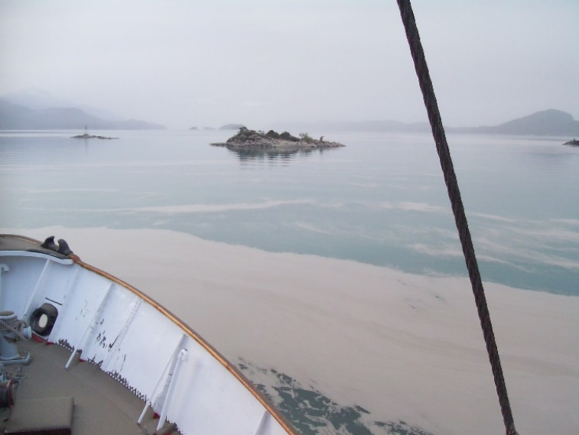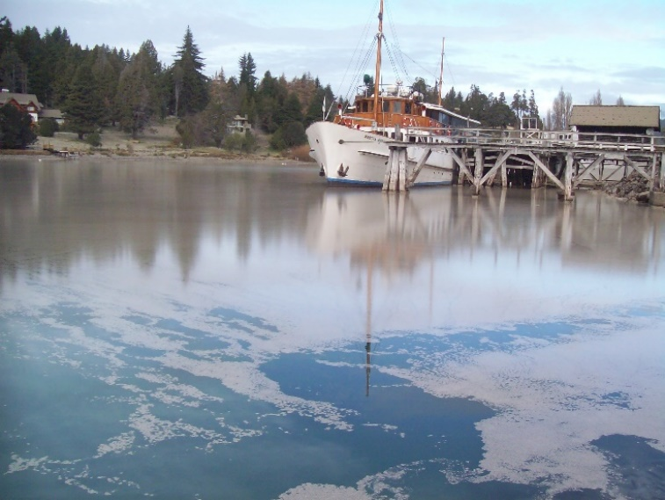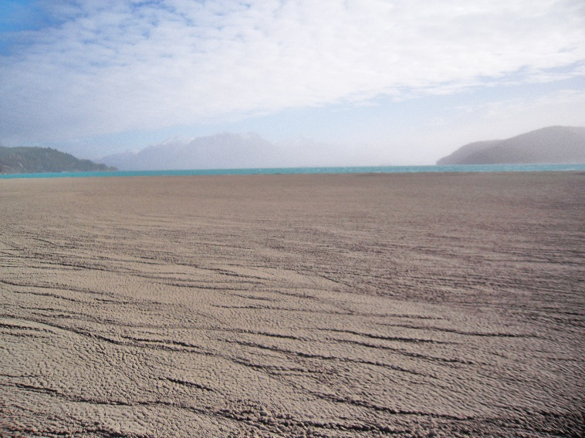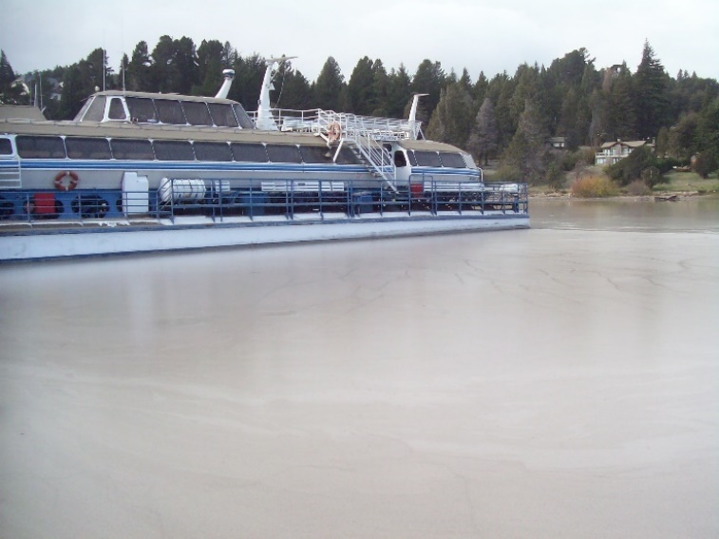
Figure S4: Above, thin coatings of (medium-grain sized) pumice rafts formed in-situ at the beginning of the volcanic ashfall in Puerto Pañuelo (05/06/2011). Below, the drifting of thicker (~35 cm), and coarser (lapilli) pumice rafts dragged by the wind towards the outer (left) and inner basin (right) of Puerto Pañuelo, the following days after the 2011-2012 volcanic eruption.

Figure S5: Video records show a seafarer in the inner bay of Puerto Pañuelo (Lago Nahuel Huapi) placing a one-meter-long iron bar over thick and coarse (lapilli) pumice rafts, generated after the 2011-2012 volcanic eruption.

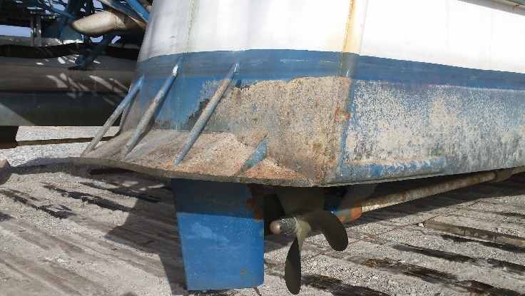
Figure S6: Accelerated abrasion and corrosion in the catamaran Victoria Andina’s hull by effect of waterborne tephra generated after the 2011-2012 Cordón Caulle volcanic eruption.

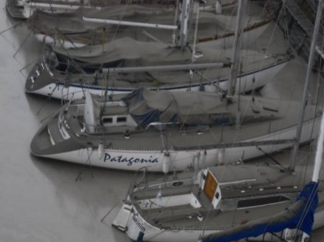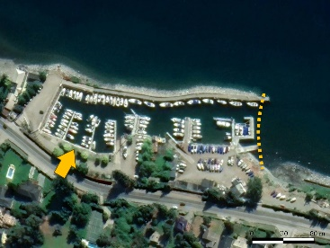
Figure S7: To the left, motor-sailors berthed at Club Náutico Bariloche, the following day after the Cordón Caulle volcanic eruption initiation (05/06/2011). Photo courtesy of Club Náutico Bariloche. To the right, an aerial view of Club Náutico Bariloche (March 2021). The dotted line indicates where the floating barrier was installed. The arrow indicates the former location of a small stream mouth that had to be later diverted away.

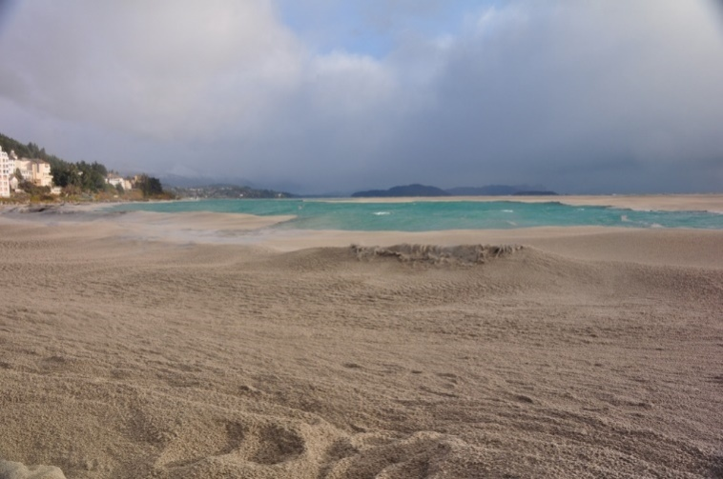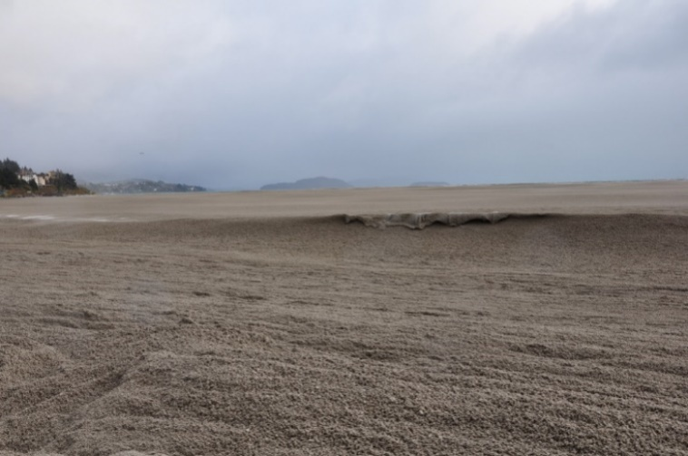
Figure S8: Massive tephra shore deposits (~45 cm thick) and thick pumice rafts (lapilli) drifting towards Bariloche and Puerto San Carlos, the following days after the 2011-2012 Cordón Caulle volcanic eruption.

S.2.4 Alicurá dam & storage lake
Large masses of floating pumice formed in-situ over the Río Limay (the single outflow from Lago Nahuel Huapi) and the 1.050 MW Alicurá power dam reservoir lake, which received about 20 mm of fine-grained rhyolitic ash (Villarosa and Outes 2013; Alloway et al. 2015). However, pumice rafts also drifted from the Lago Nahuel Huapi along the outflow Río Limay, reaching the power dam the following weeks, forming thicker, coarser, and enduring accumulations of floating pumice with measured thicknesses of over 45 cm (Figure 12). Managers at the dam deployed a total of 600 meters of containment booms, attempting to divert the floating pumice away from the generation units (Figure 12). Simultaneously, the rate of generation was also diminished to a technical minimum for the boom to work properly. Still and after all, two months later the water filters of the generator cooling system were copped with fine pumice. The totaling 4 lines making up the containment system remained mounted for six months. Occasionally, the floating pumice froze during the night, making it more difficult to divert the pumice to the spillway. Years later, during an underwater inspection, 12-meter-thick tephra accumulations were identified and settled on the reservoir floor, which required dredging in 2015. Supporting RIBs were likewise affected by the presence of pumice fragments in the water at the reservoir, requiring enhanced clearance of solids from the engine’s filters.
The enduring drift of massive pumice rafts along the Río Limay also caused the disruption of vehicular traffic out of Villa Llanquín, a remote and small settlement sitting in the shore of the river that depends on the regular service of a cable ferry barge, the Balsa Maroma, for connecting the commune with the National Route 40 and any other road out of the village.

S.3 The 2015 Calbuco eruption

S.3.1 Lago Lácar & Nonthué
In the span of only 4 years, this region was significantly affected by both volcanic eruptions (2011-2012 Cordón Caulle, 2015 Calbuco), receiving different ashfall thicknesses, grain sizes, compositions, differing lengths of ash emission, wind remobilization events, etc. This scenario allowed us to assess impacts and response actions resulting from varying hazard frameworks.
In this region, Puerto San Martín (Table 1; Figure 3) stands as the largest and most transited touristic port, from where several ships sail daily to visit different destinations along these lakes. Puerto San Martín sits on the easternmost shores of Lago Lácar, in the homonymous city of San Martín de los Andes, and it serves three main larger ships (the Stella Maris, Marí Marí and Patagonia I primary ships, sitting 70, 90, and 116 passengers each) that navigate daily to Puerto Don Bruno and Puerto Hua Hum (Table 1; Figure 3), plus several other smaller ships. Although port infrastructure in this region has been long ago restructured for tourism purposes, many settlers from the rural communities that sit sparsely on the shores of these lakes (e.g., Quila Quina; Table 1; Figure 3) still depend on the daily service of these tourist sails to move around this area, in the absence of a well-developed ground transport network.
During the 2011-2012 Cordón Caulle eruption, Puerto San Martín, located about 80 km away from the volcano, was affected by 2 mm to 4 mm of fine-grained rhyolitic ash (Villarosa and Outes 2013; Alloway et al. 2015). Based on the warnings from authorities in Villa La Angostura (Section 3.2.1), all types of shipping were preventatively disrupted in these lakes, except for a single official RIB from Prefectura Naval Argentina that remained operational in San Martín de los Andes, for transporting stranded people and supplies (Salgado et al. 2022). However, the stoppage of lake transport was not absolute, and various cases of waterborne tephra affecting waterjets and outboard engines were reported for smaller ships navigating in the lakes. Over time, and given the persistence of fine-grained volcanic ash in the air, many smaller ships were pulled out of the water and safeguarded in dry docks. The primary and wind-remobilized ashfall caused only minor physical damage to exposed deck equipment (including contamination of fuel and lubricating oils and clogging of air filters) and surfaces (including slight deterioration of sails and paintwork)on uncovered berthed and anchored ships. All interviewees consulted expressed that clean-up of exposed surfaces from uncovered ships and ports was relatively simple, and that in many cases, winter rains were enough to clear volcanic ashfall accumulations. But the cleaning of volcanic ash from engines and the ship interiors required much more laborious and delicate work. Westerly winds rapidly cleared thin pumice rafts formed on the lake surface, dragging the floating ash away from Puerto Hua Hum and Puerto Don Bruno, and towards San Martín de los Andes. However, no specific damage was reported, associated with the entrance of pumice rafts into Puerto San Martín harbor. Despite the milder and discontinuous ashfalls received during 2011-2012, in comparison to the succeeding eruption, nautical activities sustained a longer period of disruption due to the persistent emission of volcanic ash, wind remobilization events, and the associated tourist inactivity.
During the 2015 Calbuco volcanic eruption, between 7 mm and 12 mm of fine-grained dacitic-andesitic ash was measured in Puerto San Martín, located 170 km away from the volcano (Figure 3). In similarity to the 2011-2012 volcanic ashfall event, driving and shipping were strongly discouraged in the region due to the presence of both, airborne and waterborne ash, and much of the mobility of people and supplies between coastal affected sites was handled by lake authorities (Salgado et al. 2022). However, in this case, water transport was strictly interrupted for only 2 days, the time it took to clean Puerto San Martín. In contrast to the laborious clean-up that volcanic ashfall required in the urban areas of San Martín de los Andes (Hayes et al. 2019), no difficulties were encountered in cleaning Puerto San Martín, as the relatively short-lived volcanic ash fallout and westerly winds (blowing ash away from the port environment)did not signify associated issues hampering clean-up actions. Throughout this region, primary ashfalls caused only minor deterioration of exposed surfaces in all port sites, and no specific impacts were particularly associated with the entry of pumice rafts into Puerto San Martín harbor. Volcanic ashfall caused only minor damage to exposed deck equipment and surfaces on berthed and anchored ships.
In both cases, the bulk of volcanic ash removed with shovels and brooms from ships and the dock in Puerto San Martín was dumped into the lake, while ash removed from port facilities was collected in bags and disposed on the street for collection, without associated waterborne tephra impacts being reported.

S.3.2 Lago Huechulafquen & Epulafquen
Puerto Canoa (Table 1; Figure 3) is a remote but much-visited port, handling a single large catamaran (with capacity for 60 passengers) that sails daily year-round, visiting other port and tourist sites in its surroundings, plus some other smaller ships. Puerto Canoa is accessed only via a single gravel road from the nearby town of Junín de los Andes, located 56 km away from the port. During the 2011-2012 Cordón Caulle eruption, only trace amounts of fine ash reached the area, and no damage was reported (beyond mild deterioration identified on all the wooden wharves in the lakes, and the necessity to clear fine coatings of very-fine ash accumulated on ships’ exposed surfaces).
On another hand, these lakes were the most affected by the 2015 Calbuco volcanic eruption, receiving up to 15 mm of fine-grained ash measured at their eastern ends (Figure 3). Puerto Canoa, located almost 200 km away from the volcano, received 3 mm of fine-grained dacitic-andesitic ash, sufficient to deteriorate wooden frames on ships (requiring sanding and painting) and wharves, to cause accelerated corrosion on exposed metallic fittings (later requiring painting), and to ruin the catamaran’s inner upholstery (requiring full replacement). The catamaran cabin windscreens sustained deep abrasion due to volcanic ash accumulations (requiring full replacement; Figure 5C), although it could not be fully determined if the scratching was associated or not with cleaning operations, which combined dry methods and the usage of water. Oil and air filters changes were required for the catamaran and the few secondary and smaller passenger ships that remained moored and uncovered on site during the volcanic ashfall event (Figure S9).
By the onset of the 2015 Calbuco volcanic eruption, all lacustrine outings had already ended, and no tourist visitors remained on site when the volcanic ashfall began at Puerto Canoa. By the following day, and for 20 more consecutive days, lake activities and tourist visitations to Puerto Canoa remained completely interrupted, mainly due to ground-based accessibility problems, and a profound and sustained lack of tourist demand. Wind remobilization of fine-grained ash deposits caused sustained and widespread airborne visibility issues throughout this region (Figure S10).Because of this, clean-up actions at Puerto Canoa (and the many other wharves in the vicinity) were far delayed.
The few eyewitnesses that remained on site during the 2015 volcanic ashfall event indicated that no visible pumice rafts were formed on the lake; and although shore and harbors’ lake-floor deposits of fine-grained ash (Figure S11) were easily remobilized by the traffic of ships (Figure 11), there were few isolated instances of engine cooling systems being clogged with volcanic ash, reported only in smaller ships.
It is important to highlight that Lago Huechulafquen & Epulafquen are located immediately south of the active stratovolcano Lanín, on the border of Argentina and Chile. Although the 2015 volcanic eruption did not cause major damage to port infrastructure and ships, further in-depth risk analyses are required for Puerto Canoa (and other smaller ports and wharves in the area) based on its exposure to a wider range of volcanic hazards. High ground isolation-risks were already identified at these locations (Salgado et al. 2022) given limited land-based accessibilities; the great influx of tourists; the existence of many sparse rural settlements on the lakes’ shores; and the exposure to a range of volcanic hazards from different sources.

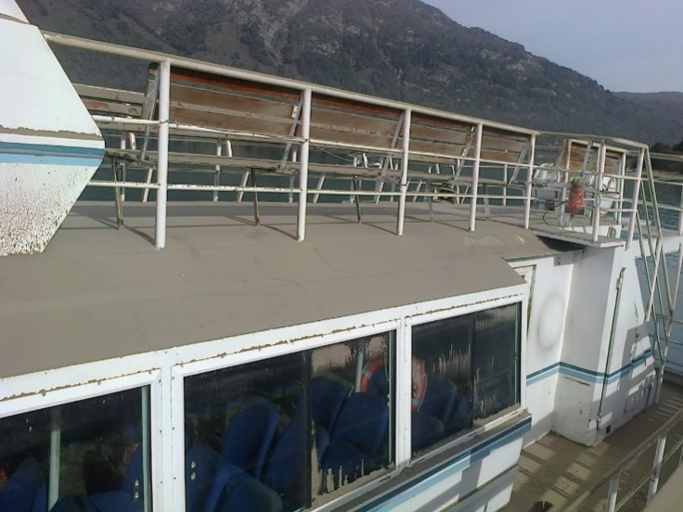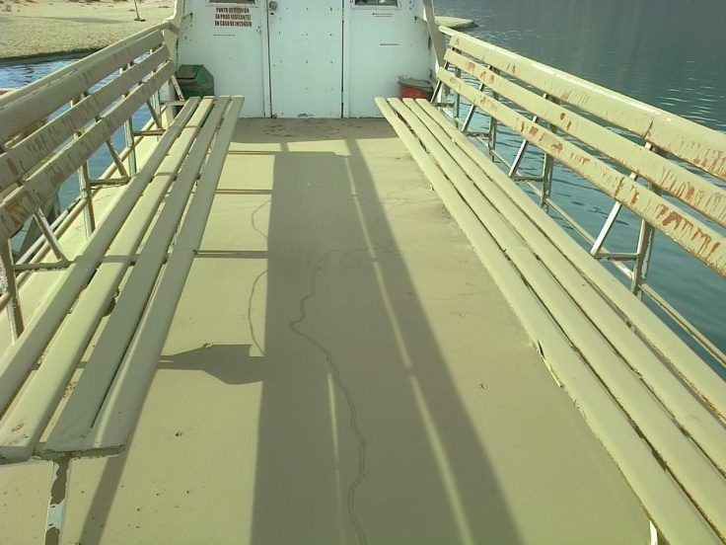
Figure S9: Volcanic ash accumulation on a double-decked primary passenger ship (Lago Huechulafquen), after the 2015 Calbuco volcanic eruption.
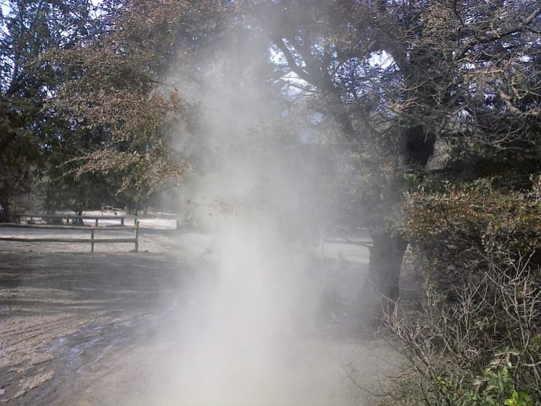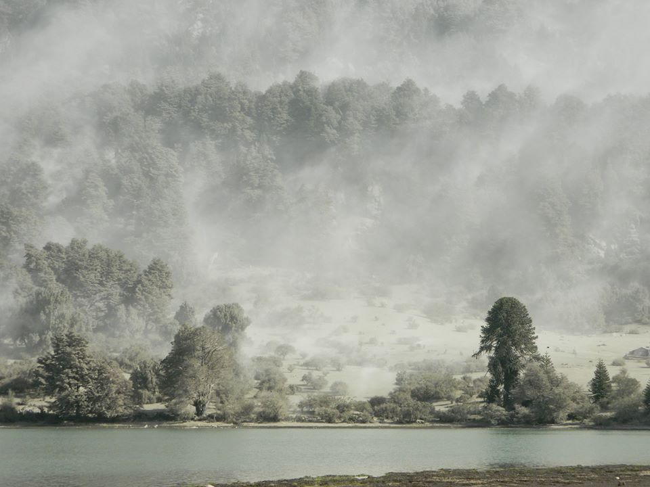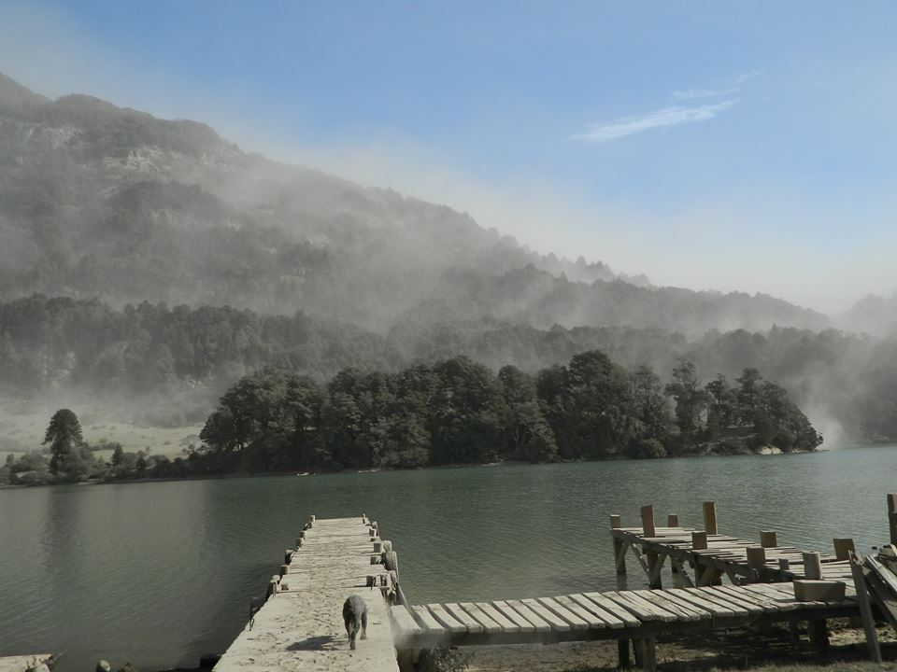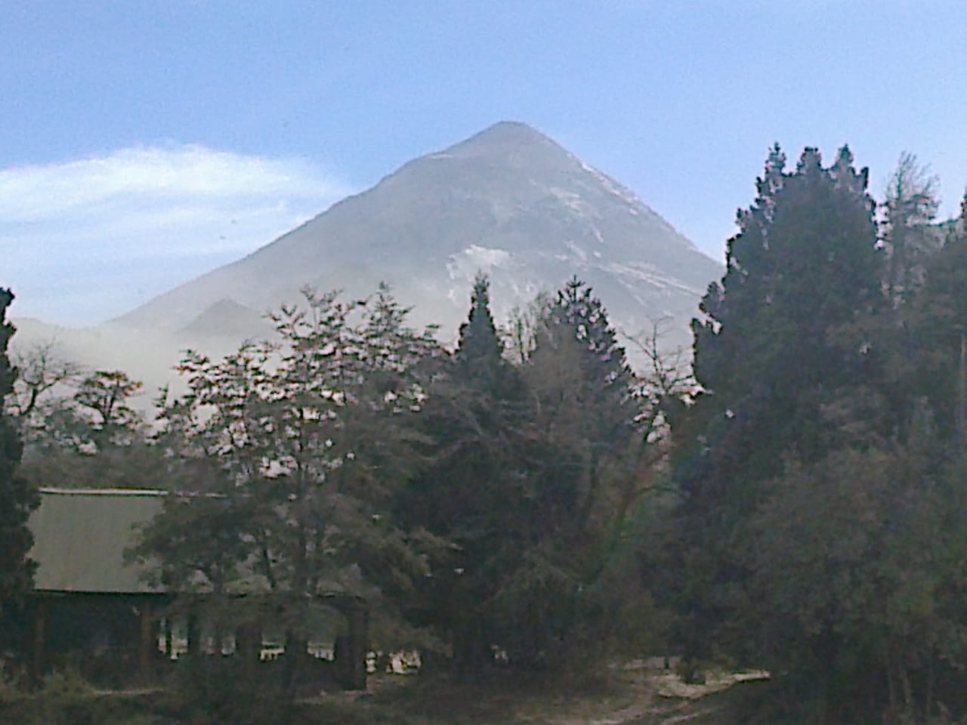
Figure S10: Wind remobilization of fine-grained ash deposits in the Lago Huechulafquen & Epulafquen surroundings, the following weeks after the 2015 Calbuco volcanic eruption. Bottom right, in the foreground, the active stratovolcano Lanín. Photos courtesy of Catamarán José Julián.
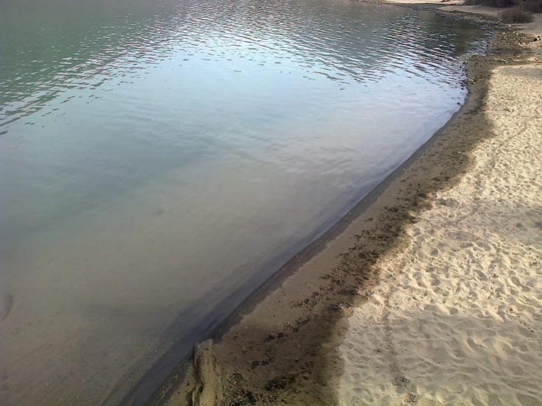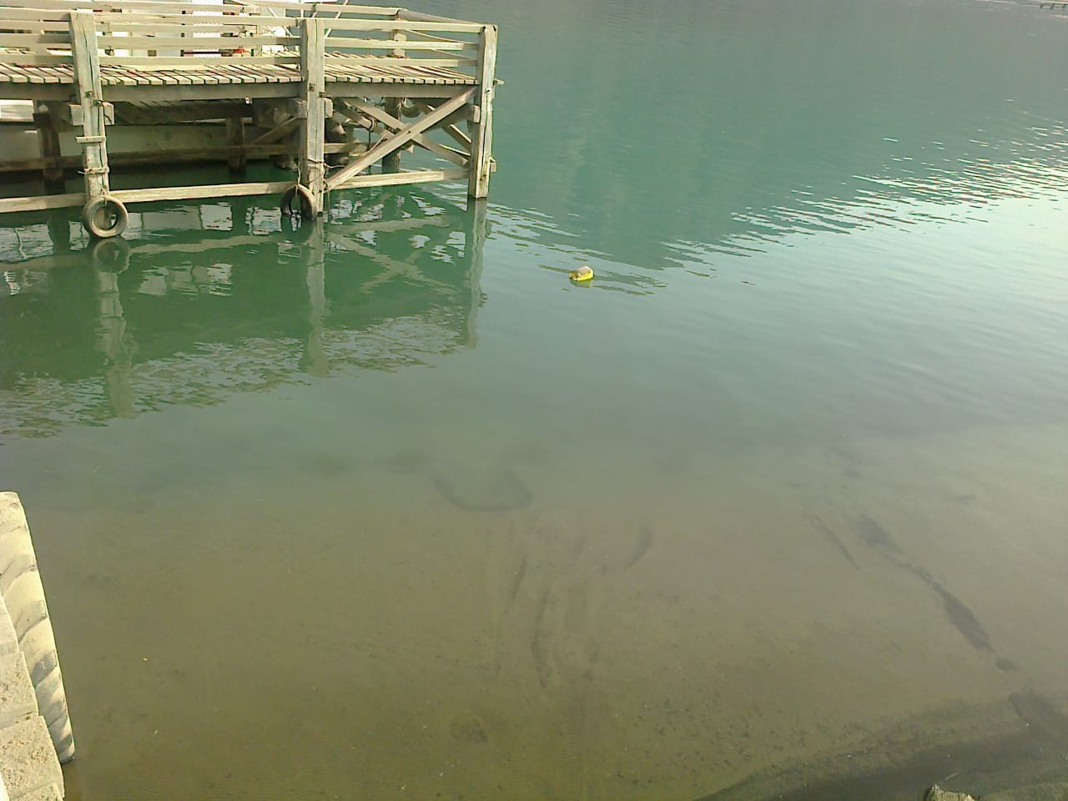
Figure S11: Tephra shore deposits and accumulation of tephra over a boat ramp at Lago Huechulafquen after the 2015 Calbuco volcanic eruption.

