This Supplementary Material accompanies the article
“Lava flow daily monitoring: the case of the 19 September–5 October 2022 eruption at Piton de la Fournaise” by M. O. Chevrel, N. Villeneuve, R. Grandin, J.-L. Froger, D. Coppola, F. Massimetti, A. Campus, A. Hrysiewicz, and A. Peltier. The original article should be cited if this material is used:

Chevrel, M. O., Villeneuve, N., Grandin, R., Froger, J.-L., Coppola, D., Massimetti, F., Campus, A., Hrysiewicz, A. and Peltier, A. (2023) “Lava flow daily monitoring: the case of the 19 September–5 October 2022 eruption at Piton de la Fournaise”, Volcanica, 6(2), pp. 391–404. doi: 10.30909/vol.06.02.391404.

Supplementary material for
Report on the lava flow daily monitoring of the 19 September–05 October 2022 eruption at Piton de la Fournaise
Magdalena Oryaëlle Chevrel^{1,2,3}, Nicolas Villeneuve^{2,3,4}, Raphaël Grandin³, Jean-Luc Froger⁵, Diego Coppola⁶, Francesco Massimetti⁶, Adele Campus⁶, Alexis Hrysiewicz^{7,8} and Aline Peltier^{2,3}

¹Université Clermont Auvergne, CNRS, IRD, OPGC, Laboratoire Magmas et Volcans, 63000 Clermont-Ferrand, France.
²Observatoire Volcanologique du Piton de la Fournaise, Institut de Physique du Globe de Paris, 97418 La Plaine des Cafres, France.
³Université Paris Cité, Institut de Physique du Globe de Paris, CNRS, 75005 Paris, France.
⁴Université de La Réunion, Laboratoire GéoSciences Réunion, 97744 Saint Denis, France.
⁵Université Jean Monnet - Faculté des Sciences et Techniques, Laboratoire de Géologie de Lyon : Terre, Planètes, Environnement - UMR CNRS 5276, France.
⁶Dipartimento di Scienze della Terra, Universita degli Studi di Torino, Torino, Italy.
⁷SFI Research Centre in Applied Geosciences (iCRAG), University College Dublin, Belfield, Dublin 4, Ireland.
⁸UCD School of Earth Sciences, University College Dublin, Belfield, Dublin 4, Ireland.

Table S1: General information, acquisition parameters and characteristics (resolution and quality) of the aerial photograph surveys made from UAS and ULM and their derived products (Point clouds and DSM).

 |  | 20220924 | 20221005 | 20220928 | 20221003
General informations | Camera | Canon 5DSR - 85 mm | Canon 5DSR - 85 mm | FC7203 - 4.49 mm | L1D-20c - 10.26mm
General informations | Resolution | 8688X5792 | 8688X5792 | 4000X2250 | 5472 x 3648
General informations | Pixel size (micron) | 4.24X4.24 | 4.24X4.24 | 1.76X1.76 | 2.41 x 2.41
Survey data | Images | 718 | 812 | 156 | 53
Survey data | Precalibrate | No | No | No | No
Survey data | Flying altitude (m) | 752 | 1.18 | 78.4 | 191
Survey data | Ground resolution (cm/pix) | 4.25 | 6.45 | 2.9 | 4.41
Survey data | total coverage (km2) | 8.6 | 14.3 | 0.155 | 0.231
Camera average locations error | X error (m) | 12.0 | 19.2 | 2.3 | 1.6
Camera average locations error | Y error (m) | 13.9 | 13.9 | 1.3 | 1.6
Camera average locations error | Z error (m) | 5.1 | 5.7 | 0.9 | 1.9
Camera average locations error | XY error (m) | 18.4 | 23.7 | 2.7 | 2.2
Camera average locations error | Total error (m) | 19.1 | 24.4 | 2.8 | 2.9
Point Cloud | Alignment accurency | High | High | High | High
Point Cloud | Ties points | 400.4 | 446.7 | 108.1 | 36.1
Point Cloud | RMS reprojection error (pix) | 0.7 | 0.6 | 0.6 | 0.8
Point Cloud | Max reprojection error (pix) | 42.3 | 28.0 | 29.4 | 31.9
Point Cloud | Projections | 2560951.0 | 2862715.0 | 496.4 | 170.9
Point Cloud | Reprojection error (pix) | 0.7 | 0.6 | 0.6 | 0.8
Dense Point Cloud | Points | 1,325,003,968 | 1,042,276,538 | 26,785,565 | 39,049,518
Dense Point Cloud | Deph maps generations quality | High | High | High | High
Dense Point Cloud | Deph maps generations filter mode | Moderate | Moderate | Moderate | Moderate
DSM | Size | 99,447X82,324 | 79,602 x 65,931 | 9,746 x 6,833 | 8,265 x 7,238
DSM | Source data | Dense Cloud | Dense Cloud | Dense Cloud | Dense Cloud
DSM | Resolution (cm/pix) | 8.51 | 12.9 | 5.79 | 8.81
DSM | Point density (points/m2) | 138 | 60.1 | 298 | 129
Table S2: Details on the InSAR images acquired during the 19 September - 5 October, 2022 eruption at Piton de la Fournaise. These data are collected by OI2: a component of the French National Service of Observation ISDeform, dedicated to the monitoring of ground surface displacements with optical and radar imagery. All the SAR images were obtained for free. The ALOS-2 images were obtained from JAXA in the framework of an EO-ERA3 project. In addition, TSX and PAZ (Band-X) data were acquired on Piton de la Fournaise during the eruption but were not delivered to us early enough to be useful for a near-real time monitoring of the lava flow progression.
Satellite | Acquisition Mode | Acquisition Geometry | Track/Frame | Date DD/MM/YYYY |  | Time UTC (HH:MM)
 |  |  |  | Primary | Replica
ALOS-2 | Spotlight | Ascending Left | 159/6801 | 23/08/2022 | 20/09/2022 | 19:56
ALOS-2 | Spotlight | Descending Right | 56/4073 | 29/07/2022 | 23/09/2022 | 07:23
ALOS-2 | Spotlight | Ascending Left | 157/6811 | 30/07/2022 | 24/09/2022 | 19:42
ALOS-2 | Spotlight | Descending Left | 65/4008 | 15/08/2022 | 26/09/2022 | 08:24
Sentinel-1A | Stripmap | Ascending Right | S6 | 15/09/2022 | 27/09/2022 | 14:53
ALOS-2 | Spotlight | Descending Right | 60/4041 | 01/09/2022 | 29/09/2022 | 07:50
ALOS-2 | Spotlight | Ascending Left | 161/6790 | 02/09/2022 | 30/09/2022 | 15:37
ALOS-2 | Spotlight | Descending Left | 64/4014 | 07/09/2022 | 05/10/2022 | 08:18

Table S3: Parameters of acquired Capella SAR data during the 19 September - 5 October, 2022 eruption at Piton de la Fournaise. Data and tasking permissions were granted at no cost to the scientists collaborating with OVPF, as part of a capacity-building partnership with Capella.
Platform | Collect Date / Time (UTC) | Delivery latency  (hours) | Orbital plane | Pass direction | Look direction | Incidence angle | Resolution (Az×Ra) (m)
Capella-7 | 01/10/2022  18:12 | +6 | 97° | ascending | left | 39.5° | 0.5×0.4
Capella-6 | 02/10/2022  11:34 | +2.5 | 53° | descending | left | 42.9° | 0.6×0.4
Capella-3 | 04/10/2022  05:53 | +7.5 | 97° | descending | left | 27.6° | 0.5×0.4

Figure S1: Thickness map of the final flow field obtained from SfM analyses aquires on 05 October 2023.

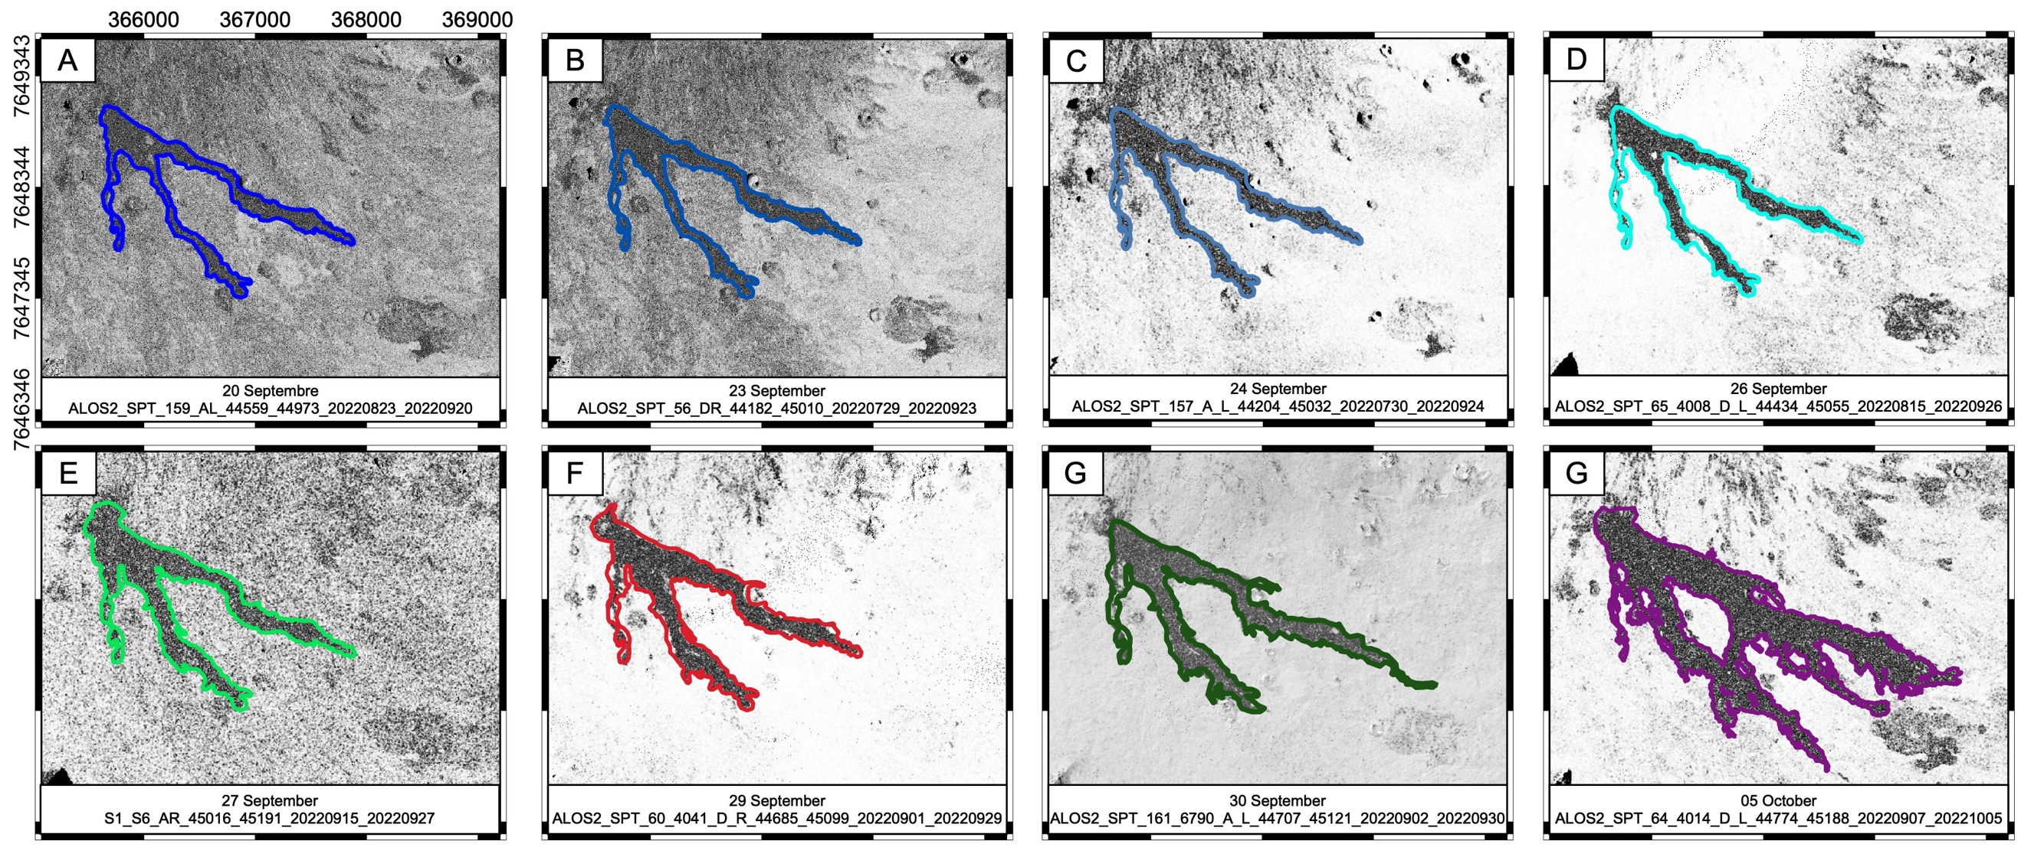
Figure S1: InSAR coherence maps acquired during the 19 September - 5 October eruption at Piton de la Fournaise. Darker grey tones show highly incoherent surfaces while clearer tones are for higher coherence. Coordinates are metres within system WGS-UTM 40S.

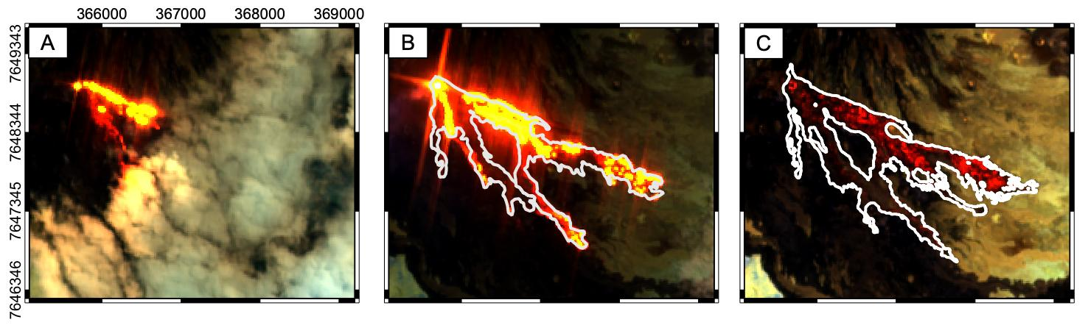

Figure S3: Sentinel-2 RGB images (band combination 12 - 11 - 8a) series, acquired on A) 28 September 2022 at 06:35, B) 3 October 2022 at 06:35, and C) 8 October 2022 at 06:35. All times are referred to UTC. Images are projected in Qgis and lava flow outlines are mapped as explained in the results section. Coordinates are metres within system WGS-UTM 40S.

