This Supplementary Material accompanies the article
“Insights on the state of stress in the mantle beneath Pahala, Hawai‘i” by J. D. Wilding and Z. E. Ross. The original article should be cited if this material is used:

Wilding, J. D. and Ross, Z. E. (2024) “Insights on the state of stress in the mantle beneath Pahala, Hawai‘i”, Volcanica, 7(1), pp. 1–19. doi: 10.30909/vol.07.01.0119.
Supplementary material: Insights on the state of stress in the mantle beneath Pāhala, Hawai`i

John D. Wilding, Zachary E. Ross

Network | Station | Latitude | Longitude
HV | AHUD | 19.371567 | -155.263462
HV | AIND | 19.372067 | -155.457228
HV | ALEP | 19.541178 | -155.644036
HV | BYL | 19.412086 | -155.259872
HV | CPKD | 19.391443 | -155.324317
HV | DAND | 19.35369 | -155.664418
HV | DESD | 19.333395 | -155.38565
HV | DEVL | 19.373568 | -155.240608
HV | ELEP | 19.450382 | -155.524977
HV | ERZ4 | 19.51702 | -154.861137
HV | HAT | 19.423037 | -155.26094
HV | HLPD | 19.296253 | -155.30748
HV | HOVE | 19.164518 | -155.749057
HV | HPP | 19.585501 | -154.988235
HV | HPUD | 19.775885 | -155.456039
HV | HQM | 19.790079 | -155.097183
HV | HTCD | 19.237503 | -155.397507
HV | JCUZ | 19.384045 | -155.101578
HV | JOKA | 19.433613 | -155.004449
HV | KAAD | 19.2633 | -155.869
HV | KAED | 19.285863 | -155.129087
HV | KIND | 19.460442 | -154.950189
HV | KKO | 19.398242 | -155.266032
HV | KKUD | 19.8868 | -155.34
HV | KLPN | 19.38743 | -154.95844
HV | KLUD | 19.455728 | -154.918443
HV | KNHD | 19.379447 | -155.169297
HV | KOHD | 20.1252 | -155.777
HV | KUPD | 19.402438 | -155.07508
HV | MITD | 19.33566 | -155.301105
HV | MLOD | 19.493172 | -155.386023
HV | MOKD | 19.485115 | -155.597133
HV | MONK | 19.339825 | -155.874496
HV | NAHU | 19.4151 | -155.23831
HV | NPOC | 19.39296 | -155.109605
HV | OBL | 19.417662 | -155.284097
HV | OTLD | 19.386532 | -155.281715
HV | P07 | 19.495094 | -154.915726
HV | PAUD | 19.373785 | -155.2155
HV | PLAD | 19.529823 | -155.456467
HV | PPLD | 19.155413 | -155.462112
HV | PUHI | 19.385509 | -155.251312
HV | RCOD | 19.402745 | -155.627597
HV | RIMD | 19.395368 | -155.273643
HV | RSDD | 19.46017 | -155.27533
HV | SBL | 19.427078 | -155.267682
HV | SDH | 19.390003 | -155.293995
HV | SPDD | 18.97936 | -155.667897
HV | STCD | 19.38486 | -155.12543
HV | SWRD | 19.451827 | -155.602737
HV | TOUO | 19.504323 | -155.702741
HV | TRAD | 19.412033 | -155.54704
HV | UWB | 19.42476 | -155.277582
HV | UWE | 19.420972 | -155.291162
HV | WILD | 19.466578 | -155.58107
HV | WOOD | 19.248378 | -155.498982
HV | WRM | 19.406623 | -155.300005
PT | HILB | 19.7033 | -155.080597
PT | KHLU | 19.591999 | -155.893097
PT | KHU | 19.246099 | -155.615005
PT | MLOA | 19.5359 | -155.576401

Table S1. List of stations used in moment tensor inversion.

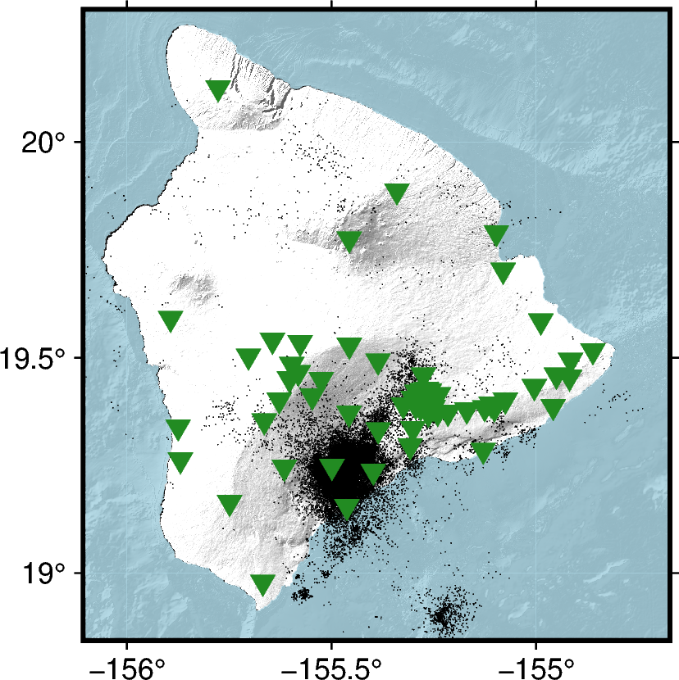

Figure S1. Seismicity below 30 km depth spanning 1 November 2018 to 1 May 2022 from the Wilding et al. (2023) catalog and stations used in moment tensor inversion (green triangles).

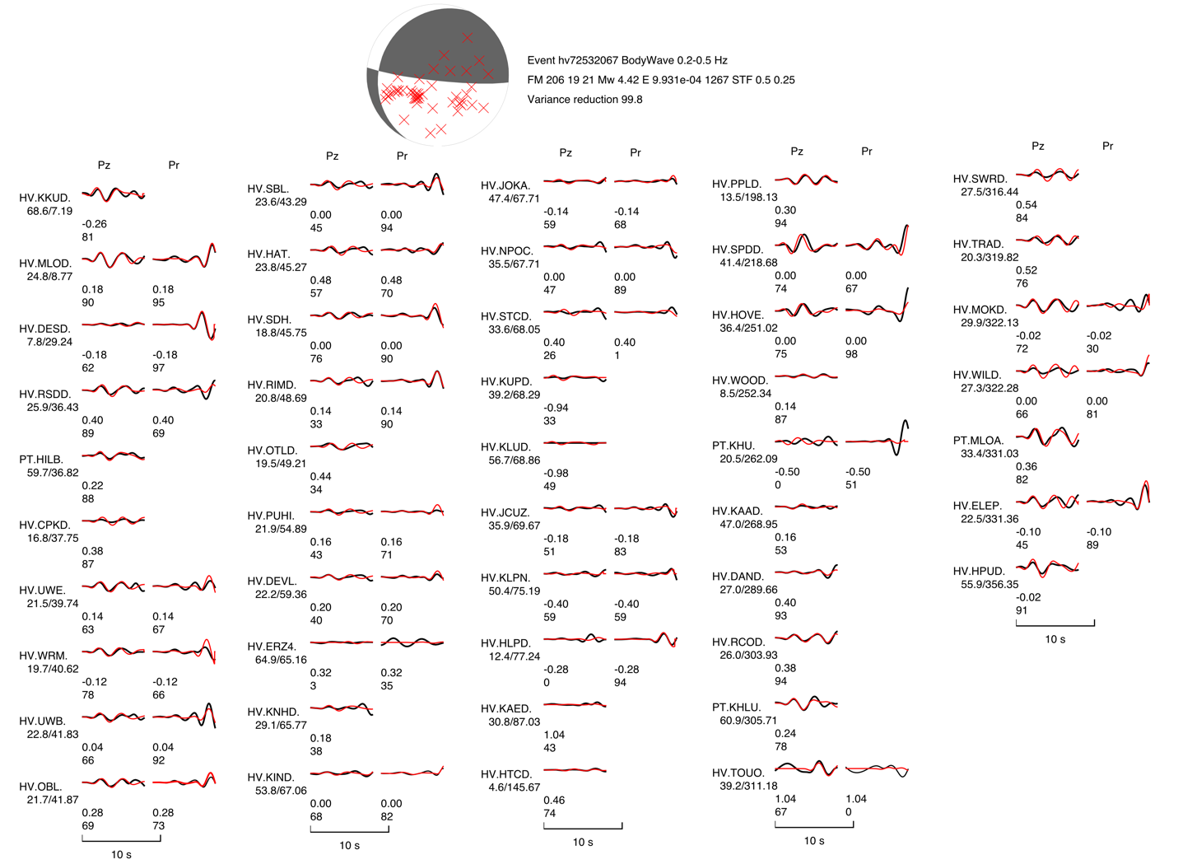
Figure S2. Waveform fits from the CAP moment tensor inversion procedure for event hv72532067. Black waveforms are observed data and red waveforms are synthetics.

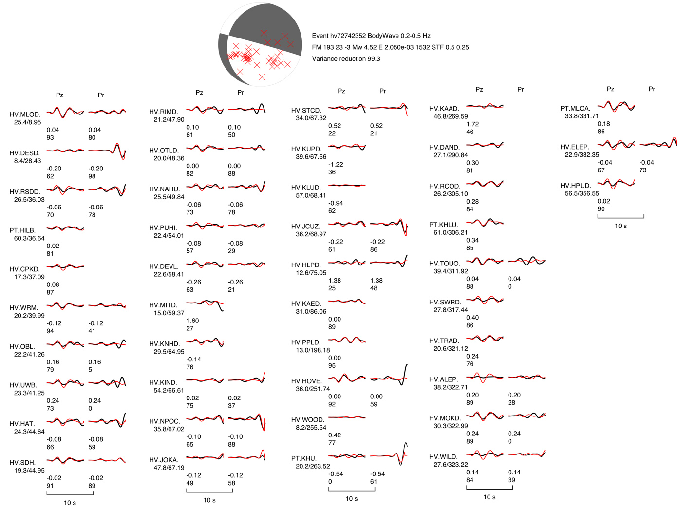
Figure S3. Waveform fits from the CAP moment tensor inversion procedure for event hv72742352. Black waveforms are observed data and red waveforms are synthetics.

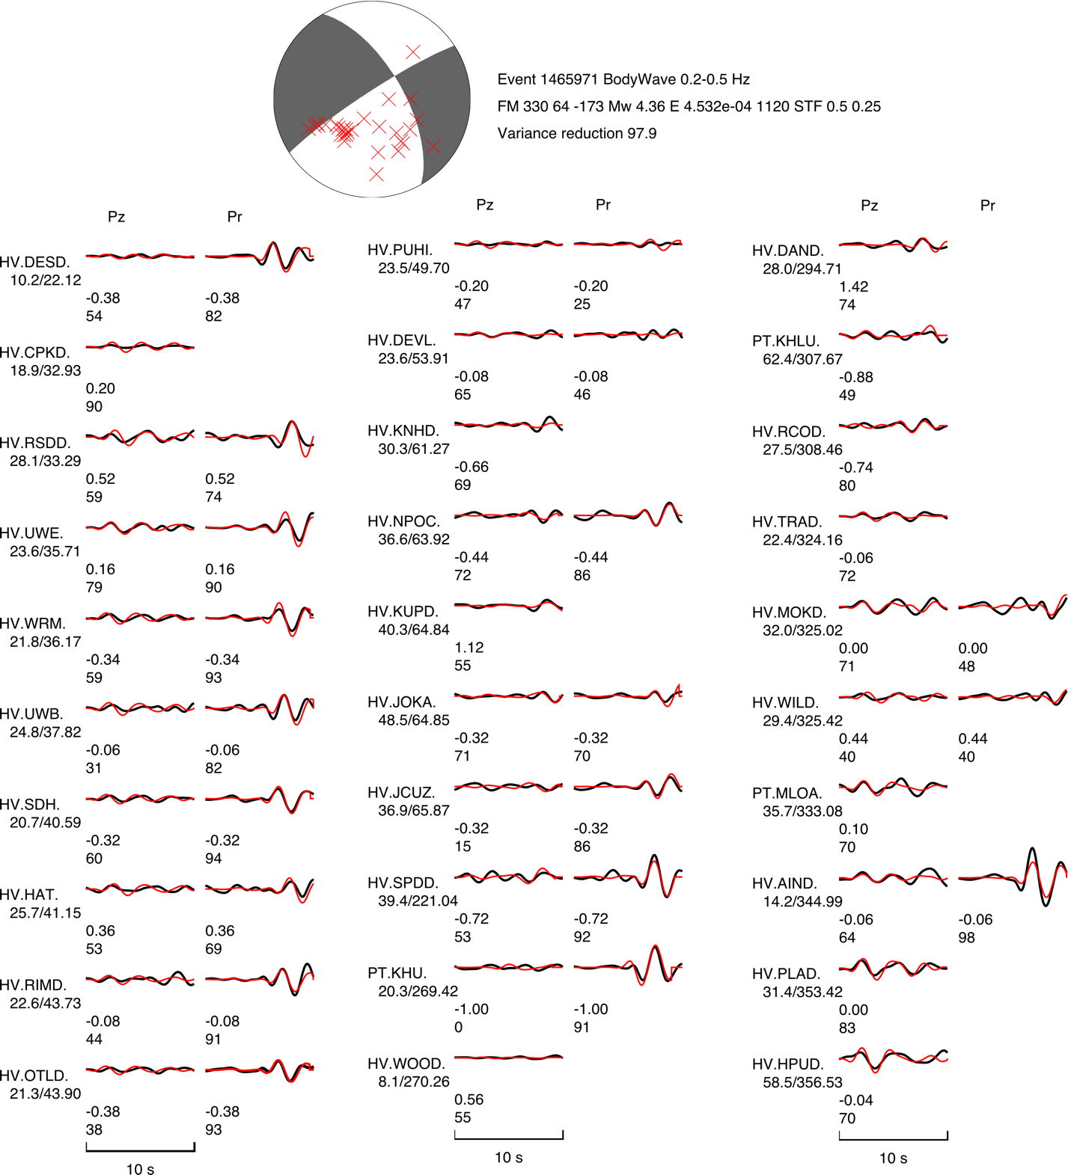
Figure S4. Waveform fits from the CAP moment tensor inversion procedure for event hv72856332. Black waveforms are observed data and red waveforms are synthetics.

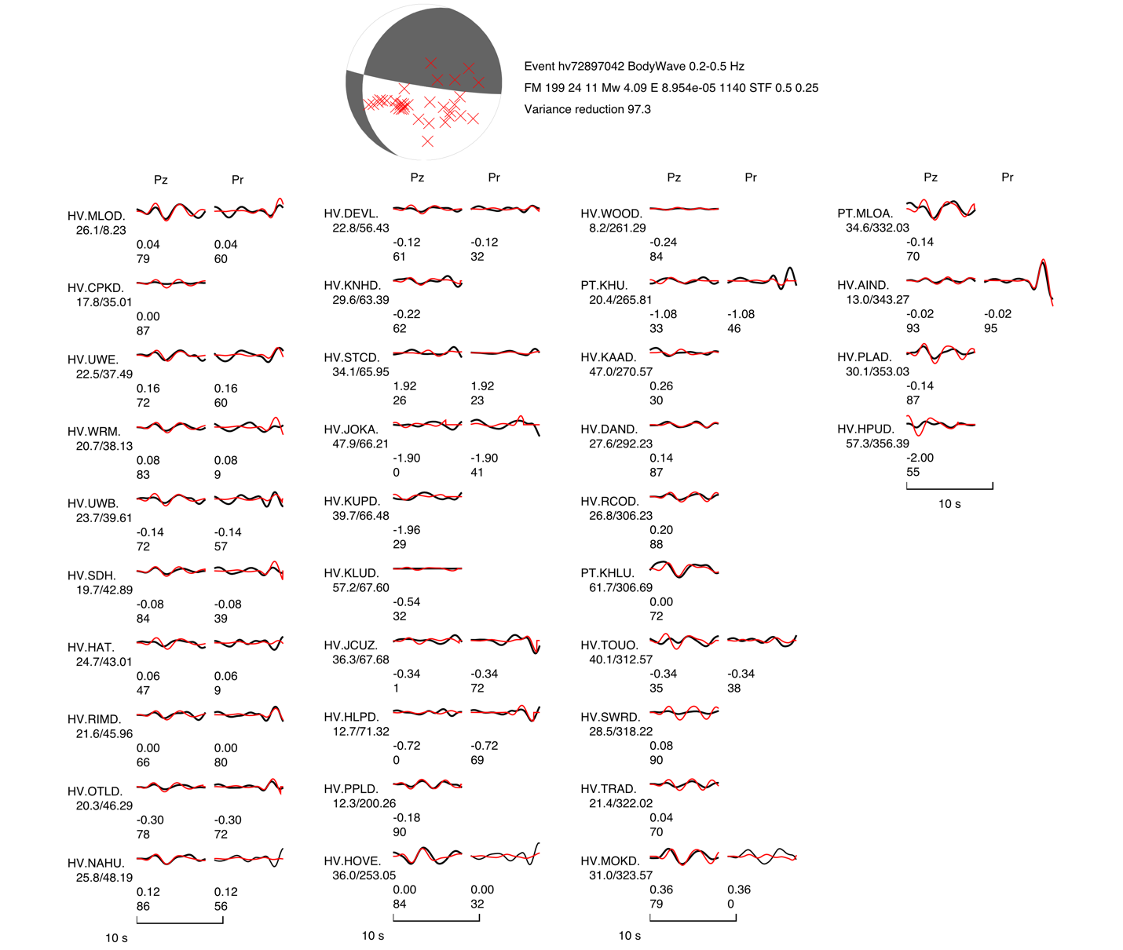
Figure S5. Waveform fits from the CAP moment tensor inversion procedure for event hv72897042. Black waveforms are observed data and red waveforms are synthetics.

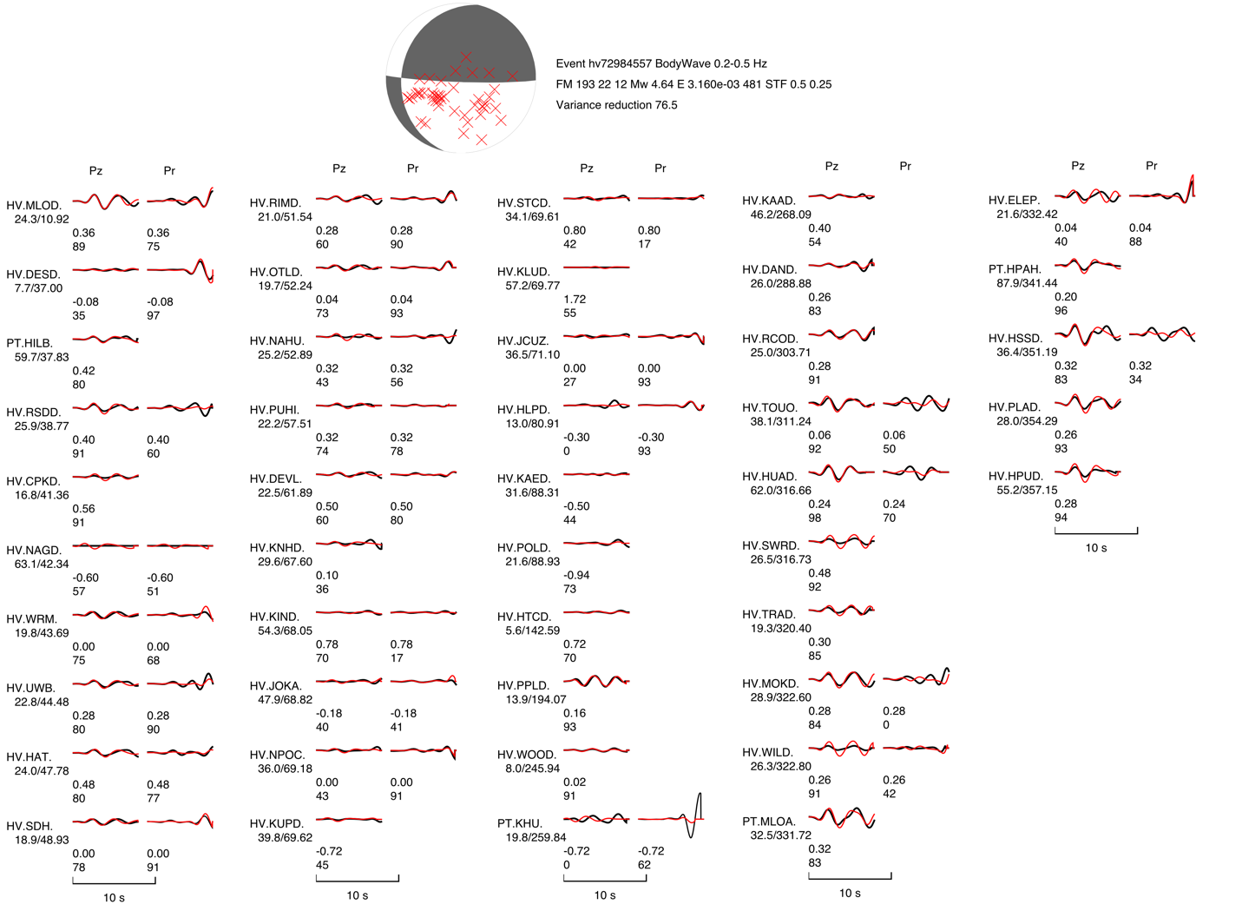
Figure S6. Waveform fits from the CAP moment tensor inversion procedure for event hv72984557. Black waveforms are observed data and red waveforms are synthetics.

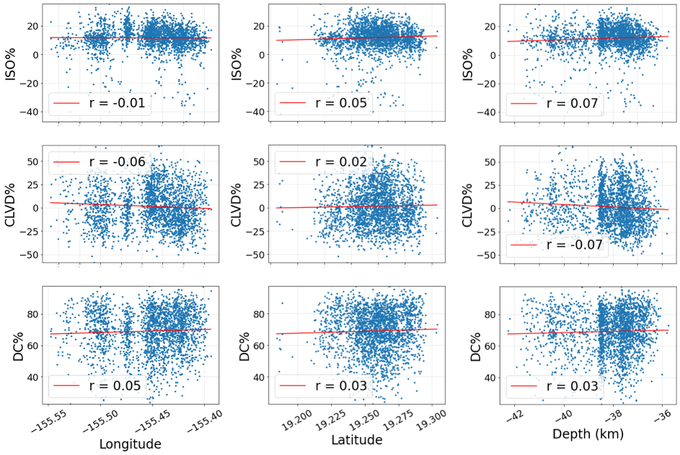

Figure S7. Dependence of double-couple and non-double-couple components on (left) event longitude, (middle) event latitude, and (right) event depth for all well-constrained events. Pearson correlation values (“r”) are provided for each plot.

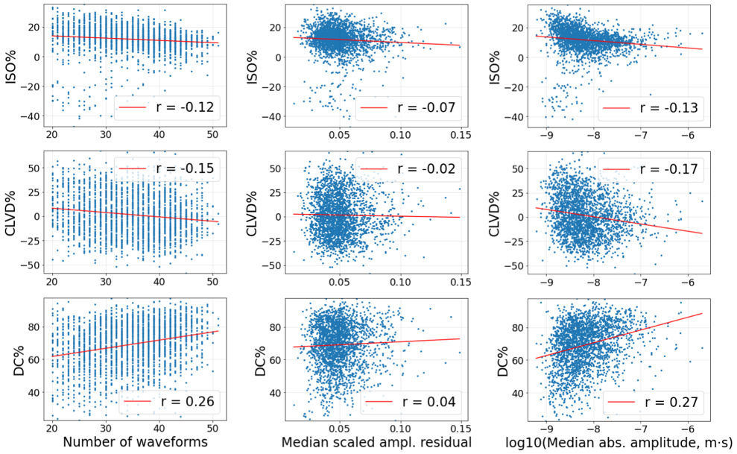

Figure S8. Dependence of double-couple and non-double-couple components on (left) the number of observations used in an inversion, (middle) the median scaled amplitude residual of an event’s observations, and (right) the median absolute P-wave amplitude of an event’s observations. Pearson correlation values (“r”) are provided for each plot.

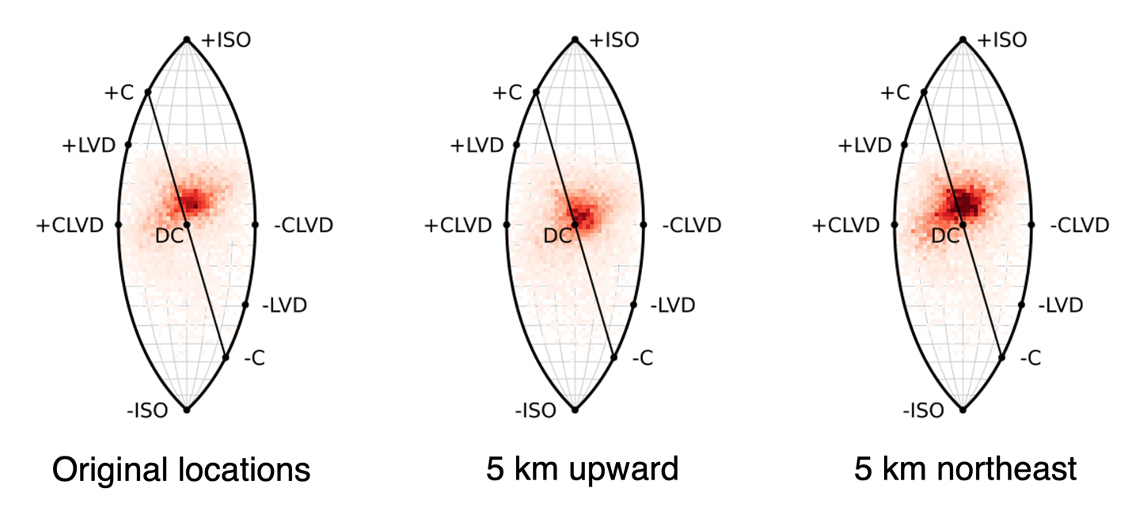
Figure S9. Left panel: heatmap of all solutions on the lune diagram using the original locations of the Wilding et al. (2023) catalog. Middle panel: heatmap of solutions with all locations displaced 5 km upward. Right panel: heatmap of solutions will all locations displaced 5 km northeast.

