Supplementary Material S2 – Gridded ash and ash crystallinity images

This supplementary file accompanies the article:
Buckland, H., Cashman, K., Rawlings, J., Day, L. and Young, S. (2024) “Complex precursory activity prior to the c.7600 yr BP Mazama (Crater Lake, USA) eruption”, Volcanica, 7(2), pp. 853–869. doi: 10.30909/vol.07.02.853869.

Gridded ash sample BSE-SEM images

(see following pages)
Please contact HMB if you would like the high-resolution stitched images. These are large files (>40MB) so are best shared directly.
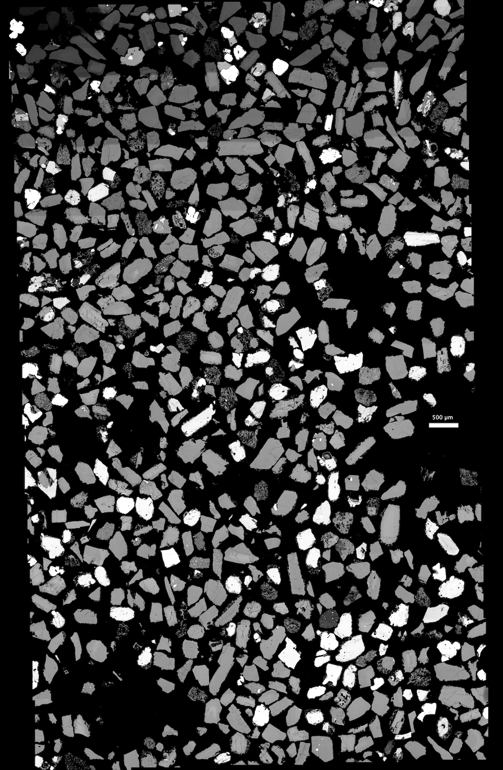

MZ18063 (UPU)
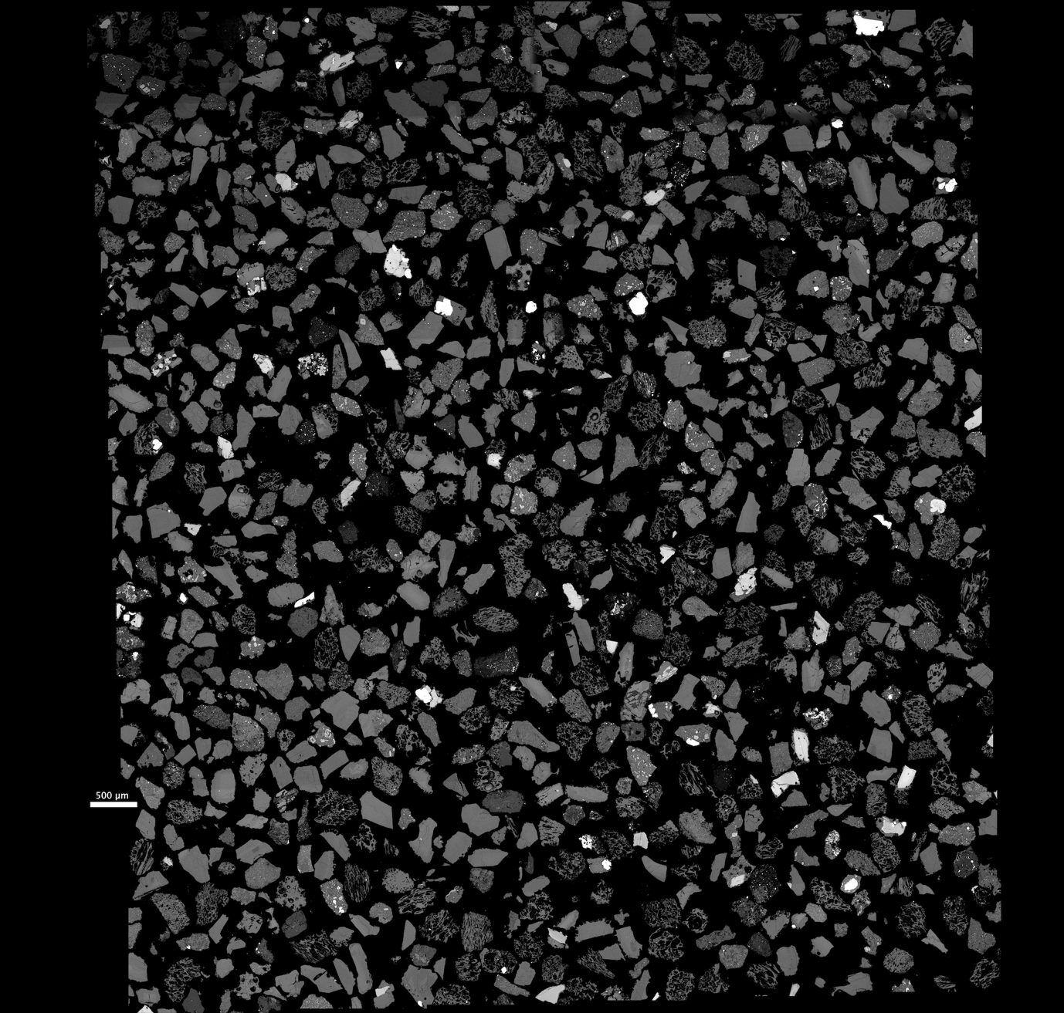

MZ18064 (DAB)

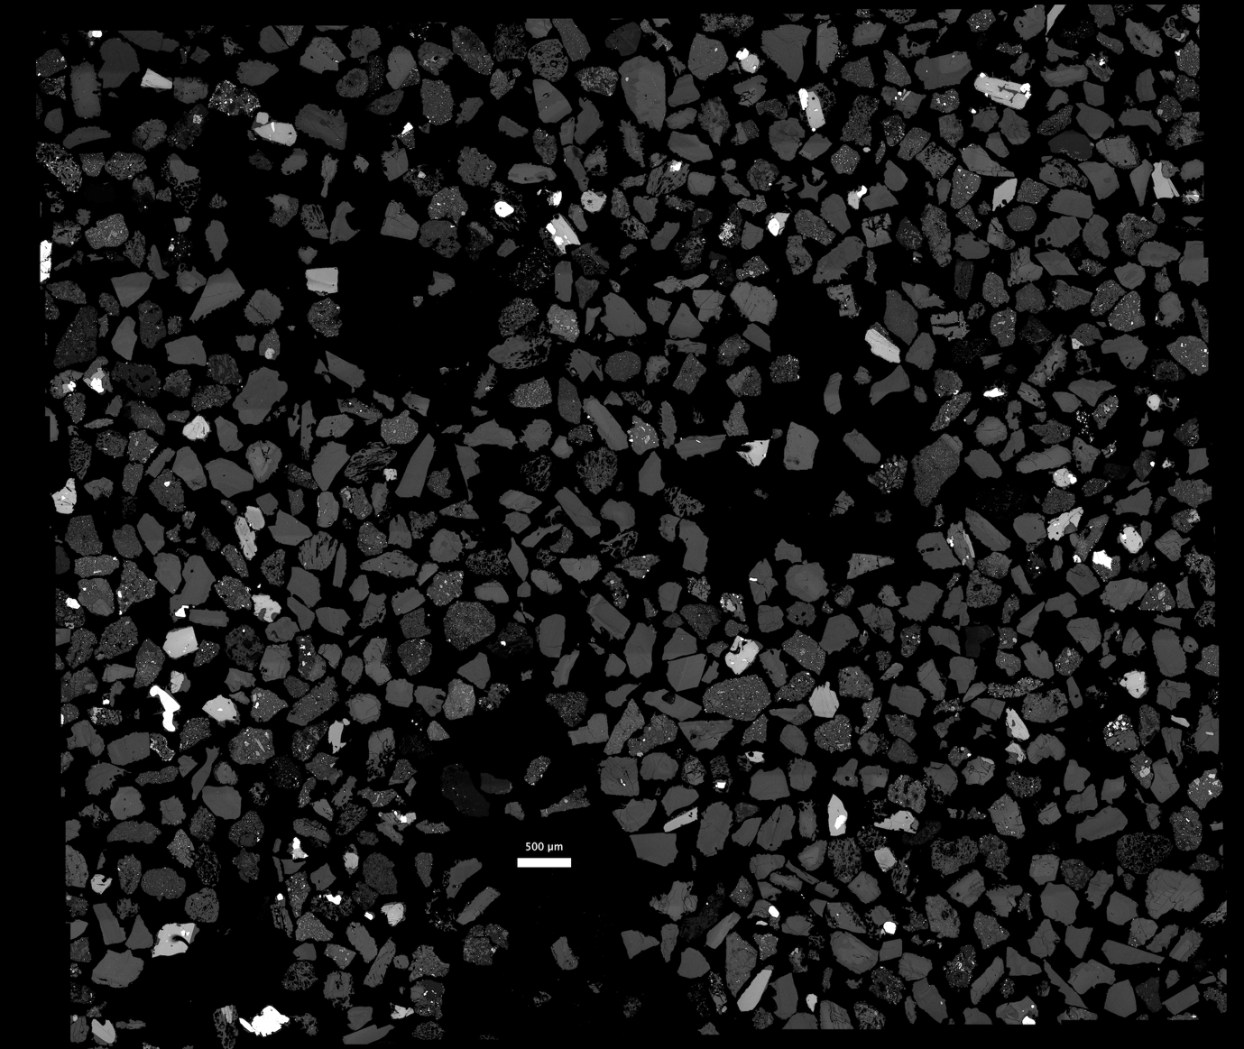

MZ18065 (NLPU)

Examples of the componentry categories are as follows (images not to scale):

Vesicular
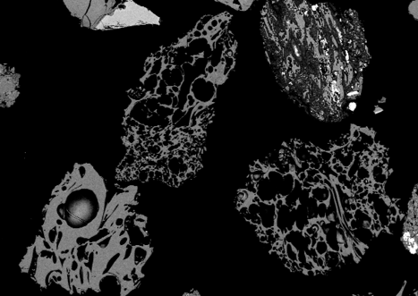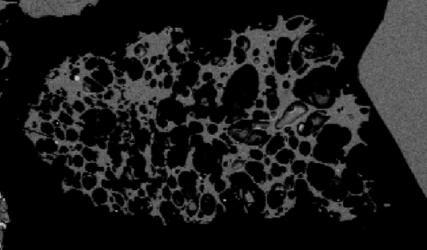

Free crystals
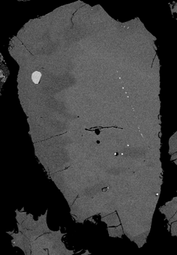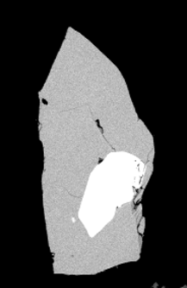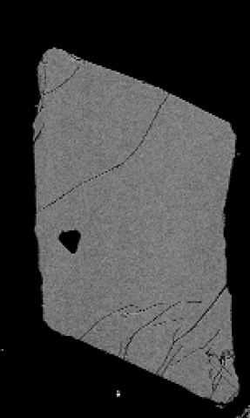

Microlite bearing glass
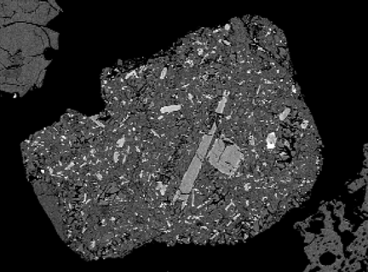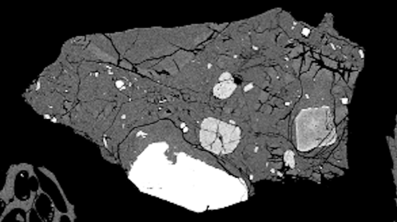

Microlite free glass
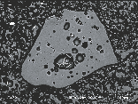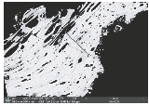

Non-juvenile
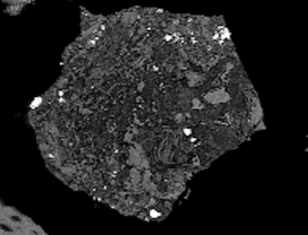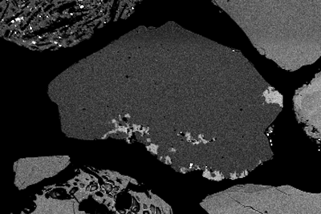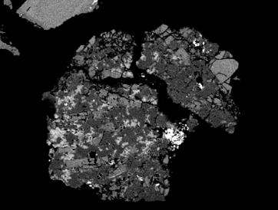
Ash crystallinity images

Please contact KVC if you would like the high-resolution stitched images. These are large files (>40MB) so are best shared directly.

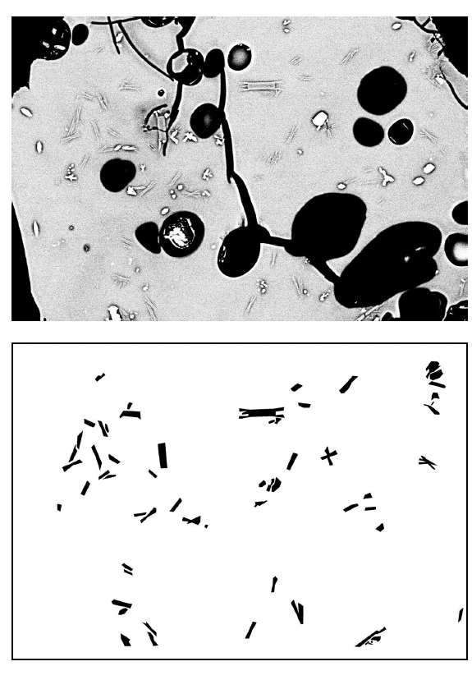
Particle 65_1.5_011
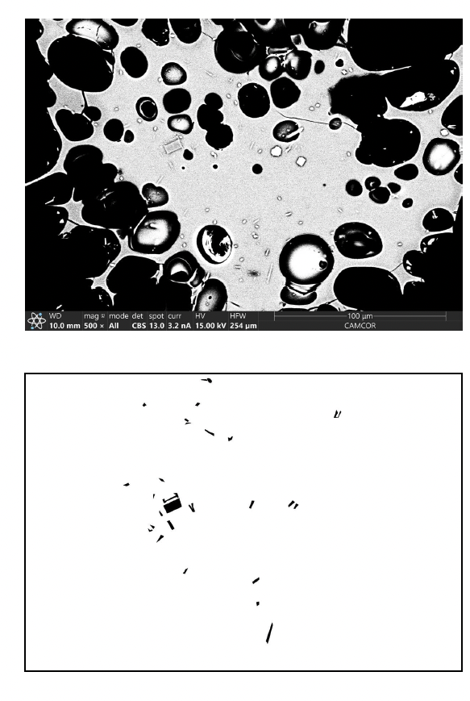
Particle 65_1.5_024
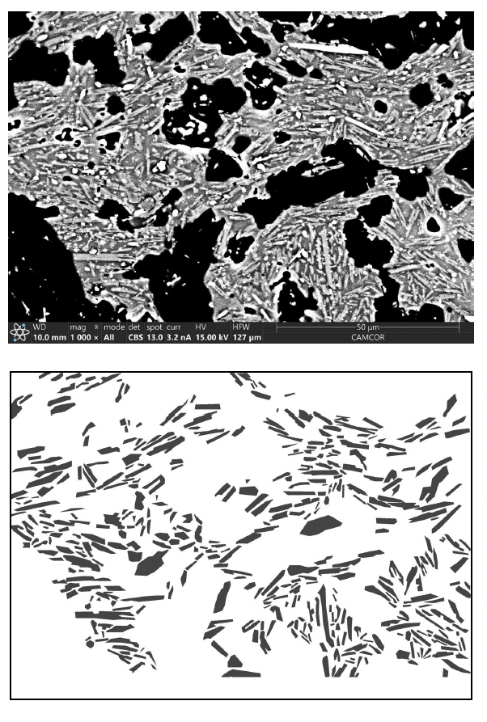
Particle 65_1.5_009
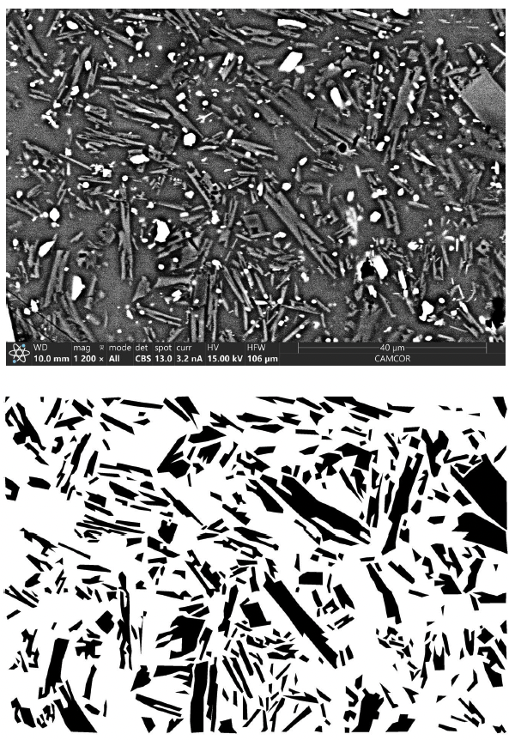

Particle 65_1.5_001
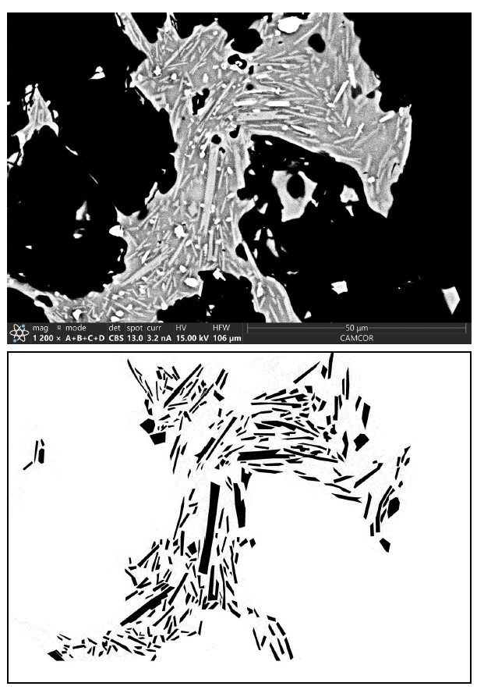
Particle 66_1.5_015

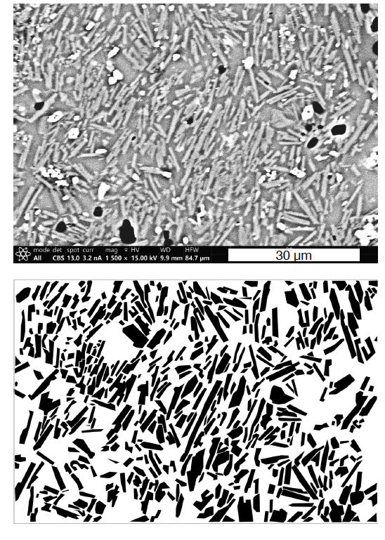
Particle ELPU_1.5_014

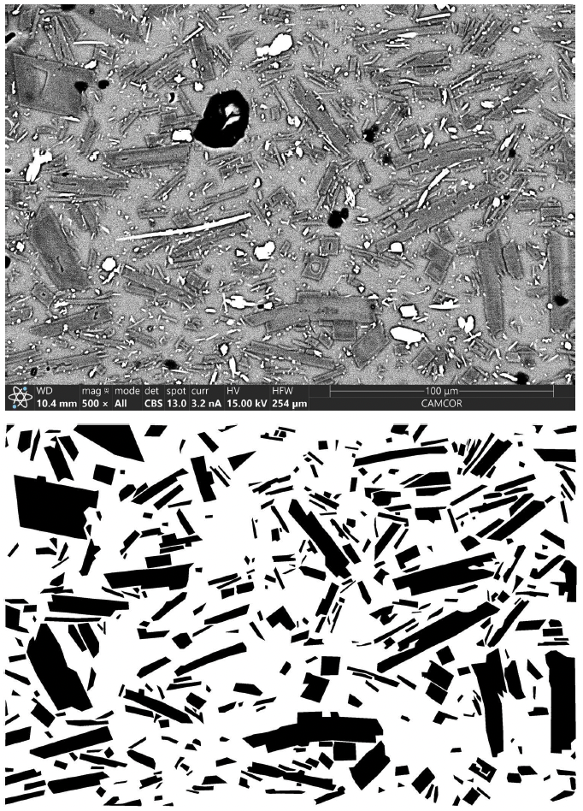

Particle 87_1_010

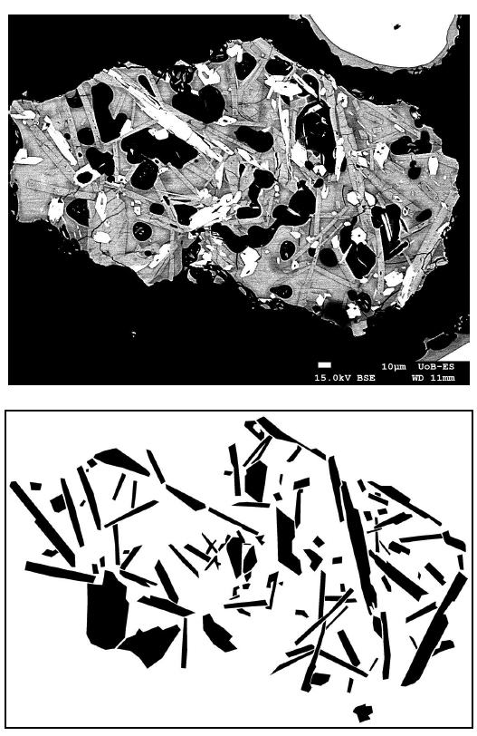
Particle 87_2_g8
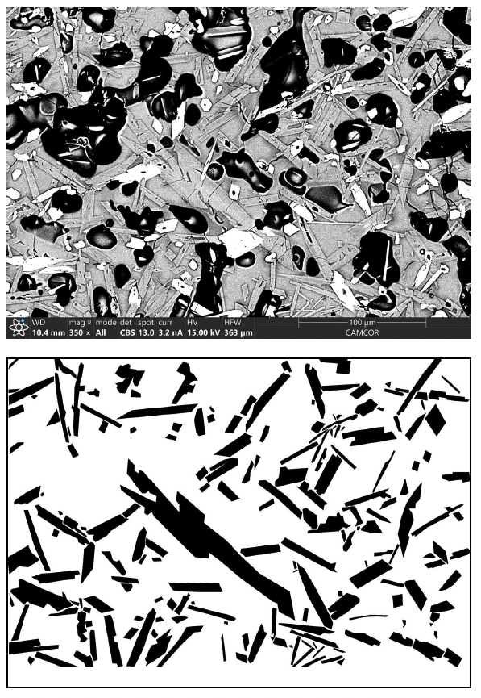
Particle 87_1_003*
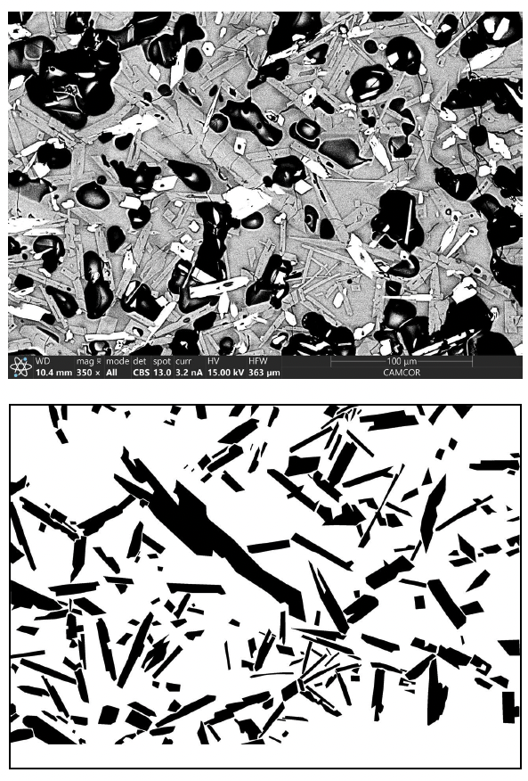
Particle 87_1_004
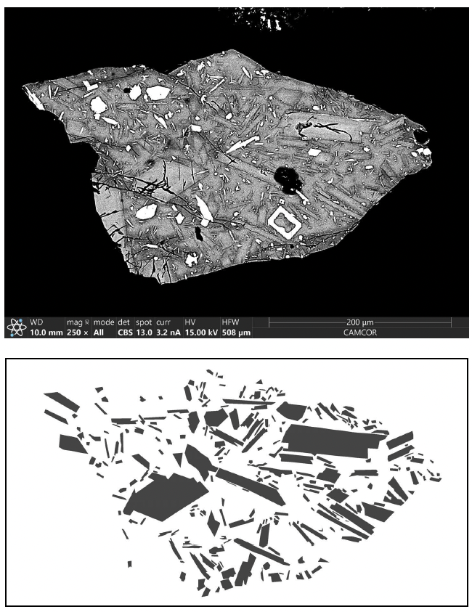
Particle 87_2_013

BSE – SEM images diktytaxitic textures in the ELPU

