Supplementary Material 2 for
A shake and a surge: Assessing the possibility of an earthquake-triggered eruption at Steamboat Geyser
Mara H. Reed*¹, Anna Barth¹, Taka’aki Taira², Jamie Farrell³, and Michael Manga^{1,2}

¹ Department of Earth and Planetary Science, University of California, Berkeley, Berkeley, USA
² Berkeley Seismological Lab, University of California, Berkeley, Berkeley, USA
³ Department of Geology and Geophysics, University of Utah, Salt Lake City, USA

* mhreed@berkeley.edu [corresponding author]

This document contains three supplementary figures referenced in the main manuscript.

Reed, M., Barth, A., Taira, T., Farrell, J. and Manga, M. (2024) “A shake and a surge: Assessing the possibility of an earthquake-triggered eruption at Steamboat Geyser”, Volcanica, 7(2), pp. 733–748. doi: 10.30909/vol.07.02.733748.
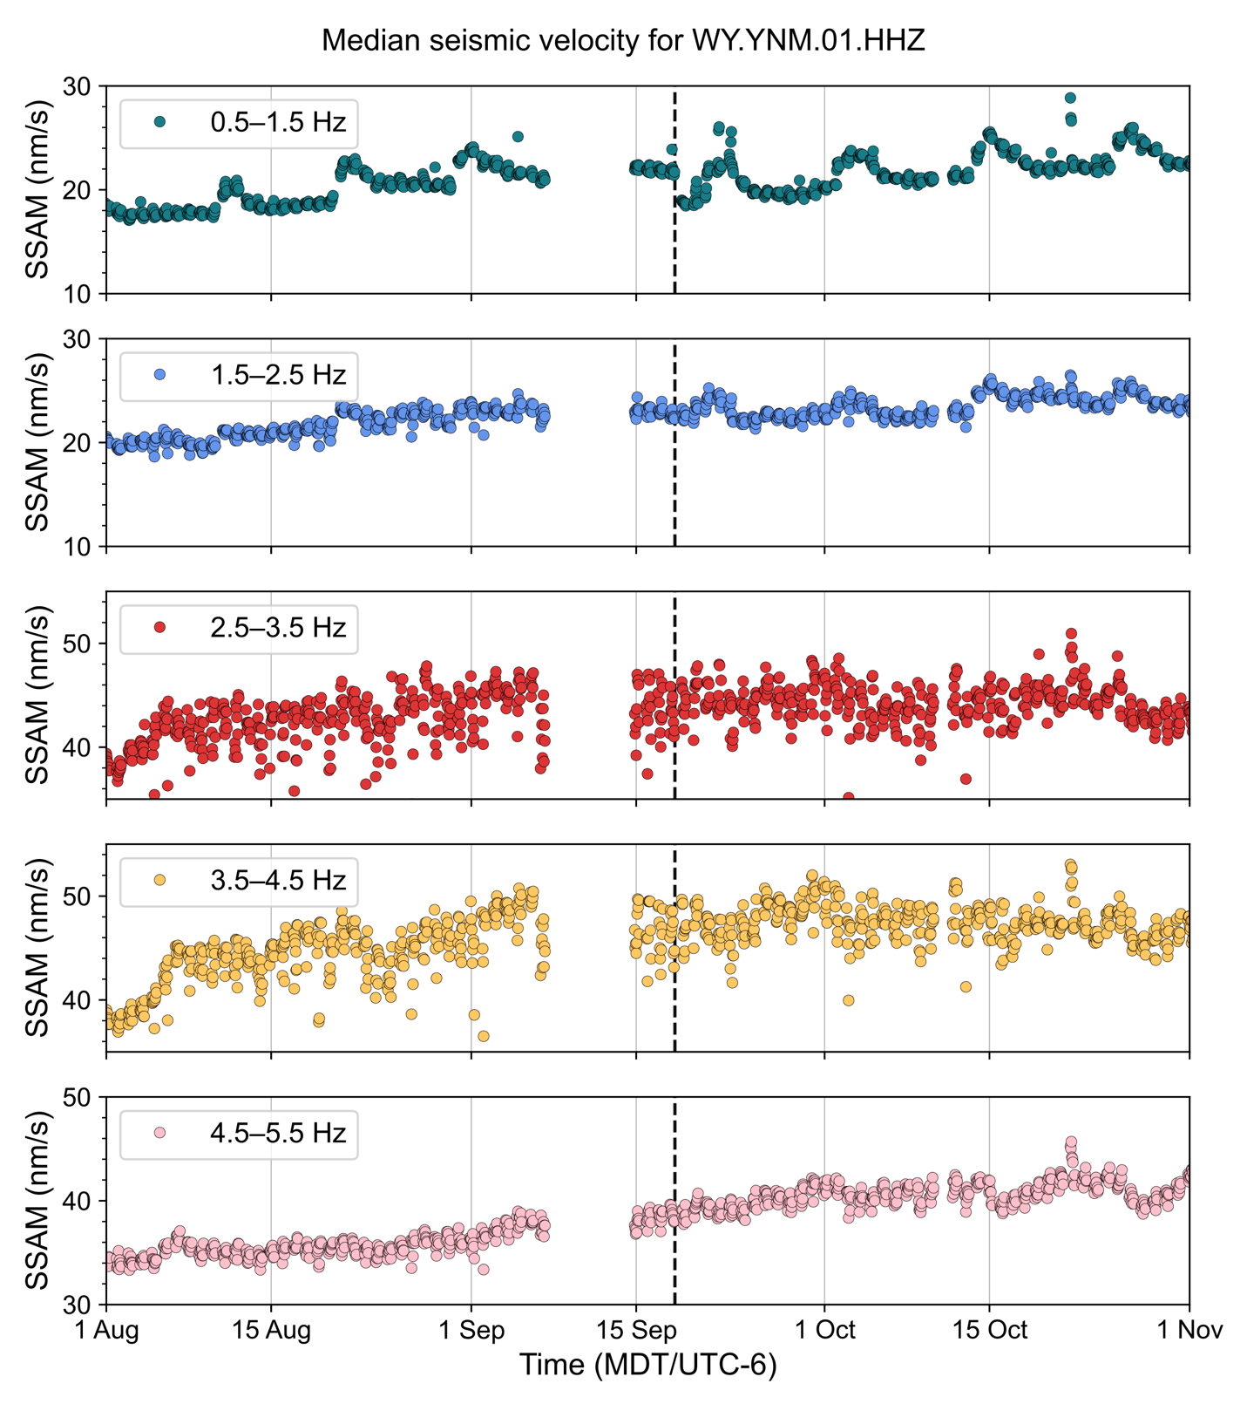Figure S1: Seismic spectral amplitude measurements (SSAM) for five frequency bands, each spanning 1 Hz. After the M3.9 earthquake on 18 September 2022 (black dashed line), only the 0.5–1.5 Hz frequency band shows an earthquake response. No SSAM calculations are plotted for several days in September because the YNM seismometer was offline. Note the differing SSAM ranges in each panel.

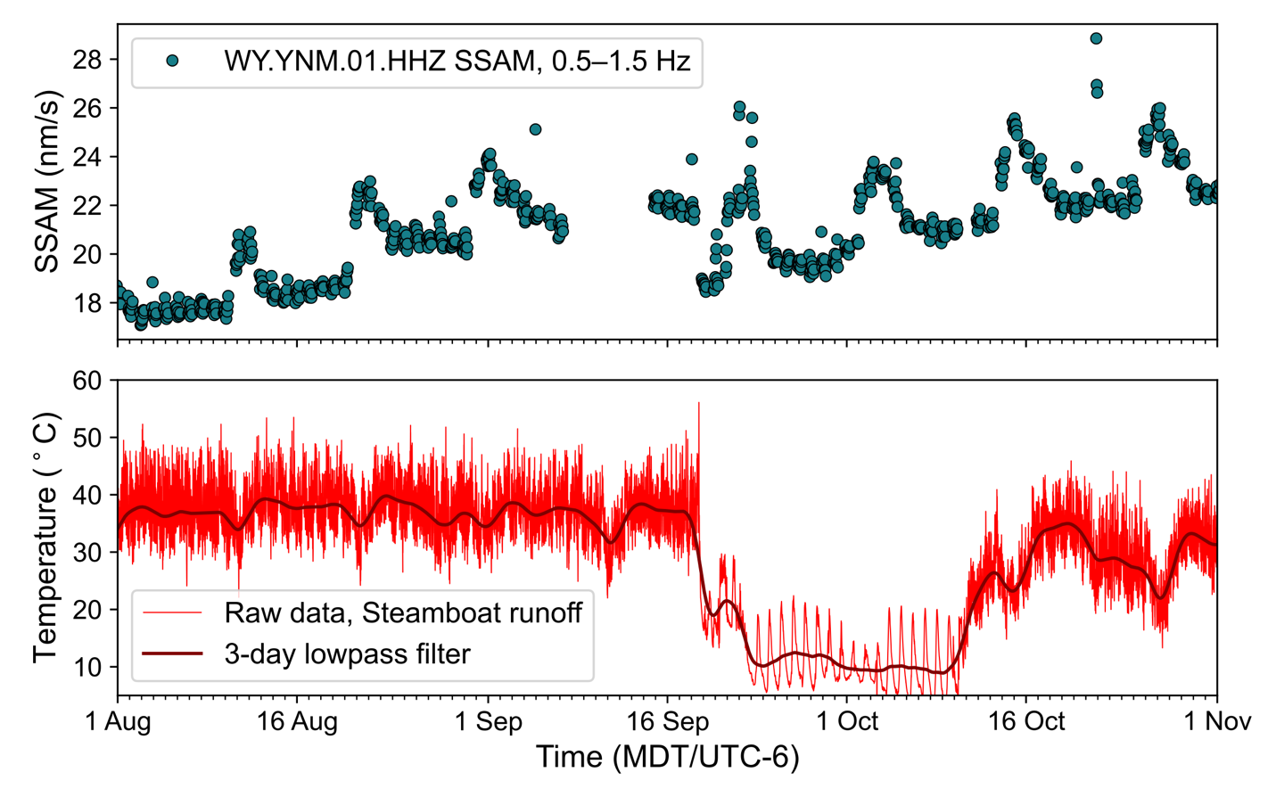
Figure S2: Upper panel shows seismic spectral amplitude measurements (SSAM) for vertical velocity at station YNM in the 0.5–1.5 Hz band. Lower panel shows both raw temperature data from Steamboat’s South Vent runoff channel and that same data with a 3-day lowpass filter applied. The periodic fluctuation in SSAM corresponds to a periodic dip in runoff temperature, likely caused by some combination of less frequent or less voluminous minor eruptions. The trace depicts air temperature from late September through mid-October during the quiet period following Steamboat’s major eruption on 18 September 2022.

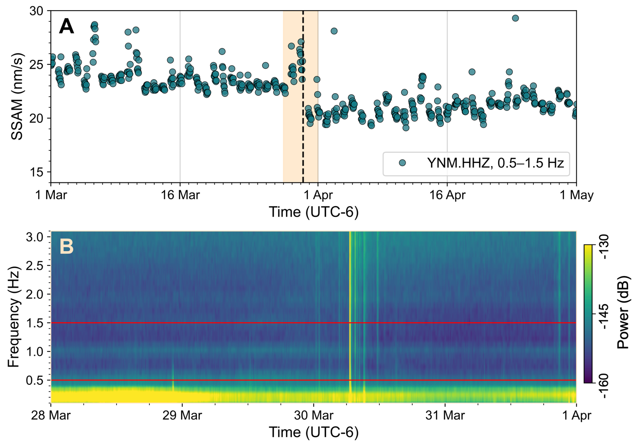
Figure S3: [A] SSAM calculated for vertical velocity at station YNM for March and April 2014. The M4.8 earthquake on 30 March 2014 is shown by the black dashed line. [B] Vertical velocity spectrogram over the time period corresponding to the light orange box in [A]. Power is clipped to -160 and -130 dB. The signal centered around 1 Hz does not shift frequency following the earthquake.

