**Supplementary material for**

**Alkali Activated materials from** **Tajogaite volcanic ash (La Palma, Spain): a green recovery after the 2021 eruption**

Occhipinti R.1, Portale S.1,2, Lanzafame G.1, Gimeno D.3, Kudrna Prasek M.4, Mazzoleni P.1, Barone G.1

1Dipartimento di Scienze Biologiche, Geologiche e Ambientali, Università degli studi di Catania, Italy.

2 Dipartimento di Scienze Umanistiche, Università degli studi di Catania, Italy

3 Departament de Mineralogia, Petrologia i Geologia Aplicada, Facultat de Ciències de la Terra, Universitat de Barcelona, Spain

4 Elettra-Sincrotrone Trieste S.C.p.A., Basovizza (Trieste), Italy

This supplementary material accompanies the article:  
  
Occhipinti, R., Portale, S., Lanzafame, G., Gimeno, D., Kudrna Prašek, M., Mazzoleni, P. and Barone, G. (2024) “Alkali Activated Materials from Tajogaite volcanic ash (La Palma, Spain): a green recovery after the 2021 eruption”, Volcanica, 7(2), pp. 717–731. doi: 10.30909/vol.07.02.717731.

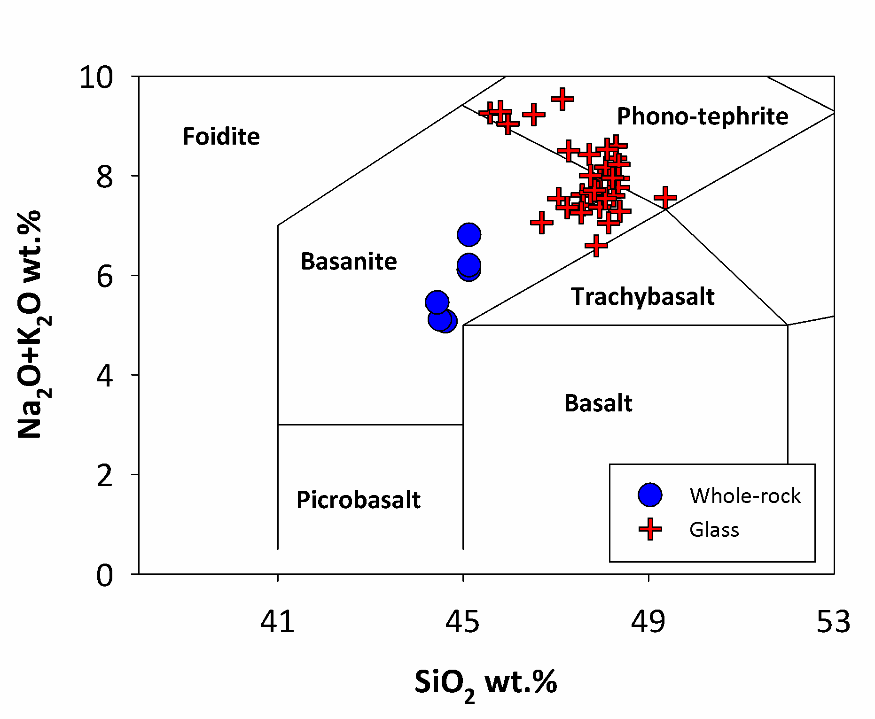

Fig. S1 – Results of the whole rock analysis by X-ray fluorescence on crushed ash samples (blue circles) and of the microchemical analysis by SEM-EDS of the glass of selected grains (red cross) reported in the Total Alkali vs SiO2 classification diagram of Le Maitre (2002).

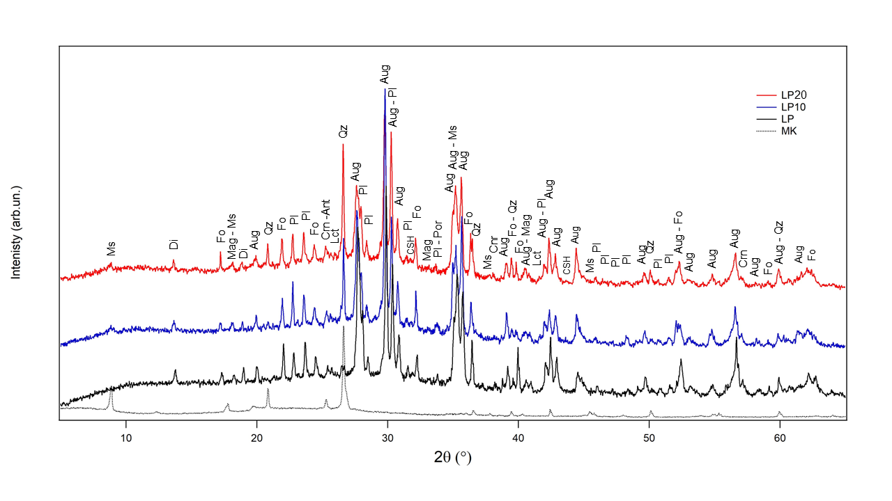

Fig. S2 – X-ray diffractograms of raw materials (LP and MK) and relative Alkali Activated Materials (LP10 and LP20). Ant = anatase; Aug = augite; Fo = forsterite; Mag = magnetite; Ms = muscovite; Pl = plagioclase; Qz = quartz; Tnat = thermonatrite.

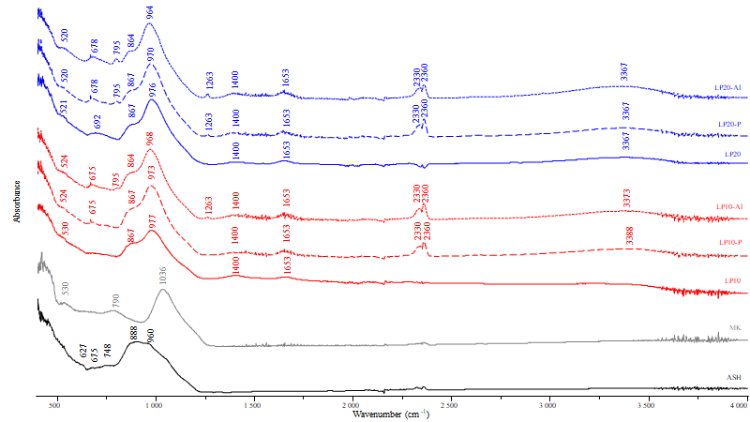

Fig. S3 – FTIR-ATR spectra of powdered raw materials (ASH and MK) and of alkali activated binders synthesized with 10-20 wt.% metakaolin (LP10 and LP20), [hydrogen peroxide](https://www.amazon.it/hydrogen-peroxide/s?k=hydrogen+peroxide) (LP10-P and LP20-P) and aluminium (LP10-Al and LP20-Al).

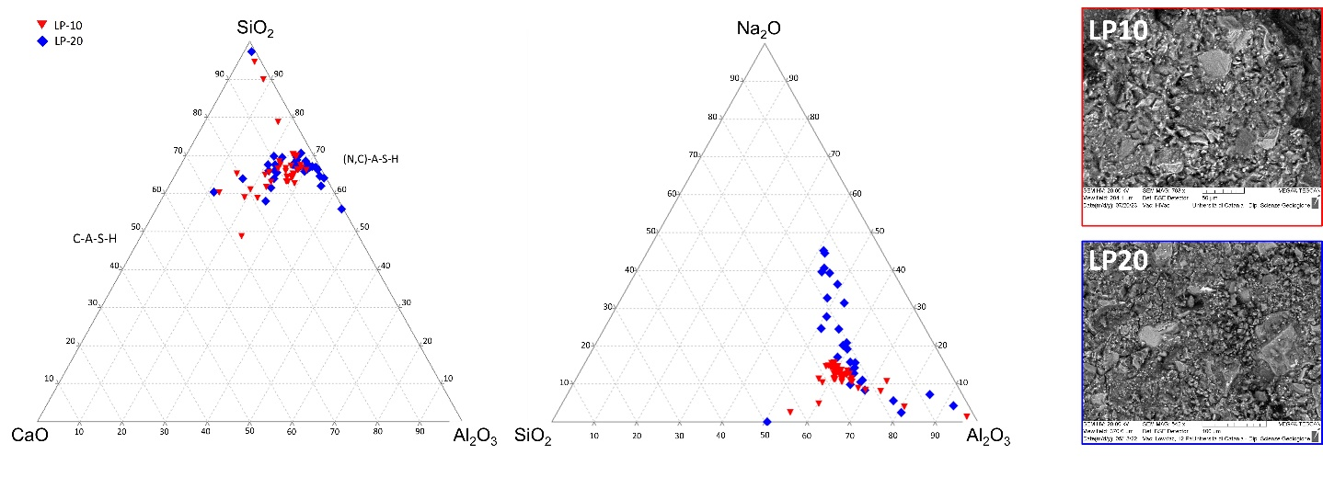

Fig. S4 – Results of SEM-EDS analyses of precipitated gels plotted in the CaO-SiO2-Al2O3 and SiO2-Al2O3-Na2O-ternary diagrams.

Fig. S5 – Electrical conductivity of the alkali activated binders LP10 (blue squares) and LP20 (red squares) over time.

|  |  |  |  |  |  |  |  |  |  |
| --- | --- | --- | --- | --- | --- | --- | --- | --- | --- |
| **Table S1 - Results of 3D analysis of pores on representative Volumes of Interest (VOIs) of the samples.** | | | | | | | | | |
|  | VOI (mm3) | Euler (mm-3) | Integ. Mean. Curv. (mm-2) | Spec. Surf. (mm-1) | Porosity (vol.%) | Pore density (#/mm-3) | Average Volume (mm3) | Sphericity | Aspect Ratio |
| LP10 | 13.82 | 6367 | 1033 | 11.66 | 6.41 | 6683 | 9.60E-06 | 0.74 | 0.21 |
| LP10-P | 13.82 | 4405 | 1024 | 16.74 | 23.69 | 5265 | 4.50E-05 | 0.75 | 0.21 |
| LP10-Al | 13.82 | 1018 | 602 | 14.76 | 61.54 | 2391 | 2.57E-04 | 0.77 | 0.22 |
| LP20 | 12.14 | 10188 | 1415 | 13.67 | 5.79 | 10597 | 5.46E-06 | 0.76 | 0.21 |
| LP20-P | 13.82 | 1650 | 798 | 16.97 | 51.39 | 3040 | 1.69E-04 | 0.76 | 0.22 |
| LP20-Al | 13.82 | 2044 | 546 | 15.02 | 48.35 | 2837 | 1.71E-04 | 0.78 | 0.24 |

|  |  |  |  |  |  |  |  |  |  |  |  |  |  |  |
| --- | --- | --- | --- | --- | --- | --- | --- | --- | --- | --- | --- | --- | --- | --- |
| **Table S2 - Results of SEM-EDS spot analysis on crystals and glass of the volcanic ash and Alkali activated material** | | | | | | | | | | | | | | |
| Plagioclase | | | | | | | | | | | | | | |
| Sample | Crystal type | Spot N. | SiO2 | TiO2 | Al2O3 | FeO | MnO | MgO | CaO | Na2O | K2O | P2O5 | Cr2O3 | NiO |
| LP1 | plg | 1 | 52.69 | 0.26 | 28.92 | 0.88 | 0.07 | 0.43 | 11.12 | 4.4 | 0.5 | n.d. | n.d. | n.d. |
| LP1 | plg | 2 | 51.94 | 0.47 | 28.51 | 1.66 | 0.14 | 0.63 | 11.47 | 4.2 | 0.39 | n.d. | n.d. | n.d. |
| LP1 | plg | 3 | 52.88 | 0.21 | 29.45 | 0.81 | n.d. | 0.33 | 11.23 | 4.27 | 0.39 | n.d. | n.d. | n.d. |
| LP1 | plg | 4 | 53.04 | 0.25 | 29.28 | 0.68 | n.d. | 0.27 | 11.13 | 4.46 | 0.44 | n.d. | n.d. | n.d. |
| LP1 | plg | 5 | 53.27 | 0.48 | 26.28 | 2.84 | 0.14 | 1.48 | 9.27 | 4.91 | 0.61 | n.d. | n.d. | n.d. |
| LP1 | plg | 6 | 52.78 | 0.3 | 29.23 | 0.77 | 0.06 | 0.3 | 11.19 | 4.28 | 0.44 | n.d. | n.d. | n.d. |
| LP1 | plg | 7 | 52.37 | 0.23 | 29.54 | 0.84 | 0.12 | 0.32 | 11.61 | 4.15 | 0.41 | n.d. | n.d. | n.d. |
| LP1 | plg | 8 | 53.53 | 0.11 | 29.19 | 0.69 | n.d. | 0.24 | 10.9 | 4.72 | 0.38 | n.d. | n.d. | n.d. |
| LP1 | plg | 9 | 53.38 | 0.34 | 28.26 | 0.83 | 0.06 | 0.53 | 10.44 | 4.97 | 0.59 | n.d. | n.d. | n.d. |
| LP1 | plg | 10 | 52.76 | 0.17 | 28.27 | 0.84 | n.d. | 0.69 | 12.1 | 4.36 | 0.38 | n.d. | n.d. | n.d. |
| LP1 | plg | 11 | 55.62 | 0.94 | 20.82 | 3.12 | 0.19 | 0.83 | 2.76 | 9.16 | 5.05 | n.d. | n.d. | n.d. |
| LP1 | plg | 12 | 52.17 | 0.33 | 29.48 | 1.02 | 0.05 | 0.36 | 11.87 | 3.89 | 0.41 | n.d. | n.d. | n.d. |
| LP1 | plg | 13 | 52.64 | 0.3 | 29.23 | 0.88 | 0.13 | 0.37 | 11.14 | 4.3 | 0.39 | n.d. | n.d. | n.d. |
| LP1 | plg | 14 | 52.51 | 0.31 | 29.29 | 0.95 | 0.05 | 0.37 | 11.46 | 4.1 | 0.43 | n.d. | n.d. | n.d. |
| LP1 | plg | 15 | 52.53 | 0.4 | 28.51 | 1.18 | 0.07 | 0.42 | 11.66 | 4.14 | 0.55 | n.d. | n.d. | n.d. |
| LP1 | plg | 16 | 52.66 | 0.32 | 28.89 | 1.02 | 0.12 | 0.36 | 11.13 | 4.52 | 0.44 | n.d. | n.d. | n.d. |
| LP1 | plg | 17 | 52.6 | 0.22 | 29.12 | 0.94 | 0.05 | 0.42 | 11.59 | 4.27 | 0.4 | n.d. | n.d. | n.d. |
| LP1 | plg | 18 | 52.47 | 0.49 | 28.71 | 1.12 | 0.15 | 0.36 | 11.25 | 4.2 | 0.54 | n.d. | n.d. | n.d. |
| LP1 | plg | 19 | 53.01 | 0.44 | 27.78 | 1.41 | n.d. | 0.6 | 11.58 | 4.25 | 0.51 | n.d. | n.d. | n.d. |
| LP1 | plg | 20 | 52.27 | 0.4 | 28.71 | 1 | 0.09 | 0.45 | 11.49 | 4.49 | 0.44 | n.d. | n.d. | n.d. |
| LP1 | plg | 21 | 52.64 | 0.4 | 28.94 | 0.95 | 0.1 | 0.28 | 11.11 | 4.49 | 0.48 | n.d. | n.d. | n.d. |
| LP2 | plg | 1 | 53.68 | 0.19 | 29.02 | 0.54 | n.d. | 0.21 | 11.2 | 4.56 | 0.41 | n.d. | n.d. | n.d. |
| LP2 | plg | 2 | 53.69 | 0.25 | 28.49 | 0.73 | 0.07 | 0.16 | 10.65 | 4.95 | 0.53 | n.d. | n.d. | n.d. |
| LP2 | plg | 3 | 53.7 | 0.34 | 28.29 | 0.92 | 0.05 | 0.27 | 10.59 | 4.76 | 0.52 | n.d. | n.d. | n.d. |
| LP2 | plg | 4 | 53.24 | 0.27 | 29 | 0.75 | n.d. | 0.19 | 11.31 | 4.64 | 0.39 | n.d. | n.d. | n.d. |
| LP2 | plg | 5 | 52.44 | 0.39 | 29.18 | 1.15 | 0.07 | 0.38 | 11.26 | 4.26 | 0.44 | n.d. | n.d. | n.d. |
| LP2 | plg | 6 | 52.41 | 0.26 | 29.35 | 0.96 | n.d. | 0.22 | 11.78 | 4.17 | 0.37 | n.d. | n.d. | n.d. |
| LP2 | plg | 7 | 53.6 | 0.33 | 28.67 | 0.86 | 0.06 | 0.27 | 10.74 | 4.71 | 0.46 | n.d. | n.d. | n.d. |
| LP2 | plg | 8 | 53.69 | 0.33 | 28.47 | 0.91 | 0.06 | 0.19 | 10.89 | 4.78 | 0.4 | n.d. | n.d. | n.d. |
| LP2 | plg | 9 | 53.54 | 0.33 | 28.78 | 0.8 | 0.13 | 0.22 | 10.79 | 4.59 | 0.48 | n.d. | n.d. | n.d. |
| LP2 | plg | 10 | 53.39 | 0.38 | 28.33 | 0.89 | 0.16 | 0.49 | 10.77 | 4.72 | 0.51 | n.d. | n.d. | n.d. |
| LP2 | plg | 11 | 54.33 | 1.49 | 20 | 5.58 | 0.24 | 1.08 | 3.77 | 8.62 | 4.17 | n.d. | n.d. | n.d. |
| LP2 | plg | 12 | 54.41 | 0.88 | 23.99 | 2.13 | 0.15 | 1.25 | 9.91 | 5.68 | 0.95 | n.d. | n.d. | n.d. |
| LP2 | plg | 13 | 50.8 | 1.23 | 24.25 | 2.86 | 0.17 | 1.95 | 12.7 | 4.55 | 0.72 | n.d. | n.d. | n.d. |
| LP2 | plg | 14 | 53.08 | 0.38 | 28.07 | 0.91 | 0.13 | 0.31 | 10.88 | 5.02 | 0.59 | n.d. | n.d. | n.d. |
| LP2 | plg | 15 | 53.09 | 0.37 | 28.23 | 0.95 | 0.11 | 0.4 | 10.62 | 5.07 | 0.61 | n.d. | n.d. | n.d. |
| LP2 | plg | 16 | 52.59 | 0.28 | 29.2 | 0.97 | 0.1 | 0.22 | 11.83 | 4.01 | 0.31 | n.d. | n.d. | n.d. |
| LP2 | plg | 17 | 52.92 | 0.33 | 28.51 | 0.79 | 0.07 | 0.34 | 11.29 | 4.52 | 0.52 | n.d. | n.d. | n.d. |
| LP2 | plg | 18 | 52.52 | 0.28 | 28.78 | 1 | 0.09 | 0.27 | 11.6 | 4.44 | 0.41 | n.d. | n.d. | n.d. |
| LP2 | plg | 19 | 52.61 | 0.59 | 28.38 | 1.33 | 0.13 | 0.25 | 11.11 | 4.72 | 0.48 | n.d. | n.d. | n.d. |
| LP2 | plg | 20 | 51.86 | 0.38 | 29.41 | 0.98 | 0.21 | 0.32 | 11.39 | 4.32 | 0.38 | n.d. | n.d. | n.d. |
| LP2 | plg | 21 | 53.59 | 0.36 | 28.14 | 1.15 | 0.08 | 0.24 | 10.22 | 5 | 0.54 | n.d. | n.d. | n.d. |
| LP2 | plg | 22 | 52.53 | 0.21 | 29.43 | 0.91 | 0.05 | 0.19 | 11.63 | 4.12 | 0.34 | n.d. | n.d. | n.d. |
| LP2 | plg | 23 | 52.7 | 0.41 | 28.71 | 1.23 | 0.15 | 0.3 | 10.88 | 4.7 | 0.59 | n.d. | n.d. | n.d. |
| LP2 | plg | 24 | 52.27 | 0.47 | 28.65 | 1.67 | n.d. | 0.46 | 11.06 | 4.52 | 0.52 | n.d. | n.d. | n.d. |
| LP2 | plg | 25 | 52.83 | 0.27 | 29.36 | 0.84 | n.d. | 0.29 | 11.22 | 4.51 | 0.38 | n.d. | n.d. | n.d. |
| LP2 | plg | 26 | 52.39 | 0.3 | 28.89 | 1.12 | 0.13 | 0.38 | 11.32 | 4.56 | 0.42 | n.d. | n.d. | n.d. |
| LP2 | plg | 27 | 52.87 | 0.42 | 28.69 | 0.98 | 0.15 | 0.21 | 11.07 | 4.51 | 0.45 | n.d. | n.d. | n.d. |
| LP2 | plg | 28 | 53.14 | 0.23 | 29.09 | 0.69 | n.d. | 0.32 | 11.15 | 4.57 | 0.36 | n.d. | n.d. | n.d. |
| Clinopyroxene | | | | | | | | | | | | | | |
| Sample | Crystal type | Spot N. | SiO2 | TiO2 | Al2O3 | FeO | MnO | MgO | CaO | Na2O | K2O | P2O5 | Cr2O3 | NiO |
| LP1 | cpx | 1 | 47.93 | 2.61 | 7.49 | 6.92 | 0.25 | 13.1 | 20.48 | 0.64 | 0.11 | n.d. | 0.07 | 0.22 |
| LP1 | cpx | 2 | 47.37 | 2.83 | 7.48 | 6.52 | 0.22 | 13.42 | 20.95 | 0.65 | 0.11 | n.d. | 0.24 | 0.08 |
| LP1 | cpx | 3 | 50.05 | 2.07 | 5.03 | 7.04 | 0.06 | 14.89 | 20.2 | 0.65 | n.d. | n.d. | n.d. | n.d. |
| LP1 | cpx | 4 | 46.74 | 3.21 | 8.27 | 6.68 | 0.19 | 12.96 | 20.34 | 0.61 | 0.11 | n.d. | 0.35 | 0.35 |
| LP1 | cpx | 5 | 48.06 | 2.71 | 6.85 | 6.78 | 0.22 | 13.97 | 19.62 | 0.67 | 0.14 | n.d. | 0.32 | 0.28 |
| LP1 | cpx | 6 | 49.16 | 2.49 | 5.33 | 6.91 | 0.23 | 14.52 | 20.24 | 0.54 | 0.13 | n.d. | 0.14 | 0.13 |
| LP1 | cpx | 7 | 47.01 | 3.04 | 8.2 | 6.71 | 0.09 | 13.07 | 20.48 | 0.74 | 0.1 | n.d. | 0.2 | 0.23 |
| LP1 | cpx | 8 | 50.46 | 1.97 | 4.82 | 6.21 | n.d. | 15.37 | 20.56 | 0.53 | 0.04 | n.d. | 0.05 | n.d. |
| LP1 | cpx | 9 | 45.99 | 3.41 | 8.45 | 6.78 | 0.18 | 12.74 | 20.73 | 0.5 | 0.21 | n.d. | 0.6 | 0.41 |
| LP1 | cpx | 10 | 48.77 | 2.49 | 5.62 | 6.8 | 0.16 | 14.15 | 20.93 | 0.62 | 0.12 | n.d. | 0.11 | 0.06 |
| LP1 | cpx | 11 | 47.23 | 3.61 | 7.08 | 7.36 | 0.26 | 12.91 | 20.38 | 0.69 | 0.17 | n.d. | 0.11 | 0.12 |
| LP2 | cpx | 1 | 47.06 | 3.73 | 7.75 | 7.37 | 0.15 | 12.7 | 20.34 | 0.44 | 0.09 | n.d. | 0.09 | 0.12 |
| LP2 | cpx | 2 | 46.75 | 3.09 | 7.86 | 7.44 | 0.09 | 12.9 | 21.14 | 0.48 | 0.12 | n.d. | 0.07 | 0.08 |
| LP2 | cpx | 3 | 45.8 | 3.47 | 8.01 | 7.16 | 0.3 | 12.86 | 20.89 | 0.56 | 0.16 | n.d. | 0.37 | 0.13 |
| LP2 | cpx | 4 | 49.92 | 1.84 | 4.68 | 6.45 | 0.15 | 15.36 | 20.55 | 0.59 | 0.13 | n.d. | 0.18 | 0.08 |
| LP2 | cpx | 5 | 47.37 | 2.73 | 6.97 | 6.78 | 0.27 | 13.65 | 20.83 | 0.7 | 0.09 | n.d. | 0.21 | 0.23 |
| LP2 | cpx | 6 | 47 | 2.72 | 7.61 | 6.78 | 0.2 | 13.44 | 20.74 | 0.7 | 0.15 | n.d. | 0.33 | 0.1 |
| LP2 | cpx | 7 | 47.21 | 2.54 | 7.17 | 7 | 0.27 | 13.32 | 21.09 | 0.74 | 0.04 | n.d. | 0.3 | 0.18 |
| LP2 | cpx | 8 | 46.18 | 3.31 | 8.19 | 7.05 | 0.11 | 13.08 | 20.61 | 0.8 | 0.07 | n.d. | 0.28 | 0.21 |
| LP2 | cpx | 9 | 47.12 | 2.65 | 7.06 | 6.88 | 0.22 | 13.84 | 20.77 | 0.68 | 0.07 | n.d. | 0.35 | 0.36 |
| LP2 | cpx | 10 | 50.19 | 1.72 | 4.73 | 6.39 | 0.17 | 15.12 | 20.46 | 0.59 | 0.11 | n.d. | 0.38 | 0.15 |
| LP2 | cpx | 11 | 49.71 | 2.25 | 5.09 | 7.39 | 0.29 | 13.98 | 19.87 | 0.58 | 0.22 | n.d. | 0.07 | 0.28 |
| LP2 | cpx | 12 | 45.87 | 3.2 | 8.08 | 7.39 | 0.17 | 13.05 | 20.91 | 0.78 | 0.14 | n.d. | 0.22 | 0.11 |
| LP2 | cpx | 13 | 45.2 | 3.73 | 9.03 | 7.25 | 0.15 | 12.71 | 20.64 | 0.74 | 0.12 | n.d. | 0.14 | 0.14 |
| LP5 | cpx | 1 | 49.42 | 2.51 | 4.92 | 7.3 | 0.23 | 14.17 | 20.27 | 0.59 | 0.17 | n.d. | 0.09 | 0.18 |
| LP5 | cpx | 2 | 46.69 | 3.32 | 7.78 | 7.37 | 0.07 | 12.75 | 21.02 | 0.55 | 0.07 | n.d. | 0.21 | 0.05 |
| LP5 | cpx | 3 | 44.54 | 4.26 | 8.94 | 7.75 | 0.17 | 12.02 | 20.85 | 0.78 | 0.12 | n.d. | 0.1 | 0.12 |
| LP5 | cpx | 4 | 48.03 | 2.45 | 6.8 | 8.11 | 0.07 | 12.03 | 20.97 | 1.16 | 0.09 | n.d. | 0.04 | n.d. |
| LP5 | cpx | 5 | 45.4 | 3.48 | 9 | 7.75 | 0.32 | 12.26 | 20.31 | 0.63 | 0.12 | n.d. | 0.17 | 0.24 |
| LP5 | cpx | 6 | 46.12 | 3.19 | 8.38 | 7.29 | 0.28 | 12.67 | 20.81 | 0.72 | 0.11 | n.d. | 0.23 | 0.13 |
| LP5 | cpx | 7 | 49.82 | 2.37 | 4.56 | 7.05 | 0.22 | 14.24 | 20.46 | 0.72 | 0.23 | n.d. | 0.05 | 0.16 |
| Olivine | | | | | | | | | | | | | | |
| Sample | Crystal type | Spot N. | SiO2 | TiO2 | Al2O3 | FeO | MnO | MgO | CaO | Na2O | K2O | P2O5 | Cr2O3 | NiO |
| LP1 | ol | 1 | 39.48 | 0.13 | n.d. | 14.74 | 0.34 | 44.03 | 0.31 | n.d. | n.d. | n.d. | n.d. | 0.32 |
| LP1 | ol | 2 | 39.39 | 0.16 | 0.11 | 15.47 | 0.34 | 42.91 | 0.44 | n.d. | n.d. | n.d. | n.d. | 0.36 |
| LP1 | ol | 3 | 39.65 | 0.19 | 0.17 | 15.13 | 0.26 | 43.28 | 0.4 | n.d. | n.d. | n.d. | n.d. | 0.33 |
| LP1 | ol | 4 | 39.78 | 0.2 | n.d. | 15.61 | 0.31 | 42.83 | 0.39 | n.d. | n.d. | n.d. | n.d. | 0.29 |
| LP1 | ol | 5 | 39.66 | 0.21 | 0.07 | 14.78 | 0.34 | 43.4 | 0.44 | n.d. | n.d. | n.d. | n.d. | 0.34 |
| LP2 | ol | 1 | 38.69 | 0.23 | n.d. | 17.79 | 0.46 | 41.23 | 0.48 | n.d. | n.d. | n.d. | n.d. | 0.28 |
| Ti-Fe Magnetite Oxide | | | | | | | | | | | | | | |
|  |  |  | SiO2 | TiO2 | Al2O3 | FeO | MnO | MgO | CaO | Na2O | K2O | P2O5 | Cr2O3 | NiO |
| LP1 | ox | 1 | 0.66 | 21.37 | 5.7 | 64.83 | 0.86 | 4.75 | 0.32 | n.d. | n.d. | n.d. | 0.76 | n.d. |
| LP1 | ox | 2 | 0.66 | 22.01 | 5.99 | 64.47 | 0.77 | 4.96 | 0.33 | n.d. | n.d. | n.d. | 0.21 | n.d. |
| LP1 | ox | 3 | 0.6 | 15.79 | 9.74 | 62.58 | 0.49 | 7.52 | 0.37 | n.d. | n.d. | n.d. | 2.23 | n.d. |
| LP1 | ox | 4 | 0.88 | 21.13 | 8.27 | 60.95 | 0.79 | 6.73 | 0.41 | n.d. | n.d. | n.d. | 0.09 | n.d. |
| LP1 | ox | 5 | 0.49 | 15.64 | 8.18 | 63.38 | 0.62 | 8.29 | 0.34 | n.d. | n.d. | n.d. | 2.28 | n.d. |
| LP1 | ox | 6 | 0.78 | 17.46 | 7.73 | 63.15 | 0.6 | 8.25 | 0.44 | n.d. | n.d. | n.d. | 0.34 | n.d. |
| LP1 | ox | 7 | 0.3 | 19.06 | 7.54 | 62.25 | 0.41 | 8.42 | 0.33 | n.d. | n.d. | n.d. | 1.59 | n.d. |
| LP1 | ox | 8 | 0.69 | 17 | 7.33 | 64.32 | 0.45 | 9.06 | 0.44 | n.d. | n.d. | n.d. | 0.13 | n.d. |
| LP1 | ox | 9 | 0.62 | 18.94 | 7.48 | 62.71 | 0.49 | 7.98 | 0.48 | n.d. | n.d. | n.d. | 0.17 | n.d. |
| LP2 | ox | 1 | 1.13 | 22.88 | 4.95 | 64.31 | 0.71 | 4.7 | 0.58 | n.d. | n.d. | n.d. | 0.13 | n.d. |
| LP2 | ox | 2 | 0.75 | 23.58 | 4.82 | 64.26 | 0.75 | 4.9 | 0.37 | n.d. | n.d. | n.d. | 0.11 | n.d. |
| LP2 | ox | 3 | 0.54 | 23.66 | 4.33 | 64.26 | 0.76 | 4.58 | 0.43 | n.d. | n.d. | n.d. | 1.18 | n.d. |
| LP2 | ox | 4 | 0.63 | 24.26 | 3.96 | 64.54 | 0.83 | 4.86 | 0.56 | n.d. | n.d. | n.d. | 0.12 | n.d. |
| LP2 | ox | 5 | 0.75 | 18.25 | 8.15 | 63.28 | 0.6 | 5.73 | 0.25 | n.d. | n.d. | n.d. | 2.59 | n.d. |
| LP2 | ox | 6 | 0.58 | 17.52 | 6.97 | 67.96 | 0.81 | 4.59 | 0.31 | n.d. | n.d. | n.d. | 0.43 | n.d. |
| LP2 | ox | 7 | 0.56 | 20.53 | 6.13 | 65.6 | 0.79 | 5.03 | 0.36 | n.d. | n.d. | n.d. | 0.19 | n.d. |
| LP2 | ox | 8 | 0.4 | 20.48 | 5.81 | 65.53 | 1.03 | 4.9 | 0.47 | n.d. | n.d. | n.d. | 0.46 | n.d. |
| LP2 | ox | 9 | 0.59 | 17.54 | 6.51 | 66.74 | 0.78 | 4.93 | 0.35 | n.d. | n.d. | n.d. | 2.05 | n.d. |
| Glass | | | | | | | | | | | | | | |
| Sample | Crystal type | Spot N. | SiO2 | TiO2 | Al2O3 | FeO | MnO | MgO | CaO | Na2O | K2O | P2O5 | Cr2O3 | NiO |
| LP1 | glass | 1 | 48.14 | 3.4 | 16.23 | 9.67 | 0.27 | 4.24 | 8.23 | 5.99 | 2.58 | 0.93 | 0.11 | 0.21 |
| LP1 | glass | 2 | 47.67 | 3.68 | 16.07 | 10.25 | 0.29 | 4.13 | 8.5 | 5.9 | 2.52 | 0.89 | n.d. | 0.11 |
| LP1 | glass | 3 | 42.83 | 1.92 | 8.67 | 13.81 | 0.41 | 22.1 | 4.71 | 2.54 | 1.67 | 0.94 | 0.1 | 0.3 |
| LP1 | glass | 4 | 47.76 | 3.53 | 15.62 | 9.41 | 0.29 | 4.69 | 9.11 | 5.49 | 2.44 | 1.27 | 0.16 | 0.23 |
| LP1 | glass | 5 | 48.03 | 3.76 | 15.68 | 9.81 | 0.32 | 4.33 | 8.41 | 5.62 | 2.34 | 1.41 | 0.08 | 0.22 |
| LP1 | glass | 6 | 48.13 | 3.38 | 15.99 | 9.81 | 0.2 | 4.23 | 8.41 | 5.9 | 2.42 | 1.21 | 0.18 | 0.15 |
| LP1 | glass | 7 | 47.97 | 3.41 | 16.33 | 9.58 | 0.28 | 4.13 | 8.82 | 5.93 | 2.22 | 1.11 | n.d. | 0.22 |
| LP1 | glass | 8 | 47.87 | 3.48 | 15.82 | 9.93 | 0.36 | 4.2 | 8.14 | 5.83 | 2.66 | 1.23 | 0.12 | 0.37 |
| LP1 | glass | 9 | 47.12 | 3.61 | 15.75 | 10.25 | 0.37 | 4.48 | 8.4 | 6 | 2.47 | 1.22 | 0.09 | 0.23 |
| LP1 | glass | 10 | 44 | 4.67 | 9.76 | 7.9 | 0.05 | 10.56 | 21.29 | 1.05 | 0.33 | 0.32 | n.d. | 0.07 |
| LP1 | glass | 11 | 46.74 | 3.43 | 7.51 | 7.23 | 0.21 | 13.49 | 20.13 | 0.74 | 0.05 | 0.08 | 0.11 | 0.28 |
| LP1 | glass | 12 | 48.28 | 3.32 | 16.24 | 9.98 | 0.16 | 4.35 | 8.36 | 5.84 | 2.37 | 0.93 | 0.05 | 0.11 |
| LP2 | glass | 1 | 45.8 | 3.75 | 14.83 | 12.29 | 0.23 | 5.12 | 7.79 | 4.92 | 4.09 | 0.82 | 0.15 | 0.21 |
| LP2 | glass | 2 | 46.53 | 3.33 | 15.51 | 10.13 | 0.1 | 5.17 | 9.01 | 7.36 | 1.87 | 1 | n.d. | n.d. |
| LP2 | glass | 3 | 49.26 | 3.28 | 16.93 | 10.46 | 0.16 | 3.15 | 8 | 5.53 | 2.01 | 1.01 | n.d. | 0.21 |
| LP2 | glass | 4 | 45.44 | 3.54 | 15.61 | 10.53 | 0.34 | 4.92 | 9.1 | 7.71 | 1.52 | 0.99 | 0.12 | 0.16 |
| LP2 | glass | 5 | 45.62 | 3.34 | 15.68 | 9.54 | 0.31 | 5.22 | 9.6 | 7.76 | 1.49 | 1.04 | 0.18 | 0.23 |
| LP2 | glass | 6 | 48.18 | 3.73 | 15.82 | 10.19 | 0.24 | 4.82 | 7.72 | 5.33 | 2.59 | 1.03 | 0.13 | 0.21 |
| LP2 | glass | 7 | 47.44 | 2.67 | 7.02 | 6.82 | 0.22 | 13.42 | 21.08 | 0.7 | 0.05 | 0.1 | 0.24 | 0.23 |
| LP2 | glass | 8 | 47 | 3.81 | 15.18 | 11.01 | 0.19 | 4.8 | 7.2 | 4.9 | 4.61 | 1.01 | 0.13 | 0.16 |
| LP5 | glass | 1 | 47.42 | 3.66 | 15.55 | 10.84 | 0.23 | 4.29 | 9.16 | 5.29 | 2.3 | 0.95 | 0.14 | 0.17 |
| LP5 | glass | 2 | 46.69 | 3.85 | 15.49 | 10.33 | n.d. | 4.82 | 10.76 | 5.05 | 2.01 | 0.99 | n.d. | n.d. |
| LP5 | glass | 3 | 47.46 | 3.67 | 15.94 | 10.64 | 0.23 | 4.28 | 9.02 | 5.09 | 2.3 | 1.11 | 0.12 | 0.14 |
| LP5 | glass | 4 | 47.86 | 3.63 | 15.8 | 10.97 | 0.25 | 4.11 | 8.53 | 5.19 | 2.48 | 1.09 | 0.06 | 0.04 |
| LP5 | glass | 5 | 47.94 | 3.7 | 16.08 | 10.66 | 0.14 | 4.19 | 8.81 | 4.99 | 2.38 | 1.1 | n.d. | n.d. |
| LP5 | glass | 6 | 48.34 | 3.62 | 16.14 | 10.1 | 0.19 | 4.29 | 8.82 | 5.05 | 2.23 | 1.14 | n.d. | 0.08 |
| LP5 | glass | 7 | 48.28 | 3.63 | 16.04 | 9.92 | 0.14 | 4.23 | 8.73 | 5.3 | 2.45 | 1.15 | 0.04 | 0.08 |
| LP5 | glass | 8 | 48.25 | 3.55 | 16.06 | 10.32 | 0.08 | 4.26 | 8.81 | 5.23 | 2.36 | 1.08 | n.d. | n.d. |
| LP5 | glass | 9 | 48.21 | 3.72 | 16.08 | 10.18 | 0.17 | 4.18 | 8.34 | 5.44 | 2.51 | 1.14 | 0.03 | n.d. |
| LP5 | glass | 10 | 47.67 | 3.62 | 16.14 | 10.34 | 0.3 | 4.32 | 8.64 | 5.21 | 2.44 | 1.16 | 0.04 | 0.11 |
| LP5 | glass | 11 | 47.45 | 3.53 | 16.07 | 10.84 | 0.28 | 4.36 | 8.98 | 4.6 | 2.64 | 1.05 | 0.07 | 0.12 |
| LP5 | glass | 12 | 46.94 | 3.6 | 15.86 | 11.1 | 0.33 | 4.48 | 8.95 | 5.24 | 2.28 | 0.97 | n.d. | 0.25 |
| LP5 | glass | 13 | 47.94 | 3.59 | 15.9 | 10.9 | 0.24 | 4.21 | 8.77 | 4.78 | 2.74 | 0.68 | n.d. | 0.24 |
| LP5 | glass | 14 | 45.95 | 4.43 | 13.7 | 13.31 | 0.17 | 5.21 | 10.43 | 4.35 | 1.36 | 1.04 | 0.05 | n.d. |
| LP5 | glass | 15 | 47.7 | 3.53 | 16.95 | 10.74 | 0.25 | 4.39 | 8.48 | 4.31 | 2.26 | 1.04 | 0.14 | 0.2 |
| LP5 | glass | 16 | 47.72 | 3.78 | 15.8 | 10.66 | 0.33 | 4.43 | 8.51 | 5.16 | 2.53 | 0.85 | 0.07 | 0.17 |
| LP5 | glass | 17 | 47.04 | 3.86 | 14.32 | 12.02 | 0.31 | 5.04 | 8.44 | 4.81 | 2.52 | 1.2 | 0.21 | 0.21 |
| LP5 | glass | 18 | 45.85 | 4.1 | 16.28 | 11.55 | 0.28 | 4.68 | 11.55 | 3.62 | 0.62 | 1.37 | n.d. | 0.09 |
| LP5 | glass | 19 | 47.57 | 3.51 | 16.25 | 10.3 | 0.25 | 4.36 | 8.6 | 5.75 | 2.22 | 0.82 | 0.09 | 0.27 |
| LP5 | glass | 20 | 47.98 | 3.56 | 16.31 | 10.62 | 0.28 | 3.82 | 9.29 | 4.68 | 2.35 | 0.8 | 0.16 | 0.16 |
| Alkali Activated Materials | | | | | | | | | | | | | | |
| Sample | Crystal type | Spot N. | SiO2 | TiO2 | Al2O3 | FeO | MnO | MgO | CaO | Na2O | K2O | P2O5 | Cr2O3 | NiO |
| LP10 | Amph | 1 | 12.79 | 4.78 | 6.15 | 57.03 | 1.84 | 2.44 | 7.23 | 6.21 | 1.09 | 0.43 | n.d. | n.d. |
| LP10 | Amph | 2 | 48.76 | 3.2 | 10.74 | 6.37 | n.d. | 10.64 | 15.02 | 3.55 | 0.38 | 1.34 | n.d. | n.d. |
| LP10 | Amph | 3 | 38.53 | 0.38 | 1.48 | 20.35 | 0.53 | 36.16 | 0.58 | 1.79 | 0.07 | 0.12 | n.d. | n.d. |
| LP10 | Amph | 4 | 45.54 | 3.51 | 9.43 | 7.8 | 0.3 | 11.49 | 20.37 | 1.43 | 0.12 | n.d. | n.d. | n.d. |
| LP10 | Amph | 5 | 41.46 | 0.34 | 3.7 | 17.03 | 0.42 | 32.52 | 0.78 | 3.49 | 0.26 | n.d. | n.d. | n.d. |
| LP10 | Amph | 6 | 51.66 | 1.26 | 19.03 | 3.73 | 0.26 | 1.65 | 2.8 | 17.96 | 1.28 | 0.35 | n.d. | n.d. |
| LP10 | Amph | 7 | 52.68 | 1.55 | 18.58 | 3.59 | 0.06 | 1.44 | 3.45 | 17.07 | 1.24 | 0.34 | n.d. | n.d. |
| LP10 | Amph | 8 | 44.95 | 4.43 | 14.81 | 15.37 | 0.35 | 1.82 | 8.62 | 7.01 | 2.32 | 0.32 | n.d. | n.d. |
| LP10 | Amph | 9 | 46.64 | 4.45 | 14.96 | 12.23 | 0.32 | 1.19 | 9.9 | 7.68 | 2.42 | 0.21 | n.d. | n.d. |
| LP10 | Amph | 10 | 50.42 | 2.17 | 16.59 | 6.49 | 0.33 | 3.27 | 6.45 | 12.46 | 1.19 | 0.63 | n.d. | n.d. |
| LP10 | Amph | 11 | 35.81 | 5.08 | 13.14 | 21.58 | 2.28 | 4.07 | 7.73 | 7.45 | 2.39 | 0.45 | n.d. | n.d. |
| LP10 | Amph | 12 | 42.07 | 4.59 | 17.44 | 17.85 | 0.39 | 1.61 | 2.58 | 12.27 | 0.89 | 0.31 | n.d. | n.d. |
| LP10 | Amph | 13 | 54.36 | 1.67 | 19.24 | 4.39 | n.d. | 1.3 | 3.41 | 13.83 | 1.42 | 0.38 | n.d. | n.d. |
| LP10 | Amph | 14 | 47.4 | 3.14 | 16.66 | 9.1 | 0.2 | 4.42 | 7.05 | 9.47 | 1.8 | 0.76 | n.d. | n.d. |
| LP10 | Amph | 15 | 21.23 | 1.71 | 7.34 | 52.29 | 4.2 | 1.68 | 3.99 | 7.56 | n.d. | n.d. | n.d. | n.d. |
| LP10 | Amph | 16 | 52.42 | 2.58 | 20.05 | 7.15 | 0.35 | 1.2 | 5.02 | 7.93 | 3.19 | 0.11 | n.d. | n.d. |
| LP10 | Amph | 17 | 37.4 | 5.85 | 12.01 | 20.45 | 1.75 | 0.92 | 13.77 | 4.52 | 2.84 | 0.5 | n.d. | n.d. |
| LP10 | Amph | 18 | 49.43 | 2.87 | 16.91 | 8.4 | 0.31 | 2.33 | 6.41 | 11.01 | 1.72 | 0.61 | n.d. | n.d. |
| LP10 | Amph | 19 | 34.23 | 5.51 | 12.8 | 23.97 | 0.75 | 1.63 | 10.68 | 7.27 | 2.42 | 0.73 | n.d. | n.d. |
| LP10 | Amph | 20 | 2.39 | 6.52 | 2.34 | 74.82 | 6.14 | n.d. | 7.26 | n.d. | 0.53 | n.d. | n.d. | n.d. |
| LP10 | Amph | 21 | 34.64 | 2.65 | 12.51 | 7.65 | 0.5 | 2.09 | 5.74 | 32.37 | 1.38 | 0.46 | n.d. | n.d. |
| LP10 | Amph | 22 | 37.97 | 2.05 | 12.52 | 7.39 | 0.3 | 1.33 | 4.13 | 32.64 | 1.44 | 0.23 | n.d. | n.d. |
| LP10 | Amph | 23 | 38.33 | 1.9 | 14.86 | 3.69 | 0.23 | 1.05 | 2.52 | 34.85 | 2.25 | 0.33 | n.d. | n.d. |
| LP10 | Amph | 24 | 33.28 | 2.64 | 10.91 | 7.53 | 0.26 | 1.73 | 5.08 | 36.47 | 1.53 | 0.56 | n.d. | n.d. |
| LP10 | Amph | 25 | 34.05 | 3.7 | 13.41 | 13.07 | 0.45 | 2.56 | 7.94 | 23.03 | 1.63 | 0.16 | n.d. | n.d. |
| LP10 | Amph | 26 | 40.19 | 3.18 | 14.9 | 11.53 | 0.41 | 2.55 | 7.79 | 17.92 | 1.29 | 0.24 | n.d. | n.d. |
| LP10 | Amph | 27 | 34.61 | 3.13 | 14.77 | 13.62 | 0.4 | 2.64 | 10.25 | 19.05 | 1.26 | 0.27 | n.d. | n.d. |
| LP10 | Amph | 28 | 33.03 | 2.64 | 10.71 | 7.95 | 0.31 | 1.48 | 6.28 | 35.24 | 1.8 | 0.55 | n.d. | n.d. |
| LP10 | Amph | 29 | 43.07 | 2.48 | 12.79 | 6.98 | 0.2 | 1.26 | 5.85 | 25.49 | 1.59 | 0.28 | n.d. | n.d. |
| LP10 | Amph | 30 | 37.35 | 2.85 | 11.28 | 9.86 | 0.35 | 1.83 | 6.6 | 27.76 | 1.77 | 0.35 | n.d. | n.d. |
| LP20 | Amph | 1 | 52.75 | 2.04 | 22.11 | 4.86 | 0.17 | 1.78 | 4.33 | 10.56 | 1.07 | 0.32 | n.d. | n.d. |
| LP20 | Amph | 2 | 51.71 | 1.95 | 21.71 | 6.25 | 0.17 | 3.37 | 4.37 | 9.26 | 1.2 | n.d. | n.d. | n.d. |
| LP20 | Amph | 3 | 52.04 | 2.59 | 22.07 | 5.09 | 0.22 | 1.52 | 6.1 | 9.03 | 1.19 | 0.15 | n.d. | n.d. |
| LP20 | Amph | 4 | 51.99 | 1.28 | 24.06 | 3.36 | 0.08 | 1.43 | 6.68 | 9.87 | 0.92 | 0.33 | n.d. | n.d. |
| LP20 | Amph | 5 | 53.72 | 1.75 | 24.33 | 3.73 | 0.12 | 1.47 | 2.76 | 10.91 | 1.01 | 0.19 | n.d. | n.d. |
| LP20 | Amph | 6 | 44.75 | 3.05 | 18.93 | 11.38 | 0.54 | 2.27 | 6.9 | 10.3 | 1.6 | 0.28 | n.d. | n.d. |
| LP20 | Amph | 7 | 46.09 | 2.53 | 19.76 | 9.89 | 0.25 | 2.63 | 5.82 | 11.41 | 1.33 | 0.29 | n.d. | n.d. |
| LP20 | Amph | 8 | 52.92 | 1.29 | 22.57 | 3.28 | 0.03 | 2.06 | 3.37 | 13.31 | 0.73 | 0.42 | n.d. | n.d. |
| LP20 | Amph | 9 | 51.11 | 2.08 | 21.38 | 6.06 | 0.14 | 1.99 | 5.63 | 10.21 | 1.22 | 0.2 | n.d. | n.d. |
| LP20 | Amph | 10 | 48.99 | 2.89 | 20.09 | 8.23 | 0.26 | 1.84 | 6.7 | 9.45 | 1.28 | 0.28 | n.d. | n.d. |
| LP20 | Amph | 11 | 47.87 | 2.56 | 20.47 | 8.73 | 0.22 | 2.41 | 5.59 | 10.29 | 1.55 | 0.31 | n.d. | n.d. |
| LP20 | Amph | 12 | 44.86 | 3.11 | 19.38 | 10.22 | 0.57 | 2.58 | 6.64 | 10.65 | 1.62 | 0.38 | n.d. | n.d. |
| LP20 | Amph | 13 | 49.48 | 2.75 | 20.95 | 7.55 | 0.32 | 1.93 | 5.22 | 9.77 | 1.81 | 0.23 | n.d. | n.d. |
| LP20 | Amph | 14 | 47.69 | 2.83 | 19.55 | 7.91 | 0.28 | 2.62 | 6.72 | 10.89 | 1.51 | n.d. | n.d. | n.d. |
| LP20 | Amph | 15 | 50.15 | 1.35 | 18.47 | 7.71 | 0.17 | 9.6 | 3.08 | 8.38 | 0.93 | 0.16 | n.d. | n.d. |
| LP20 | Amph | 16 | 52.07 | 1.96 | 22.02 | 5.02 | 0.15 | 2.01 | 4.14 | 11.25 | 1.08 | 0.3 | n.d. | n.d. |
| LP20 | Amph | 17 | 49.28 | 2.61 | 18.34 | 7.6 | 0.09 | 3.24 | 5.94 | 10.16 | 2.03 | 0.7 | n.d. | n.d. |
| LP20 | Amph | 18 | 49.73 | 2.42 | 19.1 | 6.47 | 0.12 | 3.98 | 6.42 | 10.26 | 1.07 | 0.43 | n.d. | n.d. |
| LP20 | Amph | 19 | 42.5 | 0.93 | 9.22 | 13.44 | 0.23 | 24.67 | 2.03 | 6.42 | 0.5 | 0.06 | n.d. | n.d. |
| LP20 | Amph | 20 | 44.41 | 3.89 | 16.37 | 12.03 | 0.33 | 2.52 | 9.4 | 8.22 | 2.26 | 0.57 | n.d. | n.d. |
| LP20 | Amph | 21 | 45 | 4.2 | 14.27 | 8.44 | 0.2 | 6.83 | 14.15 | 5.63 | 0.86 | 0.41 | n.d. | n.d. |
| LP20 | Amph | 22 | 42.96 | 4.39 | 15.84 | 13.66 | 0.49 | 2.16 | 10.41 | 7.56 | 2.11 | 0.43 | n.d. | n.d. |
| LP20 | Amph | 23 | 40.23 | 0.11 | 0.72 | 13.85 | 0.26 | 43.57 | 0.4 | 0.67 | 0.08 | 0.1 | n.d. | n.d. |
| LP20 | Amph | 24 | 52.9 | 0.82 | 23.46 | 2.53 | 0.11 | 1.82 | 2.85 | 14.47 | 0.81 | 0.23 | n.d. | n.d. |
| LP20 | Amph | 25 | 54 | 1.61 | 24.7 | 4.71 | 0.13 | 1.04 | 2.56 | 10.2 | 1.06 | n.d. | n.d. | n.d. |
| LP20 | Amph | 26 | 52.06 | 1.68 | 21.94 | 4.89 | 0.08 | 2.14 | 4.2 | 10.78 | 1.4 | 0.83 | n.d. | n.d. |
| LP20 | Amph | 27 | 54.39 | 0.62 | 25.29 | 1.96 | 0.05 | 1.12 | 1.43 | 13.65 | 0.94 | 0.55 | n.d. | n.d. |
| LP20 | Amph | 28 | 53.41 | 0.81 | 24.44 | 1.92 | 0.09 | 1.24 | 1.89 | 14.53 | 1.05 | 0.61 | n.d. | n.d. |
| LP20 | Amph | 29 | 54.27 | 0.74 | 24.83 | 2.26 | 0.09 | 1.07 | 2.27 | 13.2 | 1.01 | 0.27 | n.d. | n.d. |
| LP20 | Amph | 30 | 51.08 | 0.36 | 19.37 | 5.95 | 0.09 | 9.19 | 1.91 | 11.26 | 0.65 | 0.14 | n.d. | n.d. |
| LP20 | Amph | 31 | 53.73 | 0.46 | 28.68 | 1.69 | 0.16 | 1.14 | 1.21 | 9.85 | 3.07 | n.d. | n.d. | n.d. |
| LP20 | Amph | 32 | 45.83 | 3.95 | 17.91 | 12.68 | 0.27 | 3.09 | 3.39 | 9.32 | 2.65 | 0.9 | n.d. | n.d. |
| LP20 | Amph | 33 | 52.85 | 1.11 | 30.55 | 2.46 | 0.17 | 0.91 | 1.9 | 4.49 | 5.42 | 0.15 | n.d. | n.d. |
| LP20 | Amph | 34 | 55.54 | 0.75 | 24.81 | 2.15 | 0.12 | 0.54 | 2.37 | 12.56 | 1.06 | 0.1 | n.d. | n.d. |
| LP20 | Amph | 35 | 50.75 | 2.48 | 19.78 | 6.24 | 0.29 | 2.79 | 4.56 | 10.24 | 2.12 | 0.75 | n.d. | n.d. |
| LP20 | Amph | 36 | 56.68 | 1.68 | 21.44 | 4.01 | 0.19 | 1.07 | 3.44 | 9.83 | 1.48 | 0.17 | n.d. | n.d. |
| LP20 | Amph | 37 | 55.82 | 0.74 | 23.55 | 2.8 | 0.08 | 1.84 | 2.06 | 11 | 1.66 | 0.45 | n.d. | n.d. |
| LP20 | Amph | 38 | 52.35 | 0.73 | 40.79 | 1.69 | 0.15 | 0.38 | 0.36 | 2.71 | 0.83 | n.d. | n.d. | n.d. |
| LP20 | Amph | 39 | 52.11 | 1.62 | 23.77 | 4.12 | 0.11 | 1.57 | 3.28 | 11.37 | 1.76 | 0.28 | n.d. | n.d. |
| LP20 | Amph | 40 | 53.75 | 1.25 | 23.71 | 2.37 | 0.08 | 0.98 | 2 | 14.6 | 0.86 | 0.4 | n.d. | n.d. |
| LP20 | Amph | 41 | 54.79 | 1.2 | 25.38 | 3.26 | 0.42 | 1.02 | 1.51 | 10.76 | 1.65 | n.d. | n.d. | n.d. |
| LP20 | Amph | 42 | 55.13 | 0.07 | 30.49 | 0.92 | n.d. | 0.4 | 0.39 | 11.38 | 1.07 | 0.15 | n.d. | n.d. |
| LP20 | Amph | 43 | 54.57 | 0.83 | 26.1 | 1.31 | n.d. | 0.81 | 0.9 | 14.43 | 0.69 | 0.36 | n.d. | n.d. |
| LP20 | Amph | 44 | 54.05 | 1.02 | 26.66 | 1.45 | 0.09 | 0.54 | 0.73 | 14.17 | 0.96 | 0.33 | n.d. | n.d. |
| LP20 | Amph | 45 | 47.84 | 2.62 | 12.24 | 4.37 | 0.26 | 12.01 | 14.82 | 5.49 | 0.18 | 0.17 | n.d. | n.d. |
| LP20 | Amph | 46 | 46.06 | 3.24 | 8.69 | 7.83 | 0.24 | 9.46 | 21.57 | 2.4 | 0.29 | 0.22 | n.d. | n.d. |
| LP20 | Amph | 47 | 48.77 | 2.89 | 16.98 | 7.99 | 0.29 | 5.48 | 8.21 | 6.62 | 1.82 | 0.94 | n.d. | n.d. |
| plg = plagioclase; cpx=clinopyroxene; ol=olivine; ox=Ti-Fe magnetite oxide; amph=amorphous phase in the AAM matrix; n.d. = not detected | | | | | | | | | |  |  |  |  |  |