This Supplementary Material (1 of 6) accompanies the article:

Fox, J. M., Watson, S. J., Falloon, T. J., Carey, R. J., Whittaker, J. M., Spain, E. A., Duncan, R. A., Arculus, R. J. and Coffin, M. F. (2025) “Volcanic landslide post Last Glacial Maximum at sub-Antarctic Heard Island, southern Indian Ocean ”, *Volcanica*, 8(1), pp. 31–50. doi: 10.30909/vol.08.01.3150.

Fox et al. (2025) should be cited if these materials are used independently of the article.

J. M. Fox1,2, S. J. Watson3,4, T. J. Falloon5, R. J. Carey5,J.M.Whittaker, E. A. Spain3, R. A. Duncan6, R. J. Arculus7, and M.F. Coffin1,8,9

1Institute for Marine and Antarctic Studies, University of Tasmania, Hobart, Australia

2National Museum of Nature and Science, Tsukuba, Japan

3National Institute of Water and Atmospheric Research, Wellington, New Zealand

4 Institute of Marine Science, University of Auckland, Auckland, New Zealand

5Centre for Ore Deposits and Earth Science, University of Tasmania, Hobart, Australia

6College of Earth, Ocean, and Atmospheric Sciences, Oregon State University, Corvallis, OR 97331, USA

7Research School of Earth Sciences, Australian National University, Canberra, Australia

8School of Earth and Climate Sciences, University of Maine, Orono, ME 04469, USA,

9Geology & Geophysics, Woods Hole Oceanographic Institution, Woods Hole, MA 02543, USA.

Corresponding author: [jodi.fox@utas.edu.au](mailto:jodi.fox@utas.edu.au)

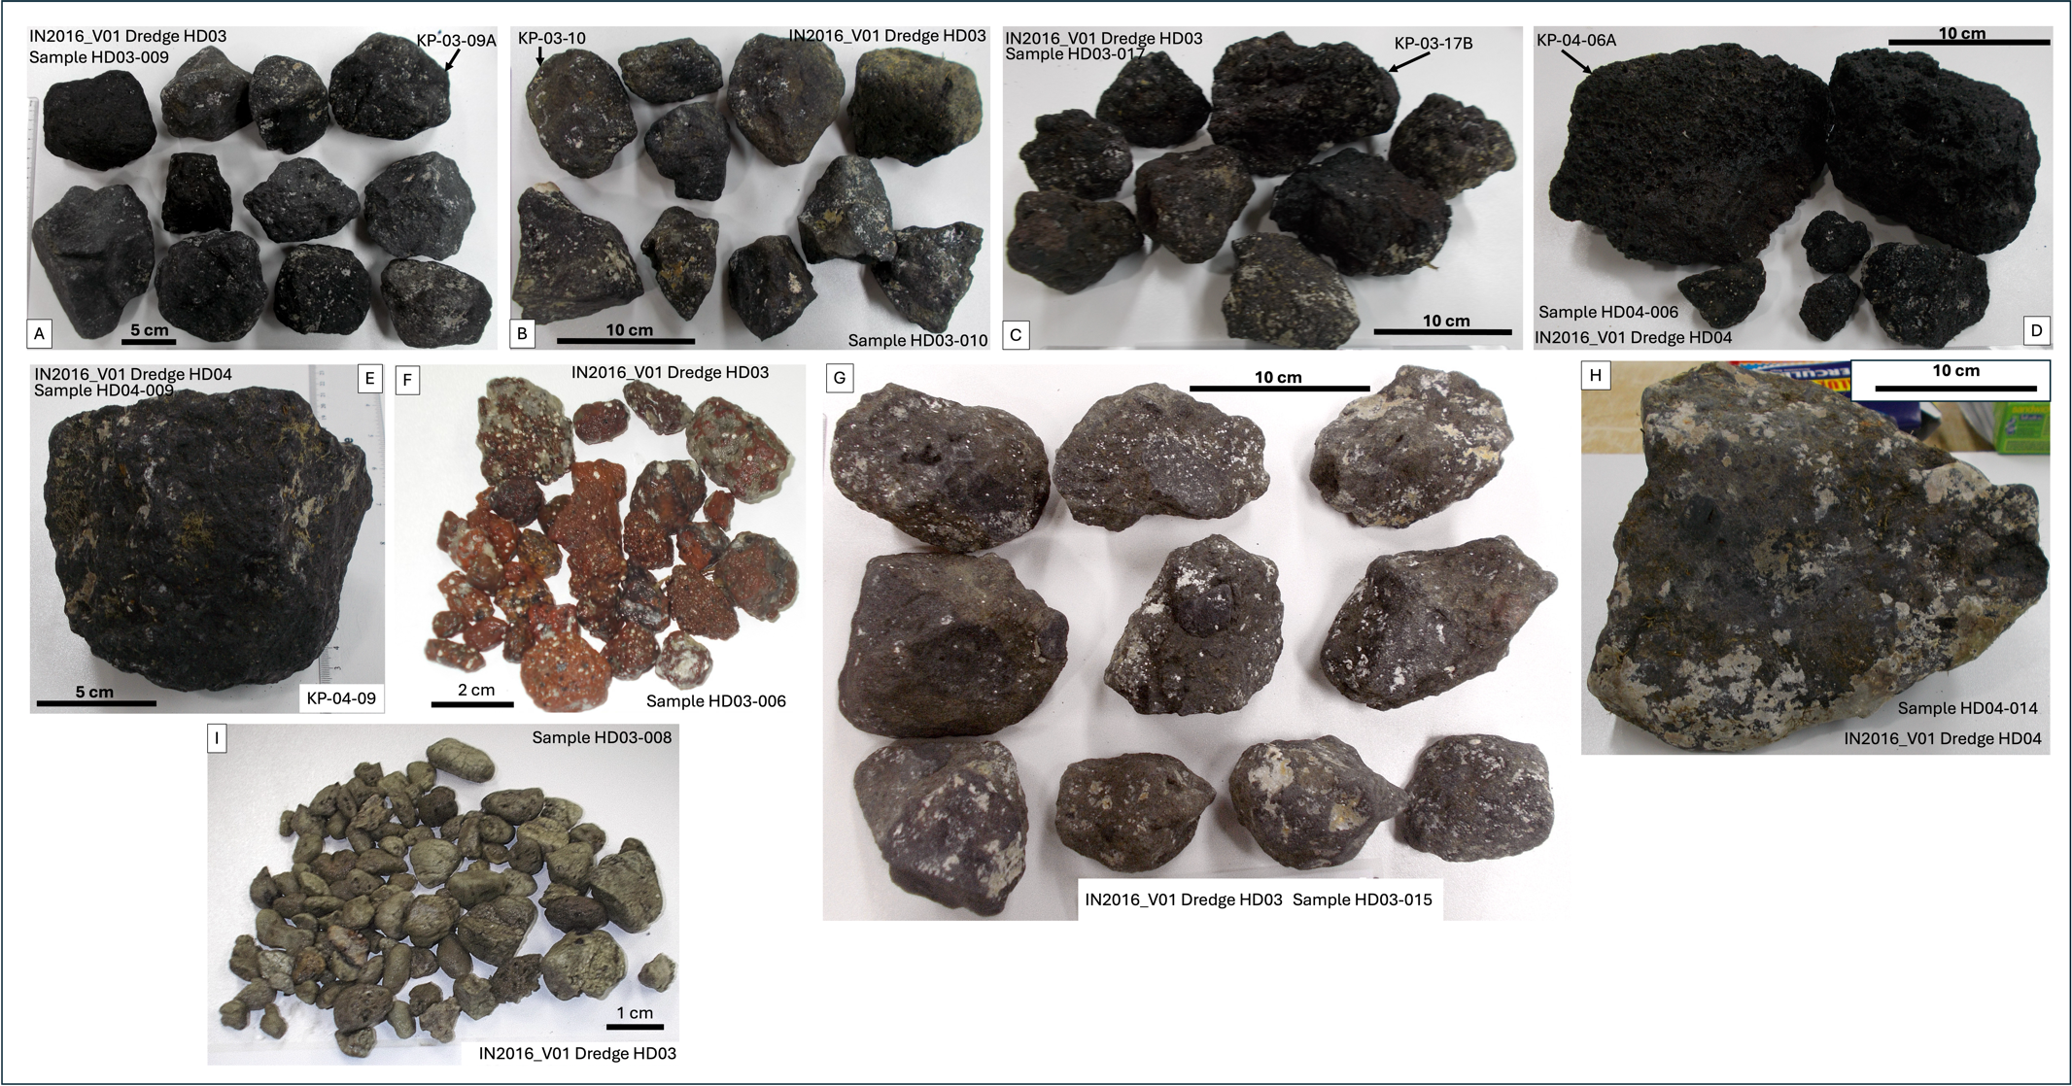

**Figure S1.** Selected samples from IN2016_V01 dredges HD03 and HD04. HDXX-XXX numbers are the field sample numbers for groups of samples of similar texture and lithology determined macroscopically. KP-XX-XXX numbers are the laboratory numbers for single samples analysed as part of this project. **A.** Alkali basalt. **B.** Trachybasalt. **C.** Basanite. **D.** Vesicular trachybasalt. **E.** Trachybasalt. **F.** Red vesicular basalt. **G.** Basaltic volcaniclastic breccia. **H.** Basaltic volcaniclastic breccia. **I.** Grey-green pumice.

S1. Summary of XRF analysis (X-Ray Fluorescence Analysis) technique at Earth Sciences - CODES, School of Physical Sciences, University of Tasmania**.**

**Analytical Apparatus**

# Instrument: PANalytical Axios Advanced X-Ray Spectrometer

X-Ray Tubes: 4kW max. Rh anode end window.

Elements analysed: F, Na, Mg, Al, Si, P, S, K, Ca, Ti, Mn, Fe, and trace elements Sc, V, Cr, Co, Ni, Cu, Zn, Ga, Ge, As, Se, Br, Rb, Sr, Y, Zr, Nb, Mo, Ag, Cd, Sn, Sb, Te, I, Ba, La, Ce, Nd, W, Tl, Pb, Bi, Th, and U.

3kW max. Au anode end window.

Elements analysed: extra sensitivity for Sc, Ba, La, Ce, Nd, Sb, Sn, Ag, Cd, Te.

Crystals: PX-10, LiF 220, PX-1 (for F, Na, and Mg), curved PE002, curved Ge111

Collimators: Coarse (0.7mm), fine (0.3mm) and high resolution (0.15mm)

Detectors: Gas flow proportional counter with P10 gas (10% methane in

argon), sealed Xe Duplex, and Scintillation Counter.

Sample Changer: PANalytical X-Y sample changer with capacity for 96 fusion discs and 64 pills.

# Sample Preparation

Major Elements: 32mm fusion discs prepared at 1100°C in 5%Au/95%Pt crucibles

0.500g sample, 4.500g 12-22 Flux (Lithium Tetraborate-Metaborate mix), 0.0606g LiNO3 for silicates. Platinum/5% gold moulds used for cooling.

Sulphide bearing samples have a different mix with more LiNO3 as oxidising agent and the mix is pre-ignited at 700°C for 10 minutes. Ore samples and ironstones use 12/22 flux and a higher flux/sample ratio. Dolomites and limestones need pure lithium tetraborate as a flux. Iodine vapour is used as a releasing agent to remove discs from the mould.

Trace Elements: 32mm diameter pressed powder pills (10g, 3.5 tonnes/cm-2), Sample Binder PVP-MC.

# Corrections

Corrections for mass absorption are calculated using PANalytical Super-Q software with its Classic calibration model and alpha coefficients. In house inter-element corrections are also applied. PANalytical ProTrace and Compton scattering can also be used for many trace elements.

# Calibration

Pure element oxide mixes in pure silica, along with International and Tasmanian reference rocks are used. Numerous checks of reference rocks and pure silica blanks are run with each program.

**References**

Robinson, P. (2003). XRF analysis of flux-fused discs. *Geoanalysis 2003,* *The 5th International Conference on the Analysis of Geological and Environmental Materials*, *Abstracts*, 90.

Watson, J.S. (1996). Fast, Simple Method of Powder Pellet Preparation for X-Ray Fluorescence Analysis. *X-Ray Spectrometry, 25,* 173-174.