This Supplementary Material (2 of 6) accompanies the article:

Fox, J. M., Watson, S. J., Falloon, T. J., Carey, R. J., Whittaker, J. M., Spain, E. A., Duncan, R. A., Arculus, R. J. and Coffin, M. F. (2025) “Volcanic landslide post Last Glacial Maximum at sub-Antarctic Heard Island, southern Indian Ocean ”, *Volcanica*, 8(1), pp. 31–50. doi: 10.30909/vol.08.01.3150.

Fox et al. (2025) should be cited if these materials are used independently of the article.

J. M. Fox1,2, S. J. Watson3,4, T. J. Falloon5, R. J. Carey5,J.M.Whittaker, E. A. Spain3, R. A. Duncan6, R. J. Arculus7, and M.F. Coffin1,8,9

1Institute for Marine and Antarctic Studies, University of Tasmania, Hobart, Australia

2National Museum of Nature and Science, Tsukuba, Japan

3National Institute of Water and Atmospheric Research, Wellington, New Zealand

4 Institute of Marine Science, University of Auckland, Auckland, New Zealand

5Centre for Ore Deposits and Earth Science, University of Tasmania, Hobart, Australia

6College of Earth, Ocean, and Atmospheric Sciences, Oregon State University, Corvallis, OR 97331, USA

7Research School of Earth Sciences, Australian National University, Canberra, Australia

8School of Earth and Climate Sciences, University of Maine, Orono, ME 04469, USA,

9Geology & Geophysics, Woods Hole Oceanographic Institution, Woods Hole, MA 02543, USA.

Corresponding author: [jodi.fox@utas.edu.au](mailto:jodi.fox@utas.edu.au)

S2. ICPMS trace elements analysis in CODES, School of Physical Sciences (Earth Sciences), University of Tasmania (modified after P. Robinson by E. Lounejeva, August 2017)

**Digestion**

100.00 ± 0.05 mg of rock powder was dissolved in a mixture of inorganic acids (HF:H2SO4=3:3) at 180°C in closed PTFE vessels in Digestion Acid System (DAS, PicoTrace®). The mixture was then evaporated to dryness. Solid residuals were dissolved in HClO4, evaporated, re-dissolved in HNO3 and then diluted to 100.000 ± 0.050 ml. The resulting final solution contained the completely dissolved sample diluted 1000 times in a weak acid (2v/v% HNO3), 10 μg/ml of a mixture of Rh, In, and Re as internal standard and traces of HF added to stabilize Ta and Nb. Digestion reagents blanks and international standards were processed along samples. All the solutions were then analysed by inductively coupled plasma mass spectrometry (ICP-MS) on an Agilent®-7700x instrument within 48 hours of dilution. Calibration of the instrument involved high purity standards solutions (CHOICE Analytical ®) for quantification and for estimation of isobaric interferences from Ba, Ce, Nd, Pr, and Zr, all prepared in the same matrix. Multi-elemental calibration solutions were prepared at concentrations 5, 10 and 20 μg/ml.

**Data reduction and Quality control**

Mass-spectral data were collected as counts per second using Mass Hunter (Agilent ®) software and reduced through home-developed spread sheet (CODES, UTAS) using Excel Software (Microsoft Corporation ®). Reduction includes corrections by isobaric interferences, background and digestion procedure blank contribution, instrumental drift, and dilution. Quantification includes a secondary correction by linear regression on three standard referenced materials (SRM), namely TASGRAN, TASBAS and AGV-1. The overall analytical uncertainty was estimated for each analysis (see report). In addition, the data quality, precision, and accuracy can be estimated on replicates for the analysed unknown samples and a very well-known SRM, basalt BCR-2, as it has a similar matrix to the analysed samples.

**Elements analysed**

Li, Be, Sc, Ti, V , Cr, Mn, Co, Ni, Cu, Zn, As, Rb, Sr, Y , Zr, Nb, Mo, Ag, Cd, Sn, Sb, Te, Cs, Ba, REE (La, Ce, Pr, Nd, Sm, Eu, Gd, Tb, Dy, Ho, Er, Tm, Yb, Lu), Hf, Ta, W , Tl, Pb, Bi, Th, U

**Reagents used:**

Seastar BASELINE high purite grade (Seastar Chemicals Inc, USA), Type-I Mili-Q ultra-pure water (Merk Millipore), and high purity standards (HPS) (CHOICE Analytical).

**Environment for Sample preparation:**

Clean lab class ISO5.

**References:**

Agilent http://www.agilent.com/about/companyinfo/

CHOICE Analytical http://choiceanalytical.com.au/standards-and-crms/high-purity-standards/

GEOREM http://georem.mpch-mainz.gwdg.de/sample_query_pref.asp.

PicoTrace http://www.picotrace.de/products-das.html

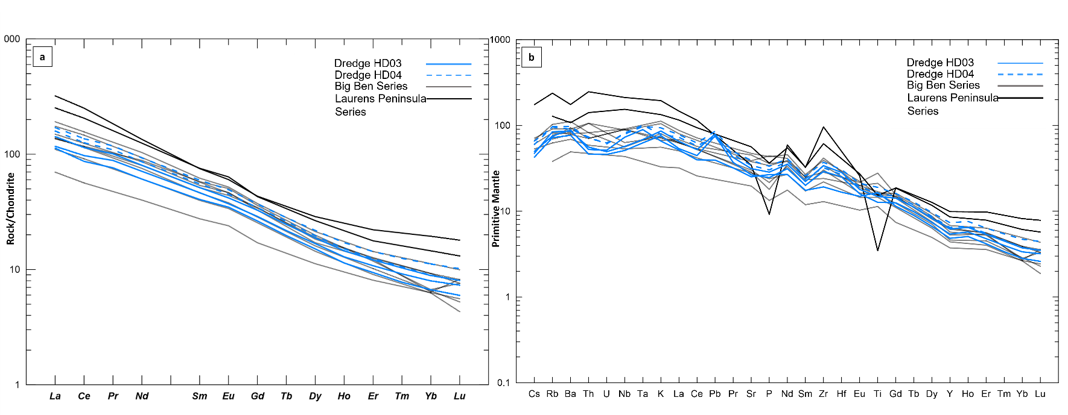

**Figure S2**. **a.** Chondrite normalised REE patterns of the dredged lavas compared to Heard Island lavas **b.** Primitive mantle normalised diagrams of the dredged lavas compared to Heard Island lavas, primitive mantle values from Sun and McDonough, 1989. Big Ben Series and Laurens Peninsula Series data from Barling et al., 1994.