This Supplementary Material (4 of 6) accompanies the article:

Fox, J. M., Watson, S. J., Falloon, T. J., Carey, R. J., Whittaker, J. M., Spain, E. A., Duncan, R. A., Arculus, R. J. and Coffin, M. F. (2025) “Volcanic landslide post Last Glacial Maximum at sub-Antarctic Heard Island, southern Indian Ocean ”, *Volcanica*, 8(1), pp. 31–50. doi: 10.30909/vol.08.01.3150.

Fox et al. (2025) should be cited if these materials are used independently of the article.

J. M. Fox1,2, S. J. Watson3,4, T. J. Falloon5, R. J. Carey5,J.M.Whittaker, E. A. Spain3, R. A. Duncan6, R. J. Arculus7, and M.F. Coffin1,8,9

1Institute for Marine and Antarctic Studies, University of Tasmania, Hobart, Australia

2National Museum of Nature and Science, Tsukuba, Japan

3National Institute of Water and Atmospheric Research, Wellington, New Zealand

4 Institute of Marine Science, University of Auckland, Auckland, New Zealand

5Centre for Ore Deposits and Earth Science, University of Tasmania, Hobart, Australia

6College of Earth, Ocean, and Atmospheric Sciences, Oregon State University, Corvallis, OR 97331, USA

7Research School of Earth Sciences, Australian National University, Canberra, Australia

8School of Earth and Climate Sciences, University of Maine, Orono, ME 04469, USA,

9Geology & Geophysics, Woods Hole Oceanographic Institution, Woods Hole, MA 02543, USA.

Corresponding author: [jodi.fox@utas.edu.au](mailto:jodi.fox@utas.edu.au)

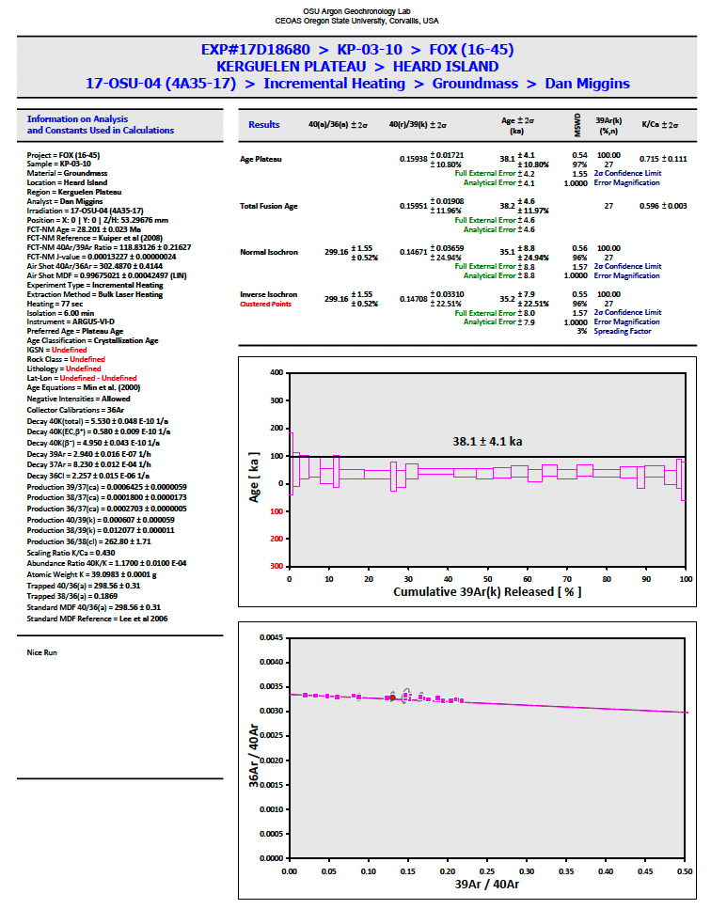S4 40Ar/39Ar Geochronology Result Summaries

