**This supplementary material accompanies the article:**

Scarrow, J. H., Pankhurst, M. J., Barbee, O. A., Chamberlain, K. J., Morgan, D. J., Longpré, M.-A., Tramontano, S., Hickey, J., Neave, D. A., Rollinson, G. K., Stewart, A. G., Wieser, P. E., Coldwell, B. C., Hernández, W., D’Auria, L. and Pérez, N. M. (2024) “Decoding links between magmatic processes and eruption dynamics: whole-rock time series petrology of the 2021 Tajogaite eruption, La Palma”, *Volcanica*, 7(2), pp. 953–980. doi: 10.30909/vol.07.02.953980.

**Mantle melting calculations**

Forward mantle melting models were performed using the fractional melting equation, as described by Shaw (1970), to determine the likely mantle source region for primitive magmas from Tajogaite 2021. Three melting scenarios were explored for spinel lherzolite, spinel-garnet lherzolite and garnet lherzolite sources at different degrees of trace element enrichment/depletion (Fig. S1). Mineral modes and reaction coefficients for spinel lherzolite melting are calculated using the major element composition of the MM-3 peridotite (Falloon et al., 2008) and pMELTS (Ghiorsoet al., 2002), see Table S1. Calculations were performed at 1 GPa and at oxygen fugacities equivalent to the FMQ buffer. The initial mineral modes are those calculated when the melt fraction (F) is zero using pMELTS and the mineral modes of the residue were used to calculate the reaction coefficients during progressive melting using polynomial regressions. Mineral modes and reaction coefficients for garnet lherzolite melting are calculated from the 3 GPa experiments of Walter (1998). Mineral modes were parameterised as a function of F using polynomial regressions and used to calculate the reaction coefficients during progressive melting. For spinel-garnet lherzolite melting, garnet was added to the spinel lherzolite melting model in the same proportions as the garnet melting model and normalised to 100%. The trace element composition of the depleted mid-ocean ridge mantle (Workman and Hart, 2008) and a hypothetical enriched mantle composition are used. The enriched mantle composition was calculated by mixing a low degree fractional melt of the DMM source (1%) with the bulk DMM source at a ratio of 95:5.

**Figure 1:** Mantle melting model outputs – note the similarity between selected lava compositions from all stages, parallel patterns, and the match with low-degree melting of enriched mantle, the lavas are fractionated, ~6-9 wt% MgO, from mantle melts which increases rare earth element concentrations.

|  |  |  |  |  |  |
| --- | --- | --- | --- | --- | --- |
| Kd | Olivine | OPX | CPX | Spinel | Garnet |
| La | 0.0004(*39*) | 0.0007(*40*) | 0.0550(*41*) | 0.0100(*39*) | 0.0100(*39*) |
| Ce | 0.0005(*39*) | 0.0015(*40*) | 0.0876(*41*) | 0.0100(*39*) | 0.0210(*39*) |
| Pr | 0.0010(*39*) | 0.0030(*40*) | 0.1318(*41*) | 0.0100(*39*) | 0.0540(*39*) |
| Nd | 0.0010(*39*) | 0.0055(*40*) | 0.1878(*41*) | 0.0100(*39*) | 0.0870(*39*) |
| Sm | 0.0013(*39*) | 0.0143(*40*) | 0.3083(*41*) | 0.0100(*39*) | 0.2170(*39*) |
| Eu | 0.0010(*39*) | 0.0204(*40*) | 0.3638(*41*) | 0.0100(*39*) | 0.3200(*39*) |
| Gd | 0.0015(*39*) | 0.0281(*40*) | 0.4169(*41*) | 0.0100(*39*) | 0.4980(*39*) |
| Tb | 0.0015(*39*) | 0.0376(*40*) | 0.4645(*41*) | 0.0100(*39*) | 0.7500(*39*) |
| Dy | 0.0016(*39*) | 0.0487(*40*) | 0.5034(*41*) | 0.0100(*39*) | 1.0600(*39*) |
| Ho | 0.0016(*39*) | 0.0601(*40*) | 0.5294(*41*) | 0.0100(*39*) | 1.5300(*39*) |
| Er | 0.0015(*39*) | 0.0714(*40*) | 0.5437(*41*) | 0.0100(*39*) | 2.0000(*39*) |
| Tm | 0.0015(*39*) | 0.0819(*40*) | 0.5482(*41*) | 0.0100(*39*) | 3.0000(*39*) |
| Yb | 0.0015(*39*) | 0.0913(*40*) | 0.5453(*41*) | 0.0100(*39*) | 4.0300(*39*) |
| Lu | 0.0015(*39*) | 0.0995(*40*) | 0.5373(*41*) | 0.0100(*39*) | 5.5000[(*39*) |

**Extended Data Table 1**. Partition coefficients used in the mantle melting modeling procedure.

**References**

Falloon, T. J., Green, D. H., Danyushevsky, L. V. & McNeill, A. W. The composition of near-solidus partial melts of fertile peridotite at 1 and 1·5 GPA: Implications for the petrogenesis of Morb. *Journal of Petrology* **49,** 591–613 (2008).

Ghiorso, M. S., Hirschmann, M. M., Reiners, P. W. & Kress, V. C. The PMELTS: A revision of melts for improved calculation of phase relations and major element partitioning related to partial melting of the mantle to 3 GPA. *Geochemistry, Geophysics, Geosystems* **3,** 1–35 (2002).

Shaw, D. M. Trace element fractionation during anatexis. *Geochimica et Cosmochimica Acta* **34,** 237–243 (1970).

Walter, M. J. Melting of garnet peridotite and the origin of komatiite and depleted lithosphere. *Journal of Petrology* **39,** 29–60 (1998).

Workman, R. K. & Hart, S. R. Major and trace element composition of the depleted MORB mantle (DMM). *Earth and Planetary Science Letters* **231,** 53–72 (2005).

**––**

**Extended Data Figure 3A.** Lava CAN-LLP-0003, QEMSCAN® map quantifies mineralogy and illustrates textures. Section is 3.90 cm long.

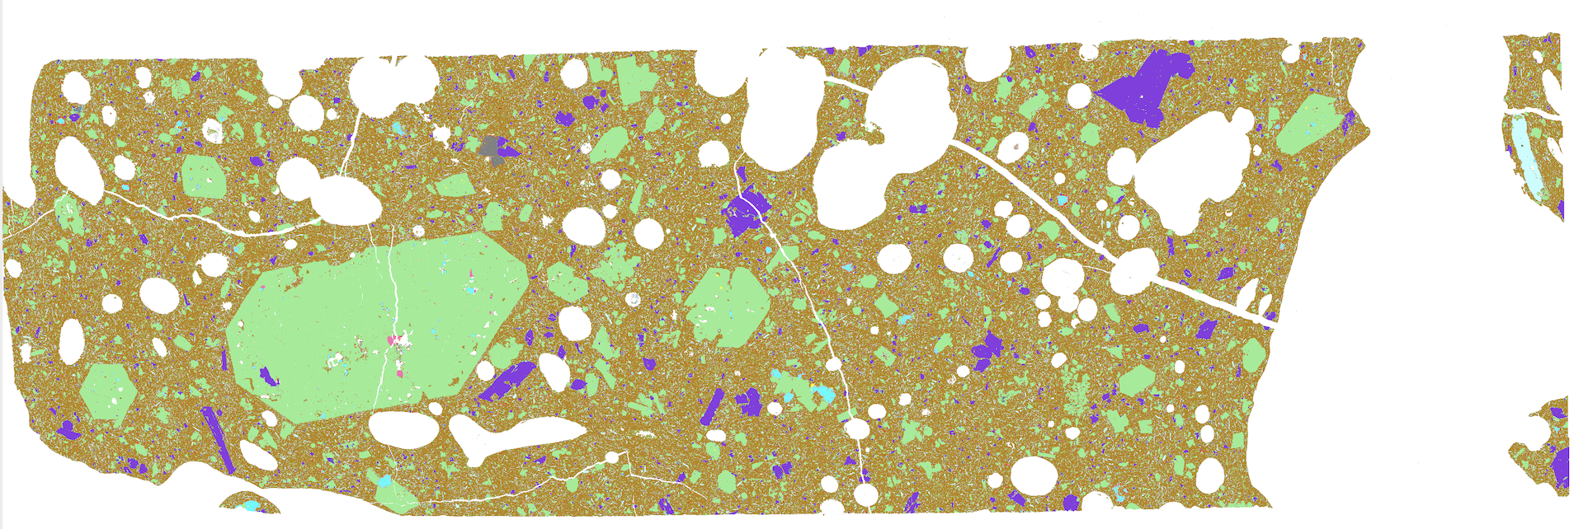

**Extended Data Figure 3B.** Lava CAN-LLP-0016, QEMSCAN® map quantifies mineralogy and illustrates textures. Section is 3.7 cm long.