Supplementary Material accompanying the article:
Roche, B., Caudron, C., van der Laat, L., de Moor, J. M., Avard, G., Pacheco, J., Bakkar, H., Govoorts, J. and Rodriguez, A. (2025) “First hydroacoustic recording of ebullition events in an active volcanic lake – Poás, Costa Rica”, Volcanica, 8(1), pp. 225–239. doi: 10.30909/vol/bzas2042.
* ben.john.rooche@ulb.be [corresponding author]

ORCiD: 0000-0002-0730-2947
Keywords: Active Volcanoes, Monitoring Techniques, Bubbles, Hydroacoustic, Phreatic Eruption, Degassing

Table S1. A table of the values used as part of the passive acoustic inversion process.

Passive Acoustic Flux Inversion Settings
Water Depth | 2 m
Temperature | 50 C
Salinity | 1 ppt
Hydrophone Range | 25 m
Hydrophone Sensitivity | -170 dBV/uPa
Minimum Inversion Frequency | 1600 Hz
Maximum Inversion Frequency | 4000 Hz
Section Duration (Flux Sample Rate) | 5 min

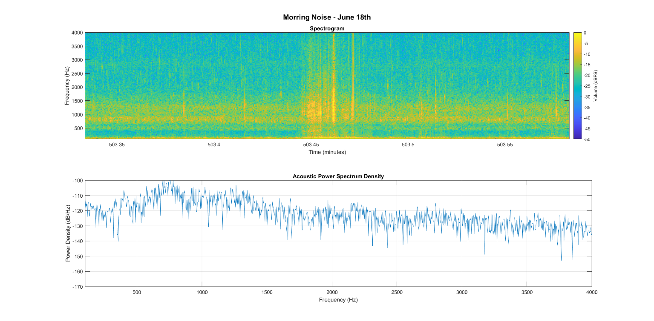
Figure S1. A spectrogram and acoustic power spectrum graph showing an example of mooring noise, June 18th between 08:23:20 and 08:23:35

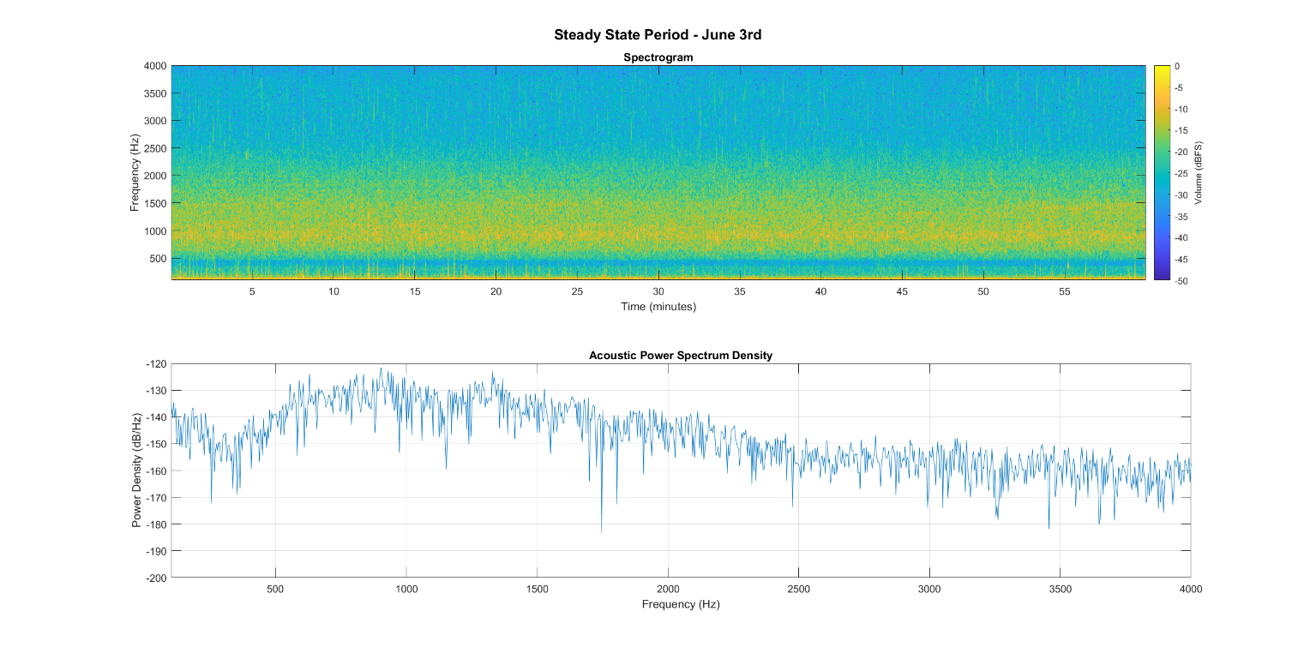
Figure S2. A spectrogram and acoustic power spectrum graph from the steady state period, June 3rd between 00:00 and 01:00

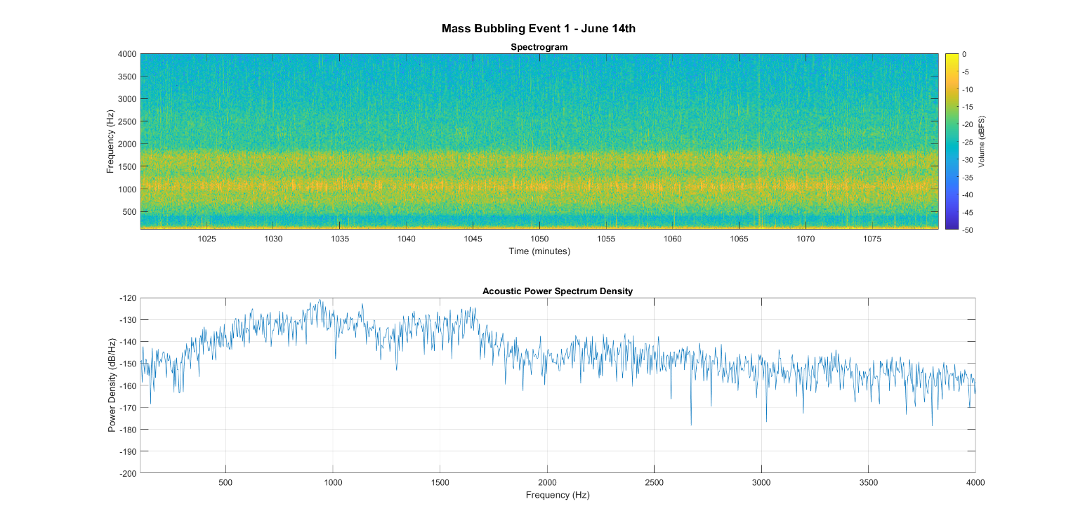
Figure S3. A spectrogram and acoustic power spectrum graph from the first mass bubbling event, June 14th between 17:00 and 18:00

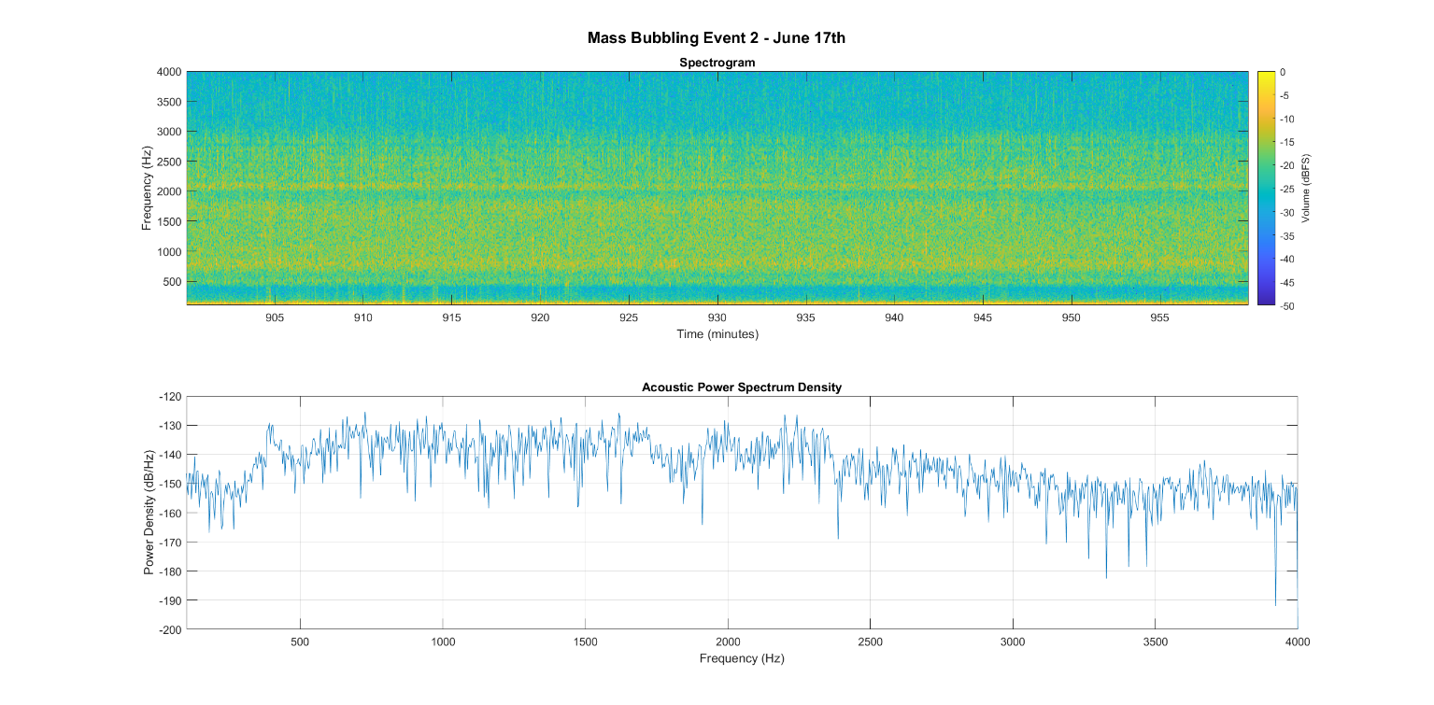
Figure S4. A spectrogram and acoustic power spectrum graph from the second mass bubbling event, June 17th between 15:00 and 16:00

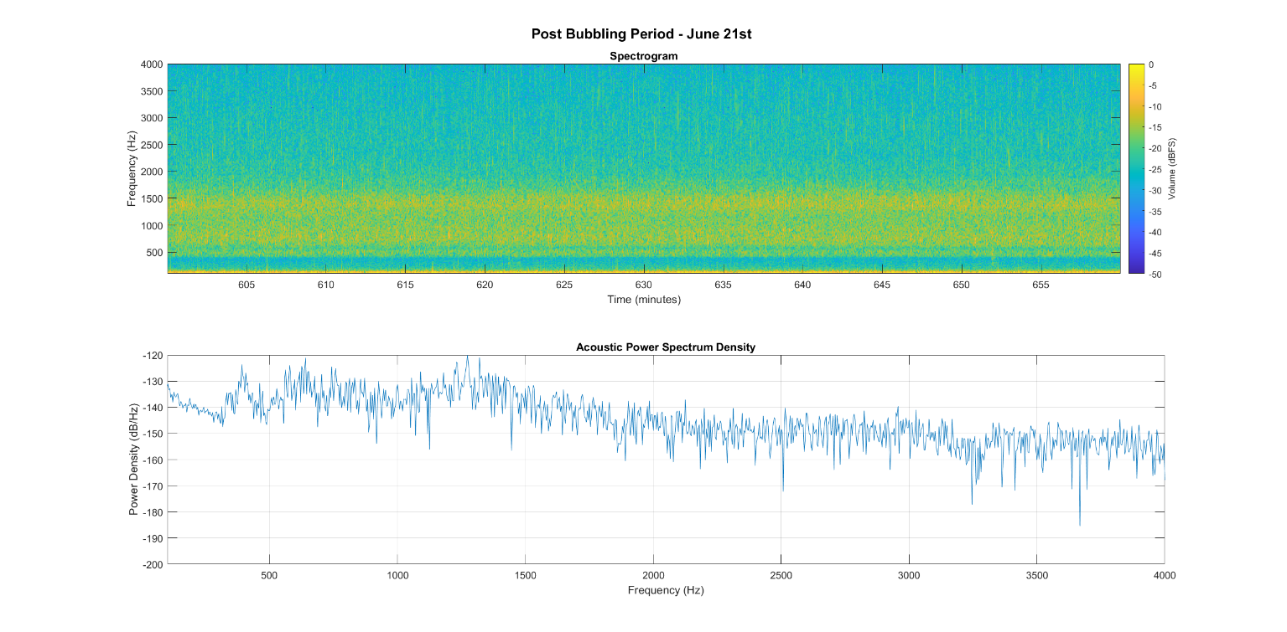
Figure S5. A spectrogram and acoustic power spectrum graph from the post release period, June 21th between 10:00 and 11:00

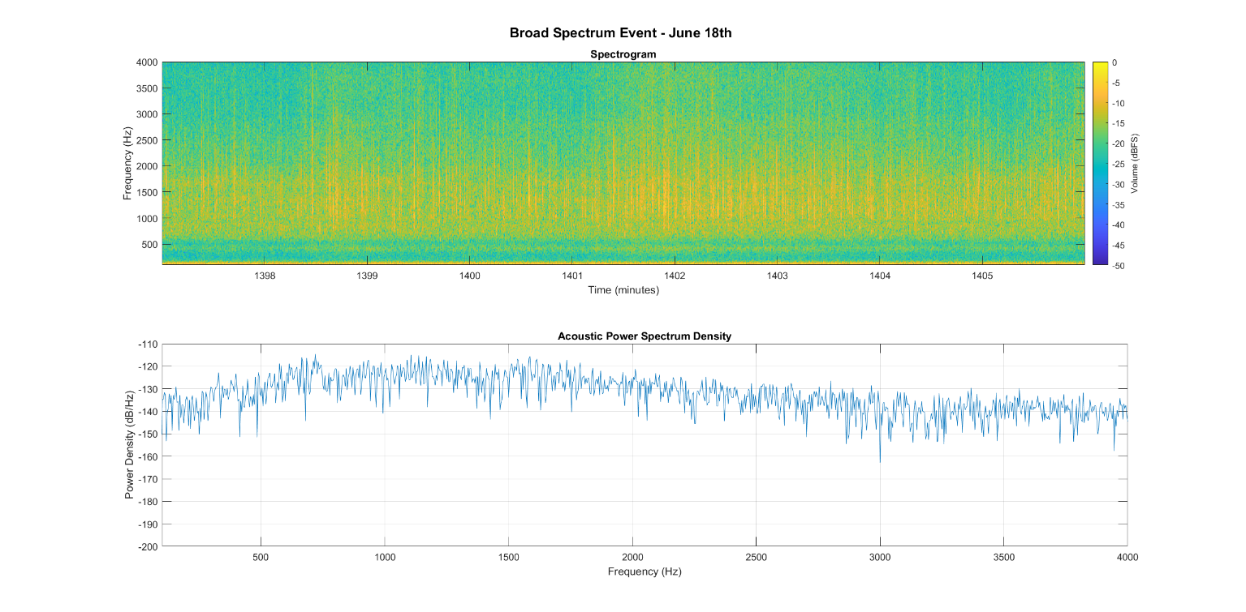
Figure S6. A spectrogram and acoustic power spectrum graph showing an example of a broad spectrum acoustic event identified as the result short-lived rain and subsequent waterfall activity, June 18th between 23:17 and 23:26. See SI Fig 8 for more details.
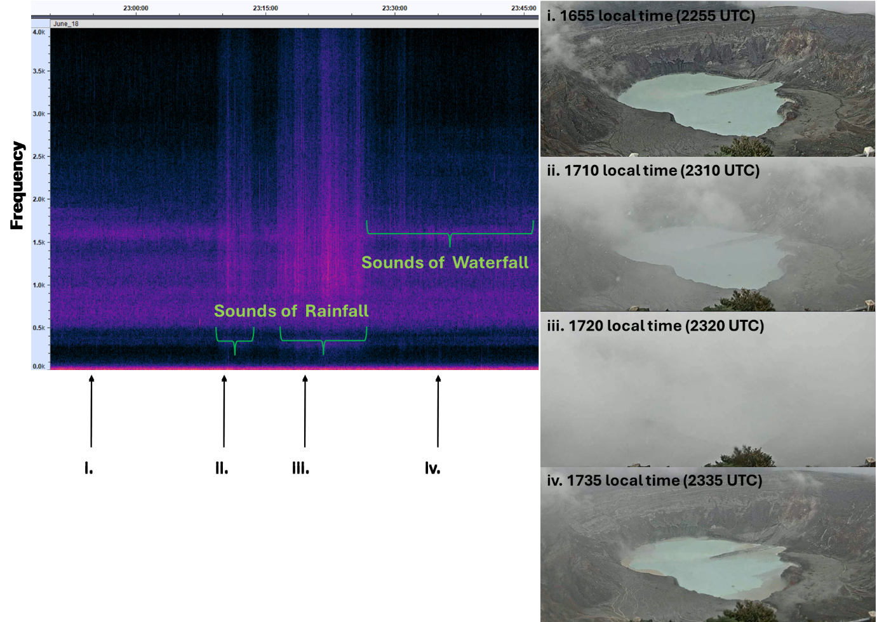

Figure S7. An example of a short-lived rain and subsequent waterfall event in Poás crater as seen by Left) the hydrophone via an acoustic spectrogram, note the broad spectrum signal lasting several minutes resulting from the rainfall and the subsequent increased in noise resulting from waterfall formation. Right) Still images as taken by a nearby observatory camera. Note the cloud cover / rainfall during ii. and iii. as well as the resulting inflow of sediment into the lake visible shortly after at 1735 (local time) due to the flow of water into the lake. This short period was excluded from the acoustic flux inversion process.

