This Supplementary Material 1 accompanies the article:
Howe, T., Christopher, T., Moune, S., Tuffen, H., Cole, P. and Schiavi, F. (2026) “Volatile emissions and magma storage conditions for the 2021 explosive eruption at La Soufrière volcano, St Vincent, from melt inclusions”, Volcanica, 9(1), pp. 231–258. doi: 10.30909/vol/odlf5080.
* Corresponding author: tivonnehowe@live.com

Contents:
- Figure S1 to S7
- Table S1 to S3

SIMS Calibration
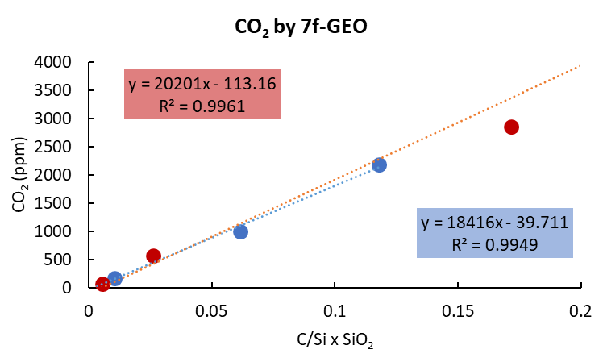
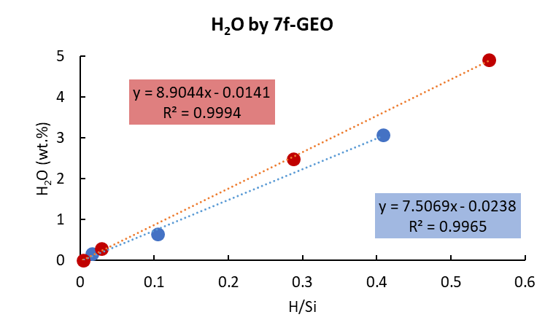
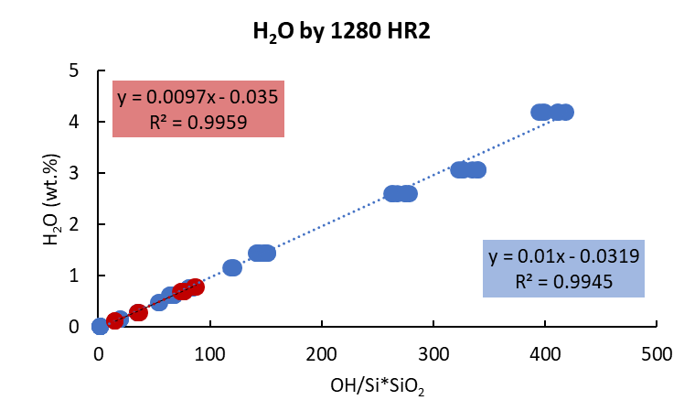
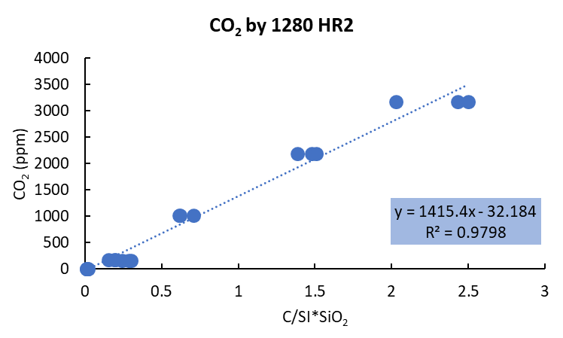

Figure S1 – Comparison of calibration curves used to calculate CO₂ and H₂O via different SIMS instruments. CO₂ and H₂O were analysed via Cameca IMS 7f-GEO using the curves of CO₂ vs C/Si * SiO2 and H₂O vs H/Si based on basaltic and rhyolitic standards and via Cameca IMS 1280 HR2 using the curves of CO₂ vs C/Si*SiO₂ and H₂O vs OH/Si*SiO₂ for basaltic and, rhyolitic standards. For the 7f-GEO, standards are N72, 5, M40, 519-4-1, RB480, Siss48, Siss61; Sisson and Grove, 1993; Brooker et al., 1999; Hauri et al., 2002; Shishkina et al., 2010). For the 1280 HR2, standards are 47963, 60701, ALV-1833-11, CY82-31-02V, KL2-G, Panum Dome, NW-Coulee, M35, M40, M43, M48, MC84-df, VG2, WOK28-3; Newman et al., 1988; Hawkins et al., 1990; Stopler and Newman, 1994; Hauri et al., 2002; Jochum et al., 2006; Shishkina et al., 2010; Bindeman et al., 2012; Sobolev et al., 2016).

EPMA Standards

Major & Volatile Elements | Standard | Diffraction Crystal | Counting Time (s) | Beam Current (nA)
Si | Wollastonite | TAP | 10 | 4
Ti | TiMnO3 | LPET | 10 | 4
Al | Orthoclase | LTAP | 20 | 4
Fe | Fayalite | LLIF | 20 | 4
Mn | TiMnO3 | LLIF | 10 | 4
Mg | Forsterite | TAP | 10 | 4
Ca | Wollastonite | LPET | 10 | 4
Na | Albite | LTAP | 10 | 4
K | Orthoclase | LPET | 10 | 4
P | Apatite | PET | 30 | 4
S | VG2 | LPET | 20 x 5¹ | 40
Cl | scap | LPET | 20 x 5¹ | 40
F | CaF2 | TAP, LTAP | 20 x 5¹ | 40

Table S1 - Analytical conditions for the application of EPMA on melt inclusion glasses.
¹ – Volatile elements were analysed with a counting time of 20 seconds for 5 cycles in the same spot, amounting to 100s for each spot.

Major Elements | Standard | Diffraction Crystal | Counting Time (s) | Beam Current (nA)
Si¹ | San Carlos | TAP | 10 | 15
Si¹ | Wollastonite | TAP | 10 | 15
Ti | TiMnO3 | PET | 10 | 15
Al | Orthoclase | LTAP | 10 | 15
Fe | Fayalite | LLIF | 10 | 15
Mn | TiMnO3 | LLIF | 10 | 15
Mg | Forsterite | TAP | 10 | 15
Ca | Wollastonite | LPET | 10 | 15
Na | Albite | LTAP | 10 | 15
K | Orthoclase | LPET | 10 | 15
Cr | Cr2O3 | PET | 10 | 15

Table S2 - Analytical conditions for the application of EPMA on crystals hosting melt inclusions
¹ – San Carlos olivine was used to calibrate for Si when measuring olivine crystals, and wollastonite when measuring plagioclase and pyroxene crystals.

ICP-OES Standards

Standard | BR | GH
SiO₂ | 38.20 | 75.80
TiO₂ | 1.40 | 4.76
Al₂O₃ | 10.20 | 12.50
Fe₂O₃ | 12.88 | 1.34
MnO | 2.60 | 0.08
MgO | 0.20 | 0.05
CaO | 13.28 | 0.03
Na₂O | 13.80 | 0.69
K₂O | 3.05 | 3.85
P₂O₅ | 1.04 | 0.01
Ba | 0.1050 | 0.0002
Sr | 0.1320 | 0.0001
H₂O | 2.80 | 0.60
Total | 99.7 | 99.7

Table S3 – Reference values for the standards BR and GH used for calibration for ICP-OES

Whole Rock Compositions

 | Whole Rock Samples
 | Dome | Unit 1 | Unit 2 | Unit 3 | Unit 5 | Unit 5 Dense
 |  | LS21-99a | LS-2189 | LS21-87 | LS21-96
SiO₂ | 54.27 | 54.05 | 53.96 | 53.96 | 52.81 | 54.21
TiO₂ | 0.99 | 0.91 | 0.91 | 0.93 | 0.94 | 0.92
Al₂O₃ | 17.72 | 18.49 | 18.71 | 18.86 | 18.23 | 18.19
Fe₂O₃ | 9.30 | 9.11 | 8.94 | 9.38 | 9.21 | 8.83
MnO | 0.21 | 0.17 | 0.17 | 0.18 | 0.17 | 0.18
MgO | 4.06 | 4.26 | 3.97 | 4.38 | 3.96 | 3.93
CaO | 8.40 | 8.91 | 8.94 | 9.15 | 8.70 | 8.50
Na₂O | 3.50 | 3.42 | 3.46 | 3.36 | 3.34 | 3.44
K₂O | 0.55 | 0.49 | 0.50 | 0.51 | 0.52 | 0.54
P₂O₅ | 0.13 | 0.11 | 0.11 | 0.12 | 0.13 | 0.13
Ba | 0.01 | 0.01 | 0.01 | 0.01 | 0.01 | 0.01
Sr | 0.02 | 0.02 | 0.02 | 0.02 | 0.02 | 0.02
H₂O | 0.03 | -0.29 | 0.07 | -0.28 | 0.27 | 0.00
Total | 99.20 | 99.70 | 99.80 | 100.60 | 97.80 | 98.90

Table S3 – Whole rock compositions in wt.% of dome and scoria samples analysed by ICP-OES. Fe₂O₃ is total iron and H₂O is loss on ignition.

Melt Inclusion Reconstruction
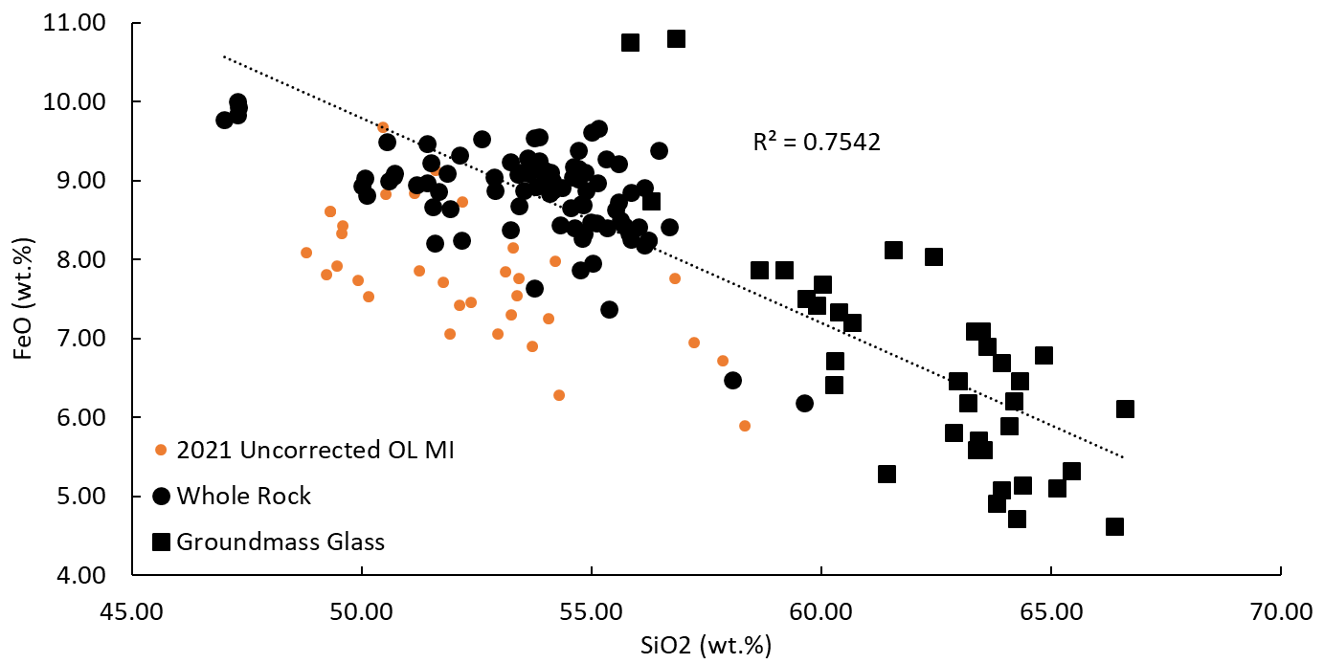

Figure S3 – Liquid line of descent of FeO vs SiO₂ and uncorrected olivine hosted melt inclusions showing up to 2 wt.% Fe loss in inclusions.
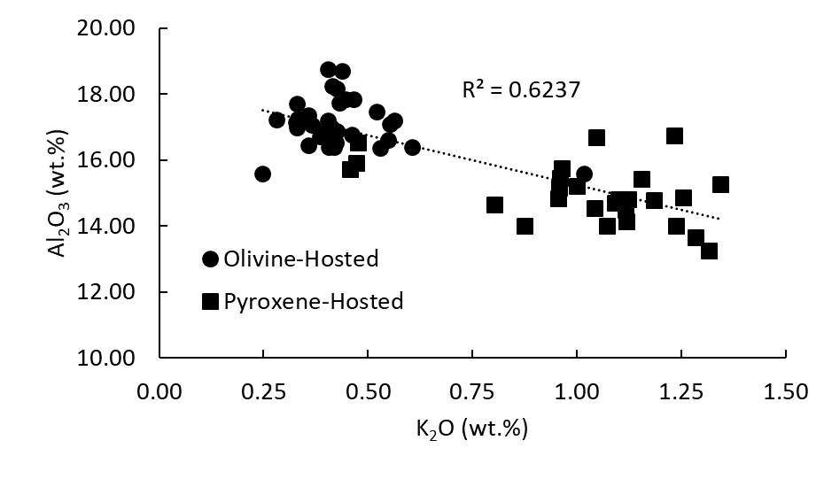

Figure S4 – Liquid line of descent of olivine- and pyroxene-hosted inclusions showing a negative correlation of Al₂O₃ with K₂O used to predict plagioclase-hosted inclusion Al₂O₃ values for reconstruction.

Melt Inclusion Bubbles

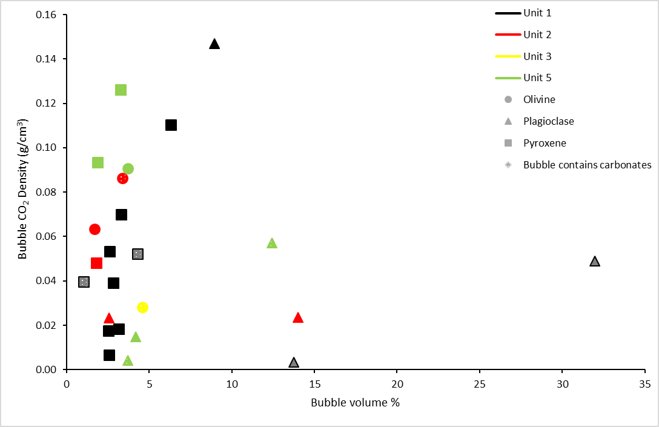

Figure S5 – Bubble CO₂ density as a function of bubble volume. Bubbles with CO₂ vapour + carbonates have similar CO₂ densities as bubble with only CO₂ vapour.

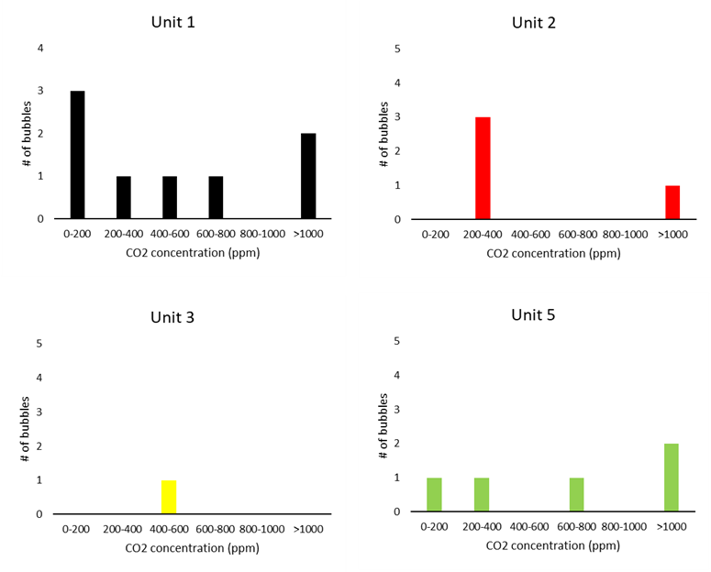

Figure S6 – CO₂ concentration of bubbles in melt inclusions from La Soufriere.

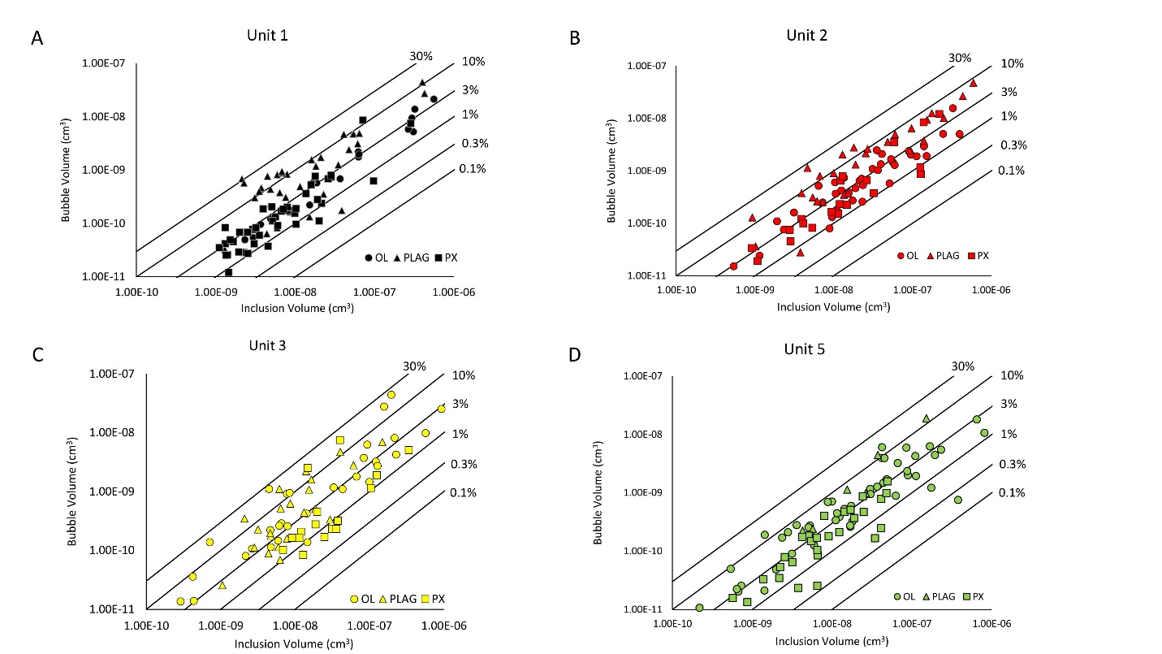

Figure S7 – Bubble volume vs inclusion volume for bubbles analysed by Raman spectroscopy. Isovolumetric lines indicate volume percentages occupied by each bubble in their respective melt inclusions. [A] Unit 1. [B] Unit 2. [C] Unit 3. [D] Unit 5.

