Supplementary Material
This Supplementary Material accompanies the article:
Cappelli, L., Buono, G., Pappalardo, L., van Gerve, T. D., Namur, O., Sielenou, V. N., Ernst, G. G., Mbede, E., Kwelwa, S., Abdallah, E. and Fontijn, K. (2026) “Conduit dynamics of the Rungwe Pumice eruption (Tanzania): From storage to fragmentation of phonolitic-trachytic magmas”, Volcanica, 9(1), pp. 123–151. doi: 10.30909/vol/bain7754.

List of Supplementary Material accompanying the manuscript:
- Table SM1: Major element composition of glass embayments, melt inclusion references, and standards analysed with SEM-EDX. Water concentrations measured using Raman spectroscopy across melt embayment transects are also included.
- 3D volume reconstructions in Dragonfly.
- Integration of vesicle size distribution plots
- Shape parameters
- Pumice lapilli vesicularity
- Results of Monte Carlo Simulation on supersaturation pressure

Stratigraphic samples chose as representative for each horizon during 2D and 3D textural investigations:
(NB: KF176L refers to top half horizon in 2D dataset, while it refers to tube pumice in 3D dataset).

b. 3D volume reconstructions in Dragonfly for samples not showed in Figure 2 of the main text. Only samples acquired with 10x lens are presented to show whole clasts morphologies.
Figure SM1: 3D reconstruction of base horizon (KF176 C).
Figure SM2: 3D reconstruction of bottom half horizon (KF176 F).
Figure SM3: 3D reconstruction of top horizon (KF176 O).

c. Integration of vesicle size distribution plots
Figure SM4: Vesicle size distributions for 2D datasets processed with FOAM. Trends are consistent with continuous nucleation and growth of bubbles, resulting in a curve that is badly interpolated by straight lines, especially toward the large size range. However, linear fitting has been attempted in correspondence with slope breaks. Slope and intercept at L=0 mm for each trend are reported in the figure. (Sample KF176L refers to top half horizon).
Figure SM5: Cumulative vesicle size distribution (CVSD) trends of 2D texture samples processed with FOAM. The distributions are fitted to an exponential trend, with the coefficients reported in the figure. Additionally, an attempt to fit two power-laws in correspondence with slope breakings is shown with their respective exponents also indicated in the figure. (Sample KF176L refers to top half horizon).
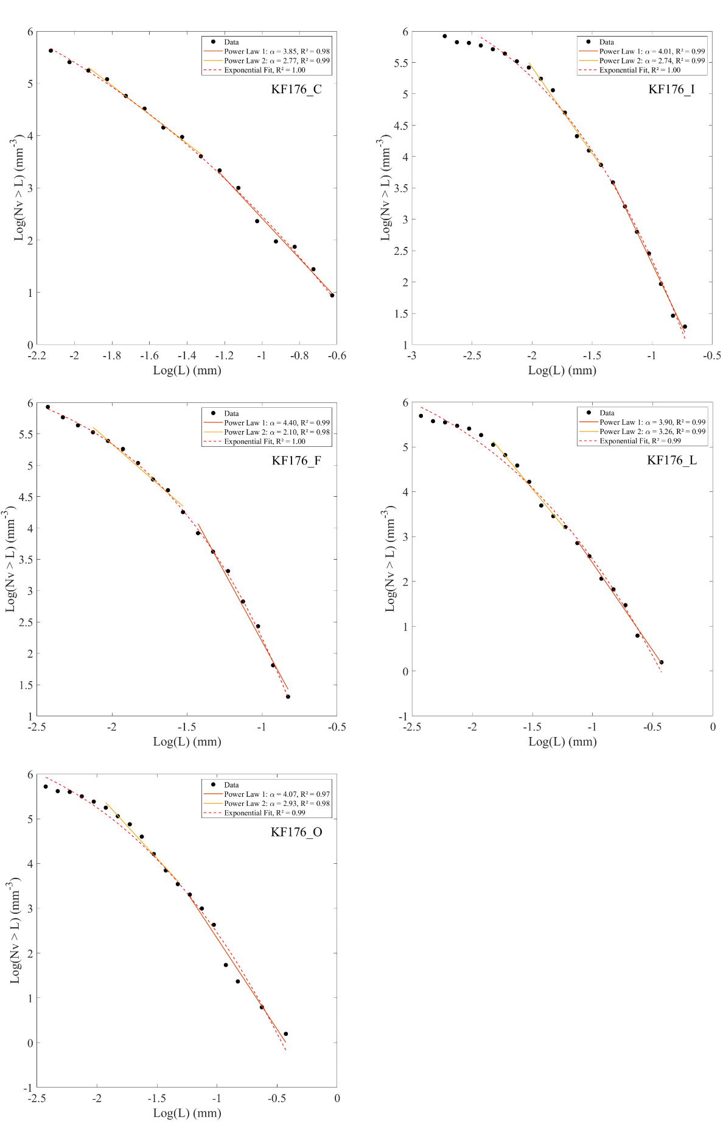
Table SM2: Exponents and goodness of fitting for first and second power law fit of CVSDs (Figure SM5), together with the coefficients for exponential interpolation.

Figure SM6: CVSD trends of μXCT samples. The distributions are fitted to an exponential trend, with the coefficients reported in the figure. Additionally, an attempt to fit two power-laws in correspondence with slope breakings is shown with their respective exponents also indicated in the figure. (Sample KF176L refers to tube pumice).

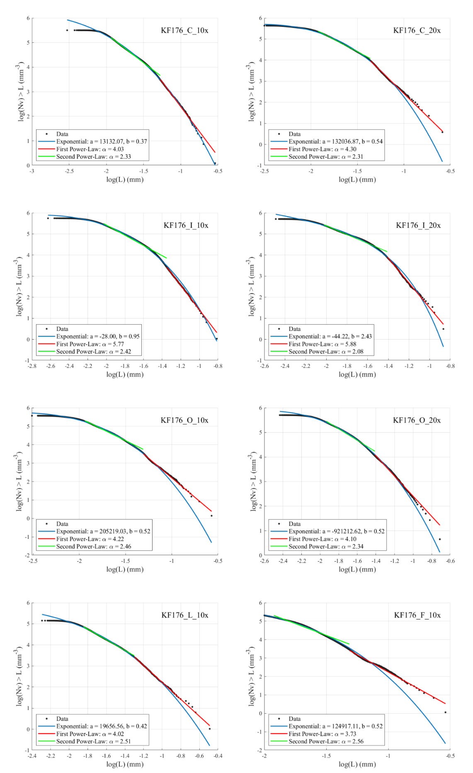
d. Shape parameters
Figure SM7: a) Elongation and b) regularity of vesicles from 2D texture datasets processed with FOAM. The shape parameter distributions reveal a tendency toward minimal elongation (indicative of equivalent bounding ellipsoid axes) and high perimeter regularity, suggesting a preference for subcircular vesicle shapes. (Sample KF176L refers to top half horizon).

Figure SM8: Frequency distribution of 3D sphericity and its relationship with vesicle size (equivalent diameter L) for XCT samples. Only samples KF176I-10x (middle horizon) and KF176L-10x (tube pumice) are shown for comparison. Sphericity values confirm the tendency toward circular perimeters observed in 2D sections (Figure SM7), supporting the validity of assuming spherical volumes for stereological conversion in FOAM.

Figure SM9: Preferential orientation of vesicles measured as the orientation of the major axis of vesicle bounding ellipsoids relative to a randomly oriented Cartesian coordinate system, with the z-axis corresponding to the sample rotational axis during μXCT data acquisition. Orientations are expressed as orientation density (number of vesicles with equivalent orientation per sample volume). Notably, the tube pumice (KF176L) exhibits the maximum iso-orientation, while bottom half (KF176F) and middle (KF176I) also show concentrated vesicle orientation. This suggests that, despite vesicles being predominantly subspherical, shear forces were sufficient to direct bubble orientation, even in more internal portions of the conduit far from conduit walls. Pixels of pole figures have a dimension of 1x1 deg.

e. Pumice lapilli vesicularity
e.1. Method
The density of pumice clasts was measured using all available clasts within the -4/-5 φ (16-32 mm) grain size range from all stratigraphic horizons in each subsample. Depending on clast abundance, between 40 and 75 clasts were collected per horizon for a total of ~300 samples. Clasts were then rinsed with multiple cycles of ultrasonic bath to remove adhering fine dust.
A Micromeritics AccuPyc II 1345 gas (helium) displacement pycnometer was used at the Université libre de Bruxelles (Belgium) to measure the bulk volume (i.e., rock skeleton plus closed vesicles) of clasts. Each clast’s volume was measured ten times and the values averaged (±1σ_{Max} = 0.092 g cm⁻³). Then, the bulk density was obtained by dividing the measured volumes by clast mass, determined with a high-precision scale (0.0001 g resolution). For the same clasts, the envelope density (i.e., rock skeleton plus open and closed vesicles) was measured with a VWR® Balance equipped with a VWR® Density Kit based on Archimedes’ principle. To seal open vesicles, samples were wrapped in a thin plastic film. The density was calculated from the difference between the sample mass in air and its mass when submerged in distilled water. Measured densities were then corrected for the mass and volume of the plastic wrap. Results were additionally validated on a small subset of samples using a Micromeritics GeoPyc pycnometer (at the Université libre de Bruxelles, Belgium) which determines envelope volume—and thus density—by measuring the displacement of a quasi-fluid medium composed of rigid microscopic beads (i.e., Dry Flo™ compound). Finally, true glass density (i.e., dense rock equivalent, representing the pumice skeleton) was determined for each stratigraphic horizon using the gas pycnometer with finely crushed pumice powders (£ 63 µm), that were devoid of major vesicularities.
Eventually, bulk (r_{Blk}), envelope (r_{Env}), and true (r_{DRE}) densities were used to calculate the open (ϕ_{Opn}), closed (ϕ_{Clos}), and total (ϕ_{Tot}) vesicularity of clasts:
$$\begin{aligned}φ_{Opn}=\frac{\left(ρ_{Blk }-ρ_{Env}\right)}{ρ_{Blk }} \#\left(SM1\right)\end{aligned}$$
$$\begin{aligned}φ_{Tot}=\frac{\left(ρ_{DRE }-ρ_{Env}\right)}{ρ_{DRE }} \#\left(SM2\right)\end{aligned}$$
$$\begin{aligned}φ_{Clos}=ρ_{Tot}-ρ_{Opn} \#\left(SM3\right)\end{aligned}$$

a.2. Results
The average total vesicularity of pumice lapilli was measured at ~85% ±4%, with no visible change across different stratigraphic horizon (Fig. SM11). Within the same horizon, clasts show similar values, with a maximum standard deviation (±1σ) of ±5%. Open vesicularity corresponds to total vesicularity, as closed vesicularity is recorded to be always around 0%, indicating fully connected vesicle networks (Fig. SM11).

Table SM3: Densities and vesicularities for pumice lapilli clasts, presented as averages for each horizon.
Figure SM10: (left) Box and whisker plots of pumice lapilli vesicularity for the different horizon of the KF176 deposit, and their (right) connected vesicularity.
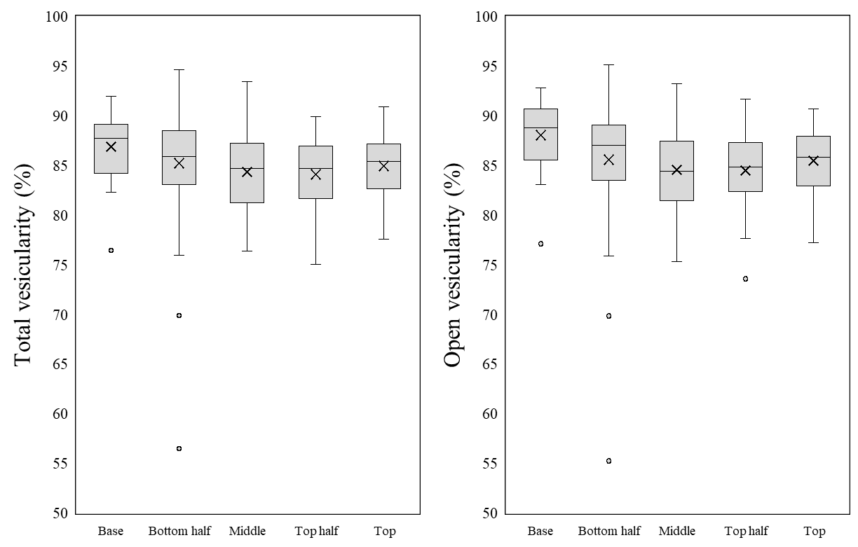

Figure SM11: Mosaic of SEM images of a thin section of a lapilli-sized pumiceous clast from sample KF176N. Notably inflated bubbles at the core of the clast reach up to millimetric size. Accurate textural investigations on these clasts resulted impractical due to preparation-produced artefacts and to polishing materials and pumiceous fine dust accumulated in voids.
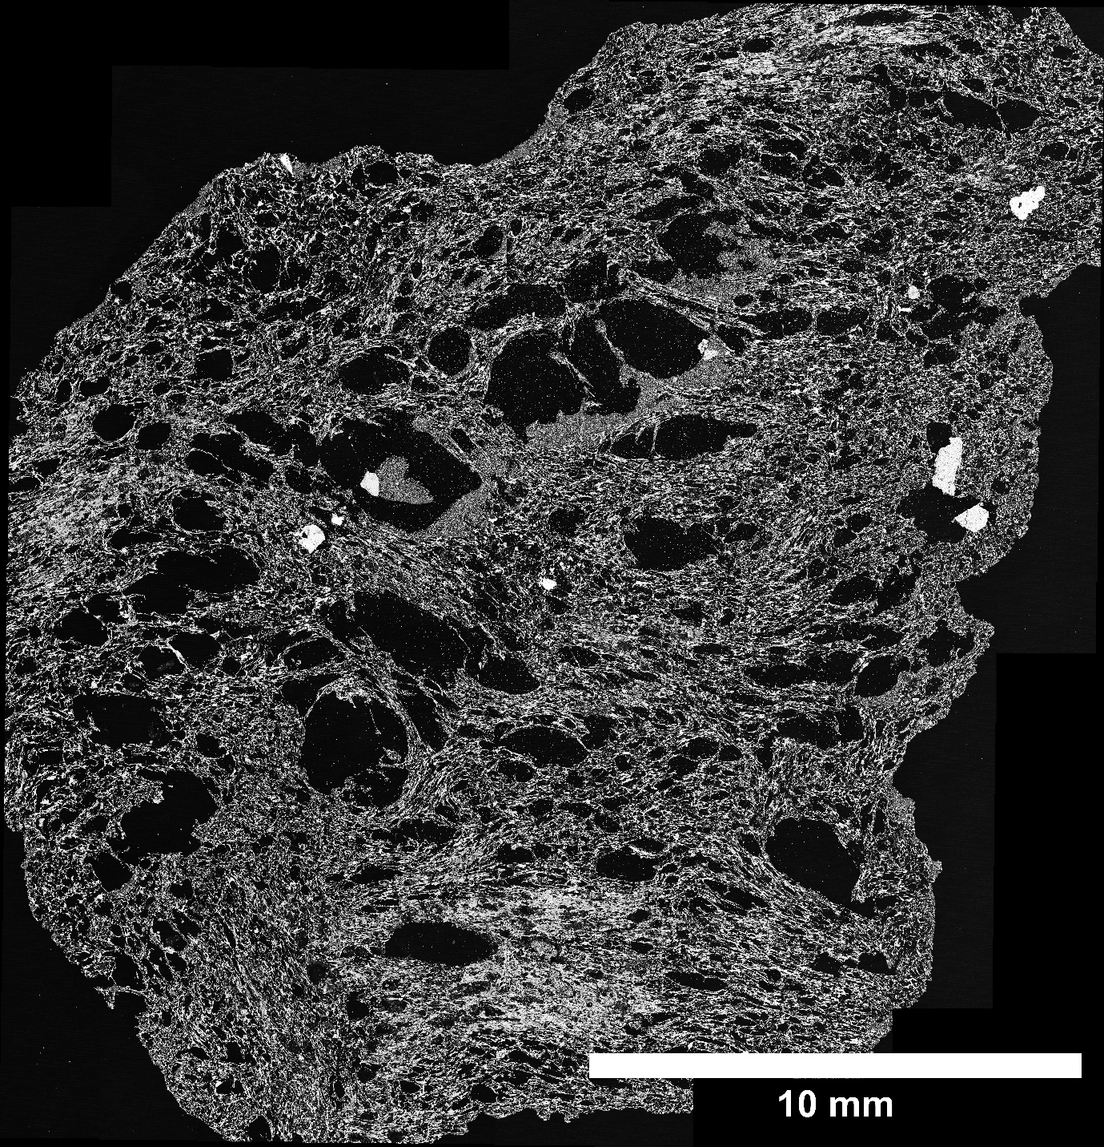

f. Results of Monte Carlo simulation for bubble supersaturation pressures
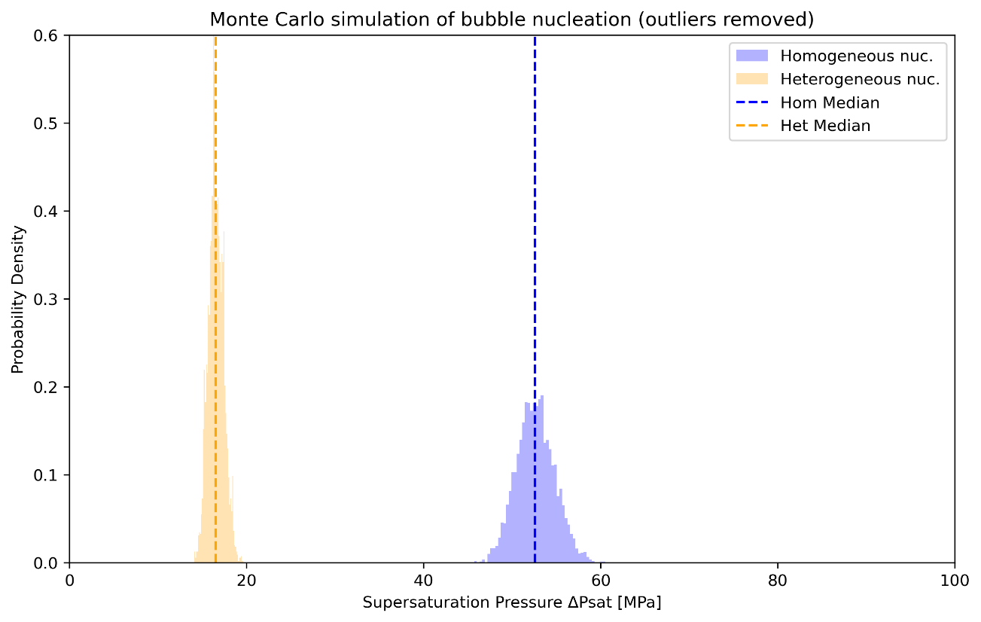
Figure SM12: Probability density of supersaturation pressures obtained from Monte Carlo simulations for homogeneous and heterogeneous nucleation. The median of each distribution is indicated by the dashed lines. Outliers comprising the 99.9th percentile, resulting from anomalous inputs, have been excluded.
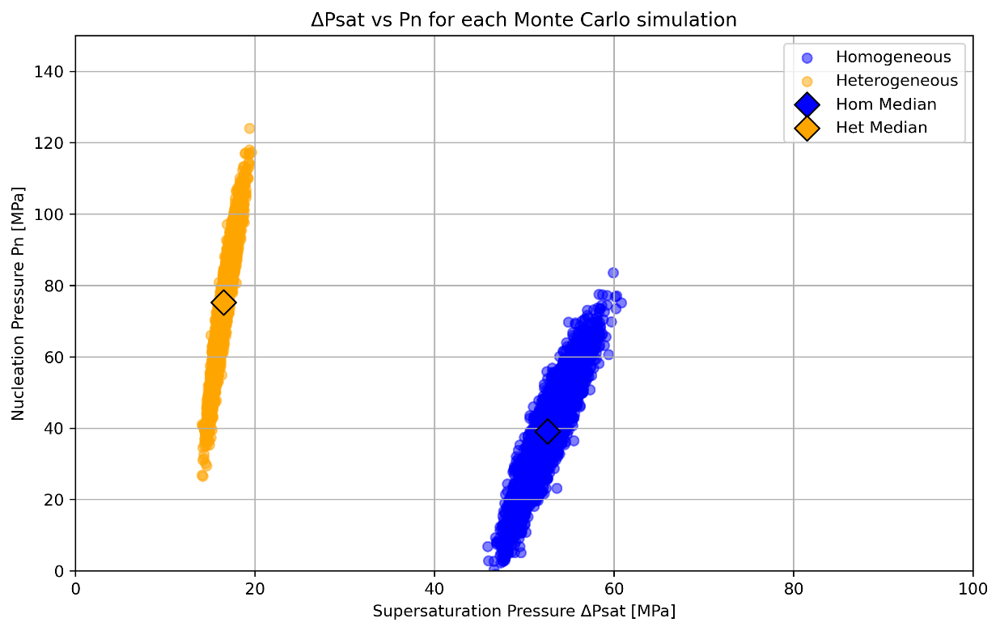
Figure SM13: Scatter plot showing individual values of supersaturation pressure versus bubble nucleation pressure, computed independently during the Monte Carlo simulation for both homogeneous and heterogeneous nucleation. The median of each distribution is indicated by the empty, black-contoured diamond.
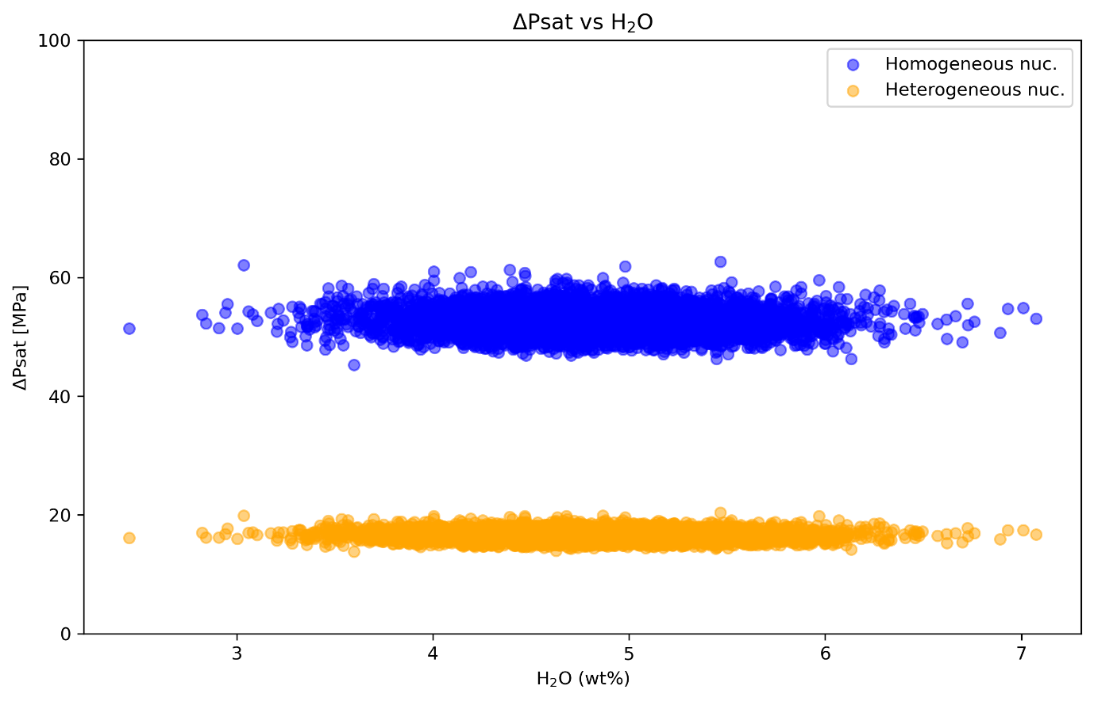
Figure SM14: Scatter plot showing the dependence of supersaturation pressure on individual water concentration values used as inputs for the Monte Carlo simulation, for both homogeneous and heterogeneous nucleation.
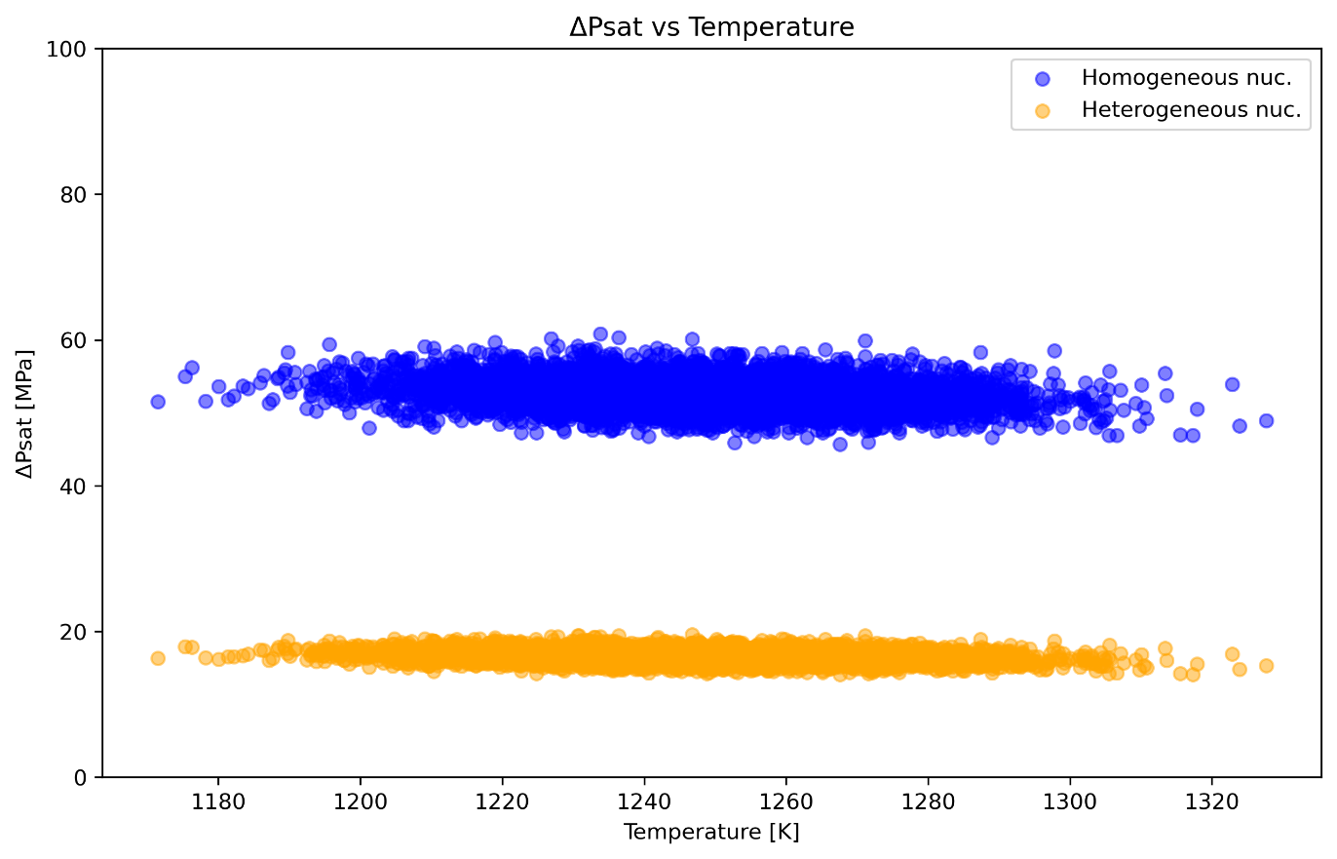
Figure SM15: Scatter plot showing the dependence of supersaturation pressure on individual melt temperature values used as inputs for the Monte Carlo simulation, for both homogeneous and heterogeneous nucleation.
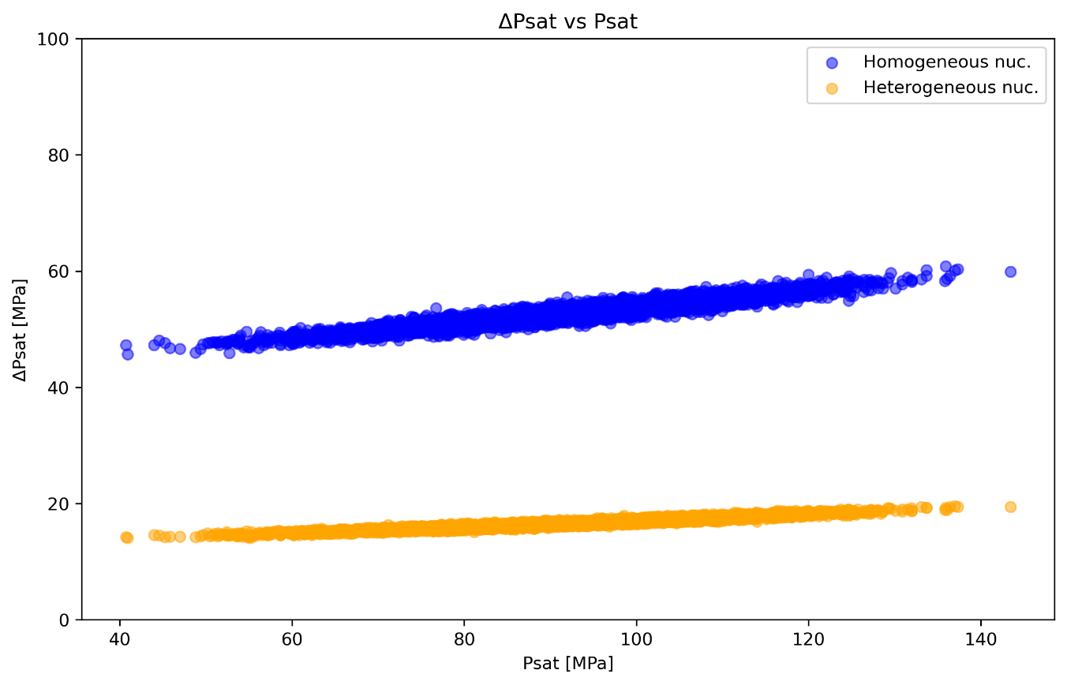
Figure SM16: Scatter plot showing the dependence of supersaturation pressure on individual water saturation pressures values used as inputs for the Monte Carlo simulation, for both homogeneous and heterogeneous nucleation.
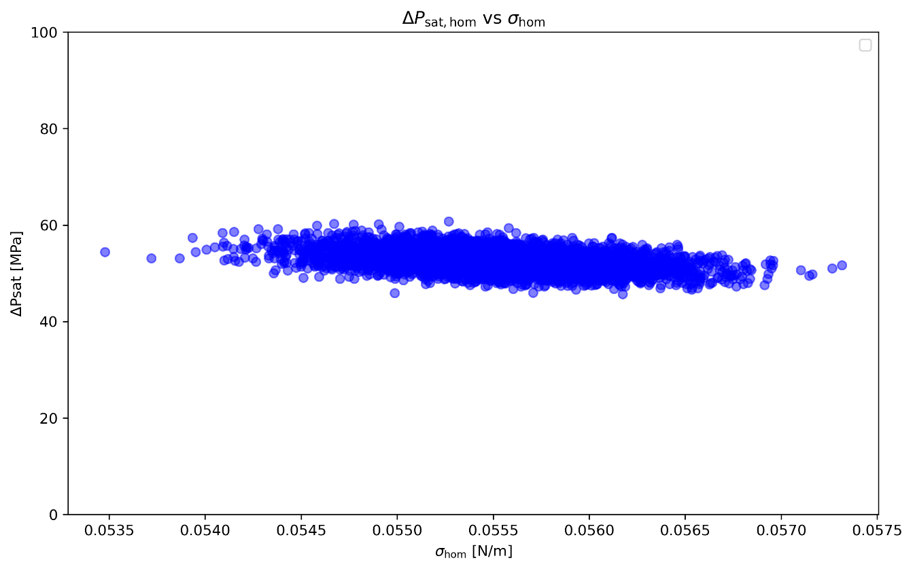
Figure SM17: Scatter plot showing the dependence of supersaturation pressure on individual homogeneous surface tension values used as inputs in the Monte Carlo simulation for saturation pressure calculations. The range of surface tension values was obtained from the Monte Carlo simulation using Eq. (13) from Shea (2017).

