This Supplementary Material accompanies the article:
Del Bello, E., Bagnato, E., Guerrieri, L., Tamburello, G., Corradini, S., Merucci, L., Pennacchia, F., Scarlato, P., Stelitano, D. and Taddeucci, J. (2025) “A cross-comparison of thermal infrared versus ultraviolet ground-based retrievals of SO2 masses during Strombolian explosions”, Volcanica, 8(2), pp. 583–599. doi: 10.30909/vol/sgic1814.
Del Bello et al. [2025] should be cited if these materials are used.
* elisabetta.delbello@ingv.it [corresponding author]

Supplementary Table S1: The supplementary Table S1 (attached as a separate .xls file) is a spreadsheet with the data used in the manuscript. The first two sheets contain SO₂ mass time series from UV and TIR camera retrievals, alongside FLIR thermal data for 23 May and 24 May 2023 respectively. The third sheet summarizes the parameters of the 49 explosions analysed in this study, including: Explosion type, location, onset time, duration, bomb elevation, mean ejection speed, SO₂ masses retrieved from TIR and UV data, peak temperature, and TIR/UV ratio.

Supplementary Figure S1
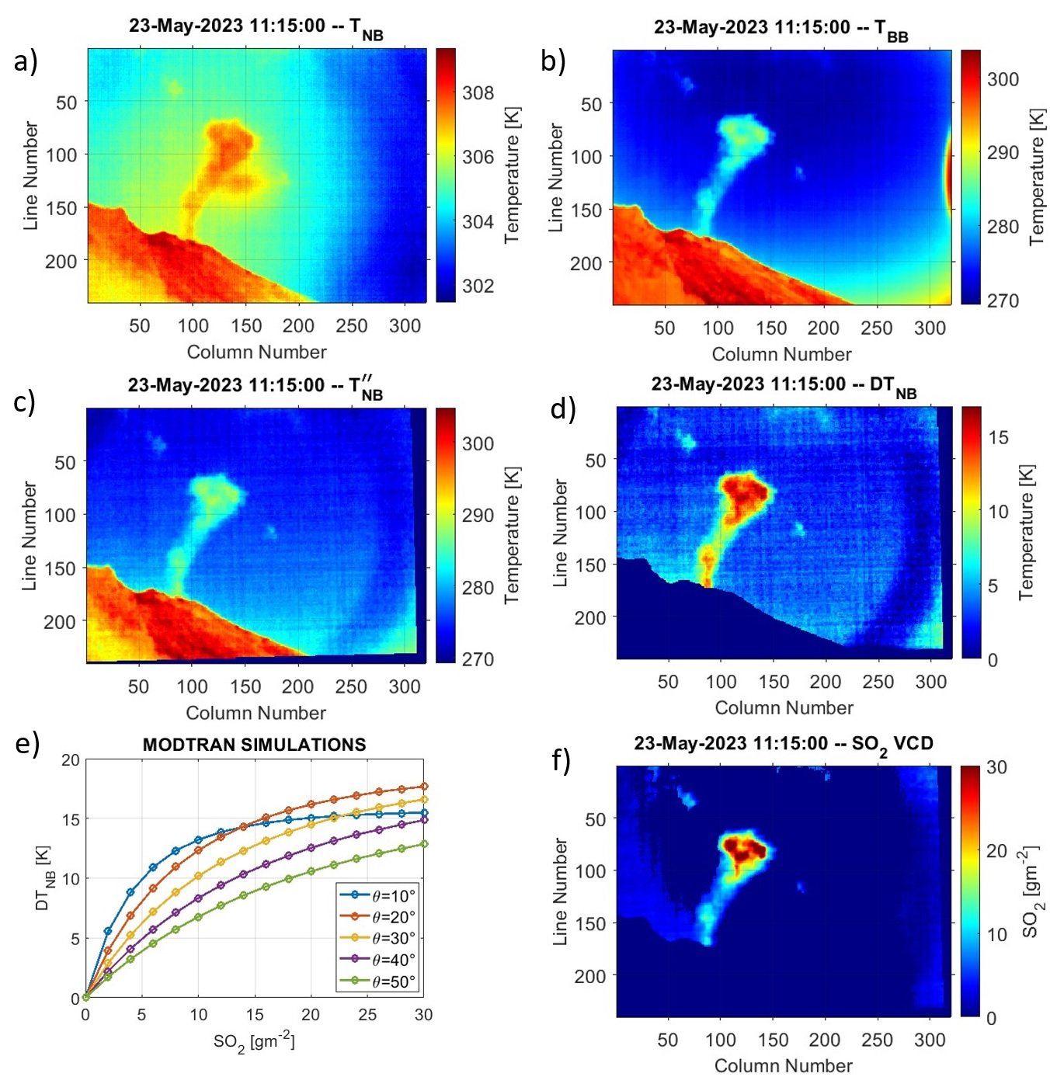
Supplementary Figure S1. Sequence of TIR images collected at Stromboli on 23 May 2023 at 11:15 UTC explaining the methodology to obtain the SO₂ vertical column density. a) Original TIR narrowband (8.7 μm, NB) image. b) Original TIR broadband (7.8-14 μm, BB) image. c) Corrected NB image, after the removal of the “ghost image” and the re-calibration process. d) The NB temperature difference image (DT_{NB}) obtained subtracting the “clear sky” temperature from the plume temperature. e) DT_{NB} temperatures simulated with MODTRAN, depending on the elevation angle (deg) and the SO₂ VCD (g m⁻²). f) The SO₂ VCD image (g m⁻²) obtained by linear interpolation between the measured and simulated DT_{NB}.
Supplementary Figure S2

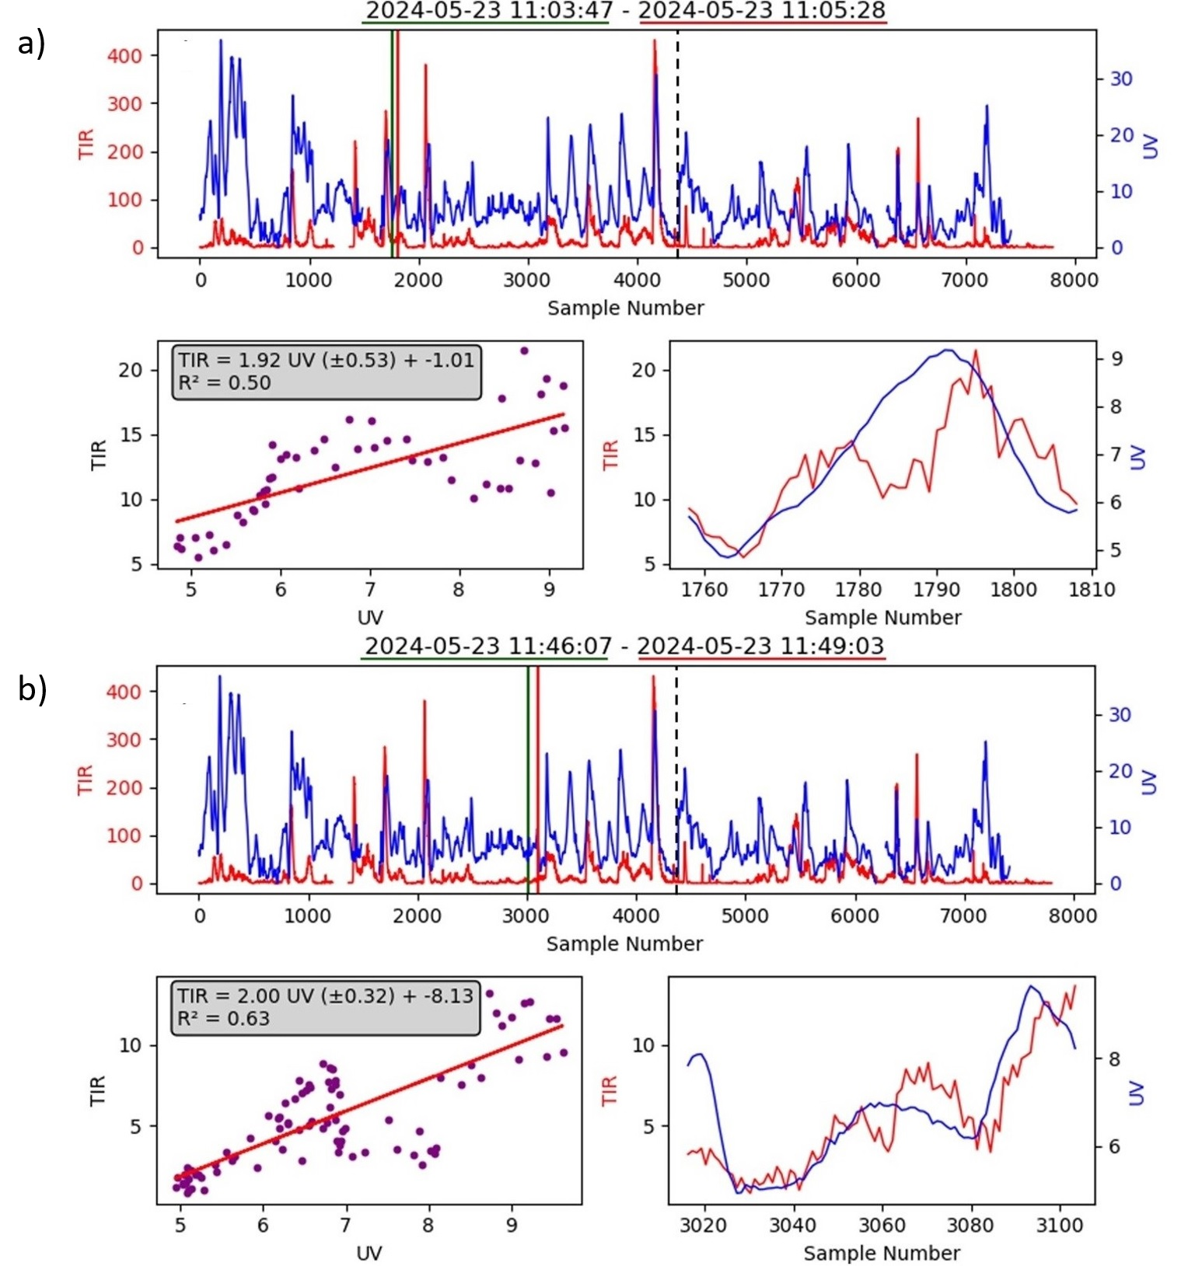

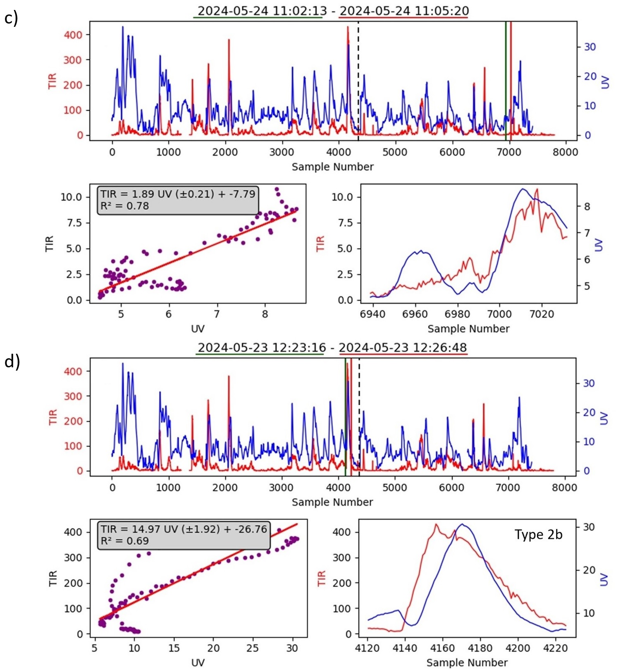

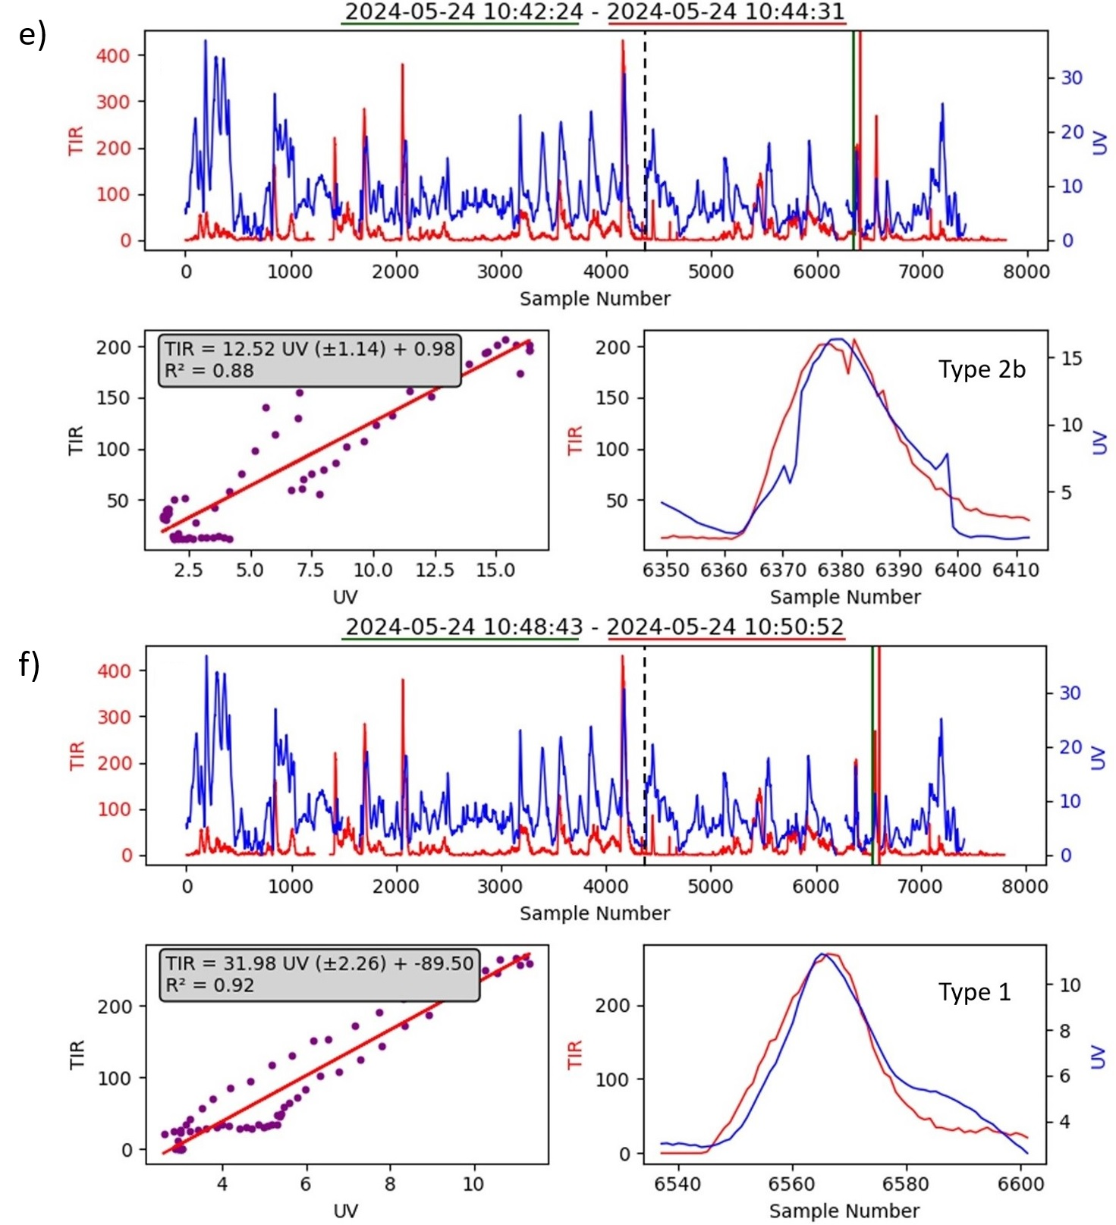
Supplementary Figure S2. Examples showing the correlation between UV and TIR data signal computed over 50-100 s windows (the vertical green and red lines mark the selected windows in the time series graph). The dashed line separates the time series from 23 and 24 May, which are displayed together with the sample number in the X axis for convenience. The examples in (a–c) correspond to non-explosive periods, while those in (d–f) represent explosive events. Over these short intervals, the correlation is high (R² = 0.5-0.9, corresponding to R ~ 0.7-1).
Supplementary Figure S3
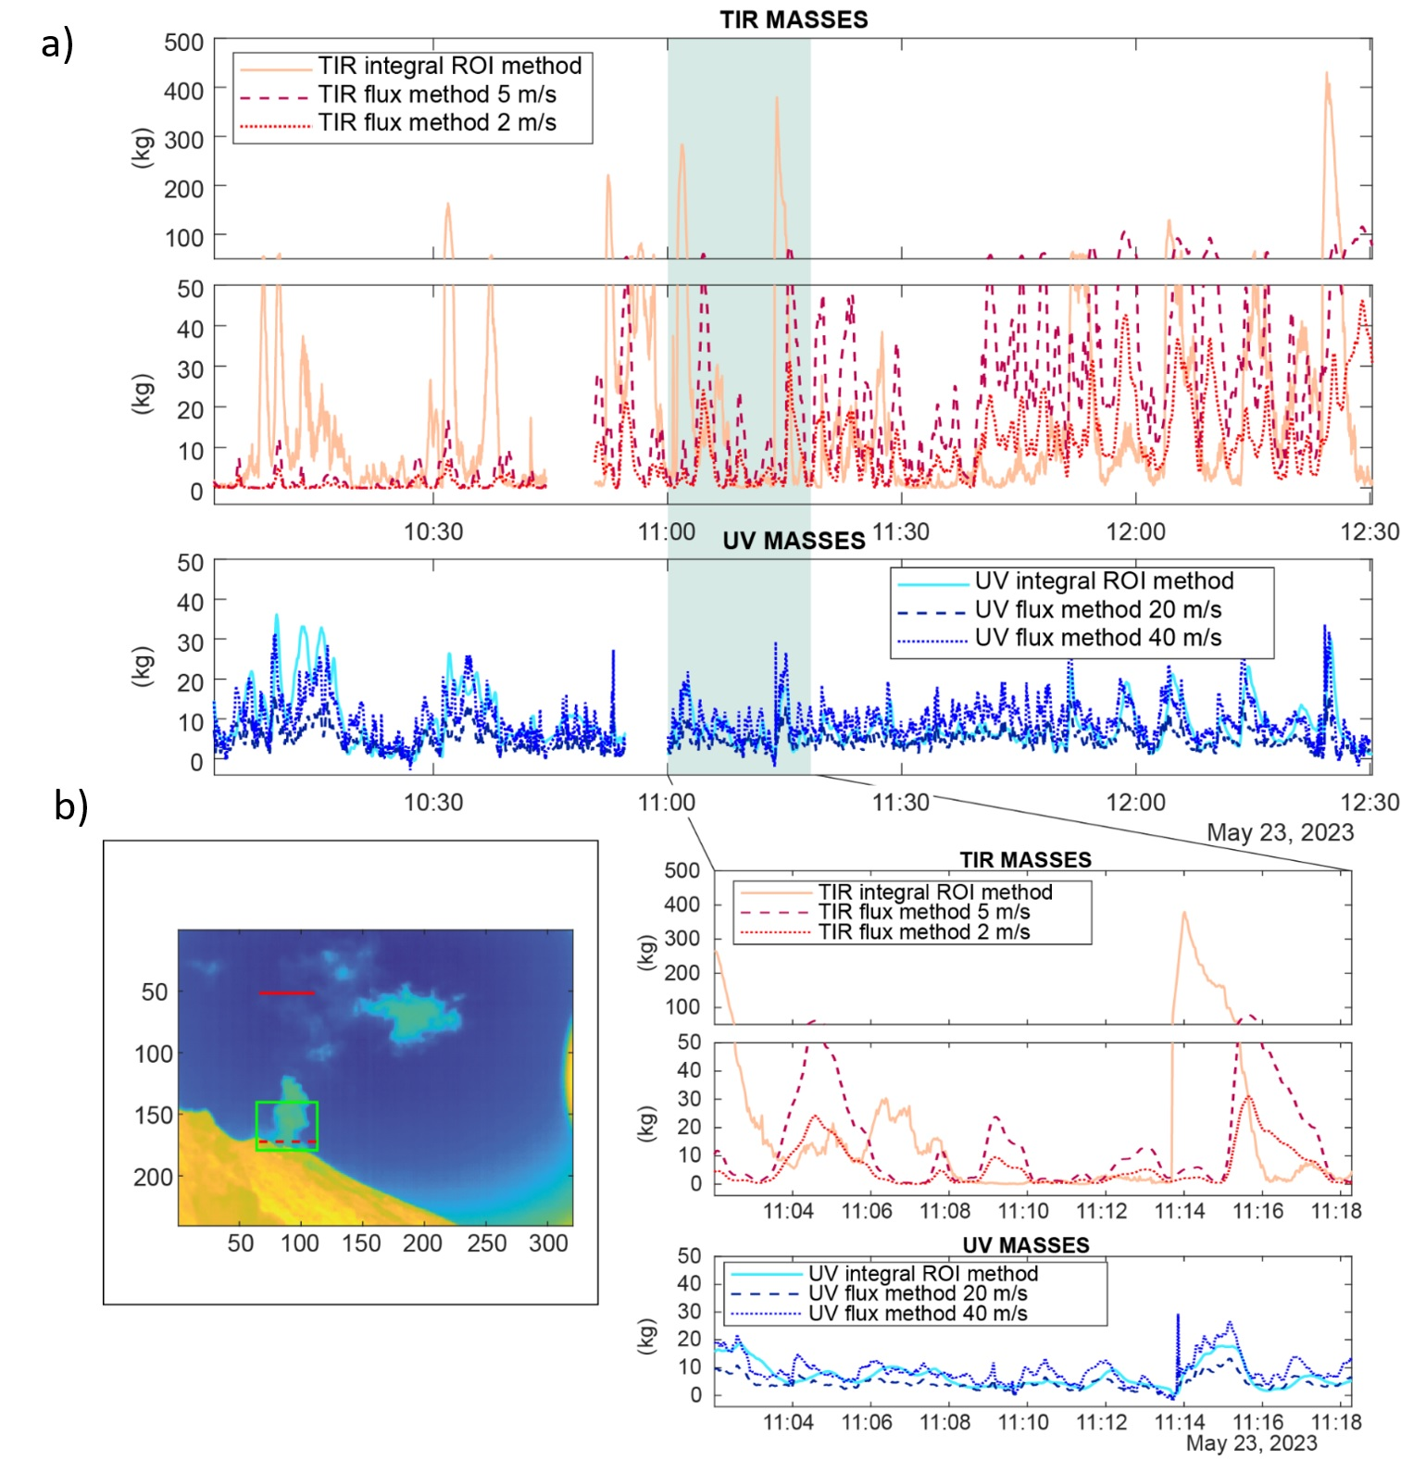
Supplementary Figure S3. a) Comparison of SO₂ mass retrievals from TIR and UV data using both integral (ROI-based) and flux-based methods under different velocity assumptions on May 23, 2023. In the TIR data (top panels), the ROI integral method (solid line) yields the highest peak masses, especially during explosive events. In contrast, the TIR flux approach (dashed and dotted lines) introduces several sources of uncertainty: (1) the use of assumed constant velocities (e.g., 2–5 m/s) can lead to unrealistic background levels during passive degassing, (2) temporal mismatches between plume arrival at the transect and the explosion time can shift peaks by up to 1 minute, and (3) some explosive plumes may not reach the TIR transect at 500 m elevation, leading to underestimated masses. UV flux retrievals (bottom panels) are also sensitive to the assumed velocities (e.g., 20–40 m/s), which mostly affect peak amplitude. The close-up view (bottom two panels) highlights timing and amplitude mismatches between methods, illustrating how retrieval strategy and geometry strongly influence the resulting SO₂ mass estimates. b) Still frame from the TIR camera showing the ROI (green box) and the transects used for flux-based measurements: UV transects are indicated by dashed lines inside the ROI, and the TIR flux transect is also shown.

Supplementary Methods

Quantification of FLIR Temperature Underestimation due to Emissivity
To address the potential bias in the mean ROI temperature measurements of gas-dominated plumes, i.e. when the emissivity is much lower than the assumed value (ϵ =0.92), we can quantify the expected underestimation. The thermal camera measures the spectral radiance, L, an object emits. For a blackbody, this is related to its temperature, T, and emissivity, ϵ, through the Planck law, but for a simplified calculation, we can use the Stefan-Boltzmann law, which states that the total radiated power is proportional to $T^{4}$:
$$L=ϵσT^{4}$$

where σ is the Stefan-Boltzmann constant.
The camera calculates an apparent temperature (T_{app}) by measuring the incoming radiance (L_{meas})​ and inverting this formula using the assumed emissivity (ϵ_{ass})
​
$$T_{app}={\left(\frac{L_{meas}}{ϵ_{ass}σ}\right)}^{1/4}$$

A volcanic plume (gas or aerosol) has a true temperature of $T_{true}$
The camera's emissivity is set to $ϵ_{ass}$ = 0.92, a typical value for volcanic particles (a near-blackbody).
We measure a gas-dominated plume with a low true emissivity, for example, $ϵ_{gas}$ = 0.1.
The radiance emitted by the gas plume and measured by the camera is:
$$L_{meas}=ϵ_{gas}σ{{(T}_{true}^{})}^{4}$$

The camera, however, calculates the apparent temperature using its assumed emissivity of 0.92:

$$L_{meas}=ϵ_{ass}σ{{(T}_{app}^{})}^{4}$$

By equating these two expressions, we can solve for the apparent temperature:

$ϵ_{gas}σ{{(T}_{true}^{})}^{4}$=$ϵ_{ass}σ{{(T}_{app}^{})}^{4}$
$$T_{app}=T_{true}{\left(\frac{ϵ_{gas}}{ϵ_{ass}}\right)}^{1/4}$$

​ Now, assuming the true temperature of the gas in a type 0 explosion is $T_{true}$= 600° C (873 K).

$$T_{app}=873 {\left(\frac{0.1}{0.92}\right)}^{1/4}≈501 K≈228°C$$
​This calculation shows that a gas plume at a true temperature of 600°C would be measured by the camera as approximately 228°C—an underestimation of nearly 370°C.

